March 19, 2017

To Whom It May Concern,

I am writing as artistic director of NACL Theatre in Highland Lake, NY, to express my support and recommendation of Jessica Barkl. My theatre company has had the pleasure of working with Jessica on a number of theatre and actor training projects. As a professional performer, Jessica has collaborated with NACL on two projects. The Weather Project, an original climate change play funded by an NEA Our Town grant. Jessica was part of the 2015 ensemble of artists, in collaboration with environmentalists, musicians, and a NASA climate scientist. The performance toured to New York City, and locally to festivals and parades in Livingston Manor, Liberty, and Honesdale, PA throughout the summer.

Recently, Jessica was a lead performer and primary creator in another large-scale NACL performance entitled Courage. Based on Bertolt Brecht’s “Mother Courage and Her Children,” Jessica created the unforgettable character of Yvette and wowed sold out audiences with her stunning portrayal of an immigrant refugee. Jessica will continue the role in 2017 locally at Apple Pond Farm and at the NYC premiere on Governor’s Island.

Jessica is a brilliant performer and singer and is a natural teacher and director. She has acted as a leader and director of the NACL Street Theatre performances and co-leads the professional actor trainings (weekly trainings where the NACL ensemble works on physical and vocal skills).

Jessica is a focused, talented, generous, and visionary artist. I have attended most of the plays she has directed at SUNY Sullivan, and I am not alone in understanding that we have a gifted and valuable asset here in our community. Her professional standards are extraordinary, she has inspired students and community members to get and STAY involved in her productions. Her endless dedication and willingness to do whatever has to get done in the theatre education milieu is a great success and boon for the college. I highly recommend Jessica Barkl, there is no one like her.

Sincerely,

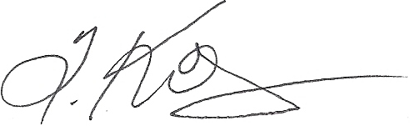

Tannis Kowalchuk, Artistic Director

