PIPPIN
Music and Lyrics by Stephen Schwartz
Book by Roger O. Hirson
Originally produced on the Broadway Stage by Stuart Ostrow
Directed on the Broadway sage by Bob Fosse

Actor and Designer Packet
Compiled by Director, Jessica Barkl
For the April 2014 Production of PIPPIN
Performed by the Intermediate Musical Theater Class
At the Public Academy for the Performing Arts

Table of Contents

Past Productions Page 4
Stephen Schwartz Page 5-6
Roger O. Hirson Page 7
Stuart Ostrow Page 7-9
Bob Fosse Page 9-11
Jessica Barkl’s Director Concept Page 11-29
Chicano Theater Movement Page 21
Acto Page 21
Corrido Page 21
Mito Page 21
Carpa Page 21
Jesucristo-Quetzalcóatl Page 21
Quetzalcóatl Page 22
Coatlicue Page 22
Coyolxauhqui Page 23
Huitzilopochtli Page 23
La Virgen de Guadalupe Page 23-24
Patron Page 24
Pachuco Page 25
La Muerte Page 26
Calaveras Page 26
Circus Characters based on Chicano Theater Character Names Page 26
Puppetry Page 27
Masks Page 27-28
One-person bunraku Page 28-29
Object puppetry Page 29
Projection Design Page 29
Choreography/Blocking Inspiration Page 29-35
Animal Studies Page 29-30
Commedia dell’Arte Page 30
Viewpoints and Composition Page 30-33
Tadashi Suzuki Method Page 33
Circus Page 33
Fight Choreography (Swordsmanship in 780 AD and Barrio Brawls) Page 33-35
Places, Time, People Page 35-65
The Holy Roman Empire Page 35-36
University of Padua Page 37-38
Palace of Aachen Page 38
Carolingian Empire Page 38-40
Lombard Wars/Northern Italy Page 40
Famine 492/3, 805 (allegorical Dust Bowl) Page 40
Arles Page 41-42
The Chapel at Arles (“Saint Boss’s Church”) Page 42
Volga Campaign of Charlemagne Page 42-43
Vistula Campaign of Charlemagne Page 43-44
Valhalla Page 44
Galilee Page 44
780 A.D. Page 45
Hunting in 780 A.D. Page 45-47
Pippin/Carloman (King of Italy) Page 47
Pepin the Hunchback Page 47-50
Charlemagne Page 50
Soldiers in Charlemagne’s Army Page 50-51
War Tactics of Charlemagne Page 51-53
Civil Disobedience during Charlemagne’s Reign Page 53
United Farm Workers Page 53-56
Brown Berets Page 56-59
Fastrada Page 59-60
Louis Page 60
Berthe Page 60-61
Where Berthe lives in the countryside – Choisy-au-Bac Page 62
Visigoths Page 62-63
Frisians Page 63-64
Pompey Page 64-65
Darius Page 65
Old King Aleric Page 65
Allusions to Modern History Page 66-68
Iraq War Statistics Page 66-67
Afghanistan War Statistics Page 67-68
Props/Costumes Page 68-73
Vocabulary from the play Page 73-77
Bibliography Page 77-79

Past Productions: (From Wikipedia).
Broadway: The show premiered at the Imperial Theater on October 23, 1972, and ran for 1,944 performances before closing on June 12, 1977. It was directed and choreographed by Bob Fosse. Clive Barnes commented for the NEW YORK TIMES, “It is a commonplace set to rock music, and I must say I found most of the music somewhat characterless…It is nevertheless tuneful and contains a few rock ballads that could prove memorable. Advertising for the Broadway production broke new ground with the first TV commercial that actually showed scenes from a Broadway show. The commercial, which ran 60 seconds, showed Ben Vereen and two other dancers (Candy Brown and Pamela Sousa, who were in the chorus of the show) in the instrumental dance sequence from “Glory”. The commercial ended with the tagline, “You can see the other 119 minutes of PIPPIN live at the Imperial Theater, without commercial interruption.””

Broadway Revival 2013: The American Repertory Theater’s recent production of PIPPIN transferred to Broadway in March 2013. The production began previews on March 23, 2013, at the Music Box Theatre, with an opening on April 25. The same cast that performed at the A.R.T. is also in the Broadway production. Diane Paulus directs, with circus choreography and acrobatics by Chet Walker and Gypsy Snider. This revival won 4 Tony Awards at the 67th Tony Awards out of 10 nominations including the Tony Award for Best Revival of a musical, Best Performance by a Leading Actress in a Musical (Patina Miller – Leading Player), Best Performance by a Featured Actress in a Musical (Andrea Martin – Berthe), and Best Direction for Paulus.

London: The show opened in the West End at Her Majesty’s Theatre on October 30, 1973, and ran for 85 performances. Bob Fosse again was director and choreographer.

It was later revived at the Menier Chocolate Factory in December 2011.

Paper Mill (2000): In June 2000, the Paper Mill Playhouse in Milburn, New Jersey, staged a revival with director Robert Johanson and choreographer Rob Ashford.

Concert (2004): In 2004, the first major New York revisitation of the show was featured as the second annual World AIDS Day Concert presented by Jamie McGonnigal. The role of the Leading Player was split up among five actors including Rosie O’Donnel, Darius de Haas, Billy Porter, Kate Shindle, and a surprise appearance by Ben Vereen, making his first New York stage appearance in over a decade.

Bay Street Theater (2005): In 2005, the Bay Street Theatre in Sag Harbor, New York, staged a production starring BD Wong (Leading Player). The production ran from August 9, 2005 through September 4, 2005.

Los Angeles (2009): The show was produced in Los Angeles at the Mark Taper Forum, from January 15, 2009, through March 15, 2009, in a radically different form. The play’s setting was changed to reflect a modern tone and was subtly modified to include deaf actors using American Sign Language. The production was choreographed and directed by Jeff Calhoun for actors from both the Deaf West Theatre Company and the Center Theatre Group. [One actor played the Leading Player that was deaf and another actor, who was not, voiced the Leading Player.] The NEW YORK TIMES noted that the duality was required by the situation, but effectively showcased the character’s “lack of a fixed self” in an exciting new fashion.

Kansas City (2012): The Kansas City Repertory Theatre produced and performed a version of PIPPIN that opened on September 14, 2012, and closed on October 7, 2012. The score was adapted to reflect a punk-rock style by Curtis Moore and featured Mary Testa.

Caracas – Venezuela (2013): A Spanish-language version of PIPPIN, produced by the Lily Alvarez Sierra Company in Caracas Venezuela. It opened December 12, 2013.

US National Tour (2014); The production will kick off its national tour in Denver, Colorado, at the Buell Theatre in September 2014.

1981 Video: In 1981, a stage production of PIPPIN was videotaped for Canadian television. The stage production was directed by Kathryn Doby, Bob Fosse’s dance captain for the original Broadway production, and David Sheehan directed the video adaptation, with Roger O Hirson in charge of the music. Ben Vereen returned for the role of the Leading Player, while William Katt played the role of PIPPIN. However, this version was truncated adaptation and several selection of the play were cut.

Feature Film: In 2003, Miramax acquired the feature film rights for PIPPIN, following the success of the musical CHICAGO. It was announced in April 2013 that The Weinstein Company has set director/screenwriter James Ponsoldt to pen and adapt the film.

Stephen Schwartz, music and lyrics: From Wikipedia. (born March 6, 1948) is an American musical theatre lyricist and composer. In a career spanning over four decades, Schwartz has written such hit musicals as GODSPELL (1971), PIPPIN (1972), and WICKED (2003). He has contributed lyrics for a number of successful films, including POCAHONTAS (1995), THE HUNCHBACK OF NOTRE DAME (1996), THE PRINCE OF EGYPT (1998; music and lyrics) and ENCHANTED (2007). Schwartz has won the Drama Desk Award for Outstanding Lyrics, three Grammy Awards, three Academy Awards, and has been nominated for six Tony Awards.

Schwartz was born in New York City, the son of Sheila Lorna (née Siegel), a teacher, and Stanley Leonard Schwartz, who worked in business. He grew up in the Williston Park area of Nassau County, New York, where he graduated from Mineola High School in 1964. He studied piano and composition at the Juilliard School while attending high school. Schwartz graduated from Carnegie Mellon University in 1968 with a BFA in drama.

Upon returning to New York City, Schwartz went to work as a producer for RCA Records, but shortly thereafter began to work in the Broadway theatre. He was asked to be the musical director of the first American rock opera, THE SURVIVAL OF ST. JOAN. He was credited as the producer of the double album of the soundtrack with the progressive rock group Smoke Rise on Paramount Records. His first major credit was the title song for the play BUTTERFLIES ARE FREE, the song was eventually used in the movie version, as well.

In 1971, he wrote music and new lyrics for GODSPELL, for which he won several awards including two Grammys. For this musical’s Toronto production in 1972, he asked Paul Shaffer to be the musical director, thus started Shaffer’s career. GODSPELL was followed by the English-language texts, in collaboration with Leonard Bernstein, for Bernstein’s MASS, which opened the John F. Kennedy Center for the Performing Arts in Washington, D.C. In 1972, the long-running PIPPIN premiered on Broadway. Schwartz had begun writing songs for PIPPIN while in college, although none of the songs from the college version ended up in the Broadway production. Both PIPPIN and GODSPELL continue to be frequently produced.

Two years after PIPPIN debuted, Schwartz wrote music and lyrics for THE MAGIC SHOW, which ran for just under 2,000 performances. By mid-1974, at age 26, Schwartz had three smash hit musicals playing in New York simultaneously. Next were the music and lyrics of THE BAKER’S WIE, which closed before reaching Broadway after an out-of-town tryout tour in 1976. However, the cast album went on to attain cult status, which led to several subsequent productions, including a London production directed by Trevor Nunn in 1990 and, in 2005, a highly-acclaimed production at the Paper Mill Playhouse in New Jersey.

In 1978, Schwartz’ next Broadway project was a musical version of Studs Terkel’s WORKING, which he adapted and directed, winning the Drama Desk Award as best director, and for which he contributed four songs. He also co-directed the television production, which was presented as part of the PBS AMERICAN PLAYHOUSE series. In 1977, Schwartz wrote a children’s book call THE PERFECT PEACH. In the 1980s, Schwartz wrote songs for a one-act musical for children, THE TRIP, which 20 years later was revised, expanded and produced as CAPTAIN LOUIE. He then wrote music for three of the songs of the Off-Broadway revue PERSONALS, and lyrics of Charles Strouse’s music for the musical RAGS.

In 1991, Schwartz wrote the music and lyrics for the musical CHILDREN OF EDEN. He then began working in film, collaborating with Alan Menken on the scores for the Disney animated features POCAHONTAS (1995), for which he received two Academy Awards, and THE HUNCHBACK OF NOTRE DAME (1996). He provided songs for DreamWorks’ first animated feature, THE PRINCE OF EGYPT (1998), winning another Academy Award for the song “When You Believe”. He wrote music and lyrics for the original television musical, GEPETTO (2000), seen on THE WONDERFUL WORLD OF DISNEY. A stage adaptation of this piece premiered in June 2006, at The Coterie Theatre in Kansas City, Missouri, and was entitled GEPPETTO AND SON, and is now known as DISNEY’S MY SON PINOCCHIO: GEPPETTO’S MUSICAL TALE. A version created for young performers, entitled GEPPETTO & SON, JR. had its world premier on July 17, 2009, at the Lyric Theatre in Stuart, Florida. It was presented by the StarStruck Performing Arts Center.

In 2003, Schwartz returned to Broadway, as composer and lyricist for WICKED, a musical based on the novel WICKED: THE LIFE AND TIMES OF THE WICKED WITCH OF THE WEST, which tells the story of the Oz characters from the point of view of the witches. Schwartz won a Grammy Award for his work as composer and lyricist and producer of WICKED’s cast recording. On March 23, 2006, the Broadway production of WICKED passed the 1,000 performance mark, making Schwarz one of four composers (the other three being Andrew Lloyd Webber, Jerry Herman, and Richard Rodgers) to have three shows last that long on Broadway (the other two were PIPPIN and THE MAGIC SHOW). In 2007, Schwartz joined Jerry Herman as being one of the only two composer/lyricists to have three shows run longer than 1,500 performances on Broadway.

After WICKED, Schwartz was tapped to contribute music and lyrics for a new musical that was commissioned to celebrate the bicentennial of the birth of Hans Christian Andersen. The production, entitled MIT EVENTYR or “My Fairytale”, opened at the Gladsaxe Threatre in Copenhagen in the fall of 2005. The American premiere of MY FAIRYTALE took place in the summer of 2011 at the PCPA Theatrefest of California and was directed by the composer’s son Scott Schwartz.

Schwartz returned to Hollywood in2007 and wrote lyrics for the hit Disney film ENCHANTED, again collaborating with Menken. Three songs from the film, “Happy Working Song”, “That’s How You Know”, and “So Close”, were nominated for the Academy Award for Best Original Song. he has written the theme song for the Playhouse Disney show JOHNNY AND THE SPRITES, starring John Tartaglia. A recent project is incidental music for his son Scott Schwarz’ adaptation of Willa Cather’s MY ANTONIA.

In 2008, Applause Theatre and Cinema Books published the first ever Schwartz biography entitled DEFYING GRAVITY, by Carol de Giere. The book is a comprehensive look at his career and life, and includes sections on how to write for the musical theatre.

Turning to the pop world in 2009, Schwartz collaborated with John Ondrasik in writing two songs on the Five for Fighting album SLICE, the title track as well as “Above the Timberline”. Ondrasik became familiar with Schwartz based on his daughter’s affection for, and repeated attendance at performances of the musical WICKED.

In September 2011, the Northlight Theatre in Chicago premiered Schwartz’ new musical, SNAPSHOTS, which featured music and lyrics by Schwarz, book by David Stern, and was directed by Ken Sawyer. It blended together “some of the best-loved music with some of the genuinely wonderful lesser known gems of (the) renowned Broadway composer.”

On March 22, 2012, the San Francisco Gay Men’s Chorus released “Testimony”, composed by Schwartz with lyrics taken from submissions to Dan Savage’s It Gets Better Project.

Roger O. Hirson, book: From Wikipedia. (Born May 5, 1926) is an American dramatist and screenwriter best known for his books of the Broadway musicals, PIPPIN, for which he was nominated for a Tony Award, and WALKING HAPPY. He has contributed extensively for original television anthology series episodes since episodes since the 1950s.

Stuart Ostrow, original producer on Broadway: From Wikipedia. (born circa 1932) is an American theatrical producer, director, professor, and author.

Born in New York City, Ostrow begins his career as an apprentice of Frank Loesser and eventually became Vice-President and General Manager of Frank Music Corporation and Frank Productions, Incorporated, the co-producers of the Broadway productions THE MOST HAPPY FELLA, THE MUSIC MAN, GREENWILLOW, and HOW TO SUCCEED IN BUSINESS WITHOUT REALLY TRYING.

Ostrow’s first solo project was as producer and director of Meredith Wilson’s HERE’S LOVE, the 1963 musical stage adaptation of the classic film MIRACLE ON 34TH STREET. Subsequent producing credits include THE APPLE TREE, 1776, PIPPIN, M. BUTTERFLY, and LA BETE, which won the Laurence Olivier Award for Best Comedy.

In 1973, Ostrow established the Stuart Ostrow Foundation’s Musical Theatre Lab, a non-profit, professional workshop for original musical theater, the first of its kind. Since its inception MTLab has presented thrity-two experimental new works, including THE ROBBER BRIDEGROOM by Alfred Uhry and Robert Waldman, REALLY ROSIE by Maurice Sendak and Carole King, and UP FROM PARADISE by Arthur Miller and Stanley Silverman.

Ostrow has served on the Board of Governors of The League of New York Theatres, the Advisory Committee of The New York Public Library, the Board of Directors of the American National Theater and Academy, and the Pulitzer Prize Drama Jury, and was a founding member of the Opera-Musical Theatre Program of the National Endowment for the Arts.

Ostrow presently is the Distinguished University Professor of Theatre at the University of Houston. he typically teaches up to three classes per school year, including a workshop class focused on the creation of new musicals.

Ostrow is the author of A PRODUCER’S BROADWAY JOURNEY, THANK YOU VERY MUCH (THE LITTLE GUIDE TO AUDITIONING FOR THE MUSICAL THEATRE), and PRESENT AT THE CREATION, LEAPING IN THE DARK AND GOING AGAINST THE GRAIN: 1776, PIPPIN, M. BUTTERFLY, LA BETE & OTHER BROADWAY ADVENTURES.

Among his other achievements, Ostrow is a trained musician, choral conductor-arranger, and clarinetist.

Bob Fosse, original direction on Broadway: From Wikipedia. (June 23, 1927-September 23, 1987) was an American actor, director, dancer, musical theater choreographer, director, screenwriter, film editor, and film director. He won an unprecedented eight Tony Awards for choreography, as well as one for direction. He was nominated for an Academy Award four times, winning for his direction of CABARET (beating Francis Ford Coppola for THE GODFATHER).

Fosse was born in Chicago, Illinois, to a Norwegian American father, Cyril K. Foss, and Irish-born mother, Sara Alice Fosse (née Stanton), the second youngest of six. He teamed up with Charles Grass, another young dancer, and began a collaboration under the name THE RIFF BROTHERS. They toured theatres throughout the Chicago area. After being recruited, Fosse was placed in the variety show TOUGH SITUATION, which toured military and naval bases in the Pacific. Fosse moved to New York with the ambition of being the new Fred Astaire. His appearance with his first wife and dance partner Mary Ann Niles (1923-1987) in CALL ME MISTER brought him to the attention of Dean Martin and Jerry Lewis. Fosse and Niles were regular performers on YOUR HIT PARADE during its 1950-51 season, and during this season Martin and Lewis caught their act in New York’s Pieer Hotel and scheduled them to appear on the COLGATE COMEDY HOUR. Fosse was signed to a MGM contract in 1953. His early screen appearances included GIVE A GIRL A BREAK, THE AFFAIRS OF DOBIE GILLIS and KISS ME KATE, all released in 1953. A short sequence that he choreographed in the latter (and danced with Carol Haney) brought him to the attention of Broadway producers.

Although Fosse’s acting career in film was cut short by typecasting, he was reluctant to move from Hollywood to theater. Nevertheless, he made the move and in 1954, he choreographed in his first musical, THE PAJAMA GAME, followed by George Abbott’s DAMN YANKEES in 1955. It was while working on the latter show that he first met the redheaded rising star whom he was to marry in 1960, Gwen Verdon. Verdon won her first Tony Award for Best Actress in DAMN YANKEES (she had won previously for best supporting actress in CAN-CAN). (Fosse appears in the film version of DAMN YANKEES, which he also choreographed, in which Verdon reprises her stage triumph as “Lola”; they partner each other in the mambo number, “Who’s Got the Pain”.) In 1957, Fosse choreographed NEW GIRL IN TOWN, also directed by Abbott and Verdon won her second Leading Actress Tony. That year he also choreographed the film version of PAJAMA GAME starring Doris Day. In 1960, Fosse was, for the first time, both director and choreographer of a musical called simply REDHEAD.

With REDHEAD, Verdon won her third Tony Award for Best Actress in a Musical; the show won the Tony for best musical and Fosse carried off the award for best choreography. Fosse was to partner star Verdon as her director/choreographer again with SWEET CHARITY and again with CHICAGO. (Fosse was to win the Tony for Best Direction of a Musical in 1973 with PIPPIN.) Fosse performed a memorable song and dance number in Stanley Donen’s 1974 film version of THE LITTLE PRINCE, and in 1977, Fosse had a small role in the romantic comedy THIEVES.

Notable distinction of Fosse’s style included the use of turned-in knees, sideways shuffling, rolled shoulders, and jazz hands. With Astaire as an influence, he used props such as bowler hat, canes and chairs. His trademark use of hats was influenced by his own self-consciousness. According to Martin Gottfried in his biography of Fosse, “His baldness was the reason he wore hats and was doubtless why he put hats on his dancers.” He used gloves in his performances because he did not like his hands. Some of his most popular numbers include “Steam Heat” (THE PAJAMA GAME) and “Big Spender” (SWEET CHARITY). The “Rich Man’s Frug” scene in SWEET CHARITY is another example of his signature style. Although he was replaced as the director/choreographer for the short-lived 1961 musical THE CONQUERING HERO, he quickly took on the job of choreographer of the 1961 musical hit HOW TO SUCCEED IN BUSINESS WITHOUT REALLY TRYING, which starred Robert Morse.

Fosse directed five feature films. Her first, SWEET CHARITY in 1969, starring Shirley MacLaine, is an adaptation of the Broadway musical he had directed and choreographed. Fosse shot the film largely on location in Manhattan. His second film, CABARET, won eight Academy Awards, including Best Director, which he won over Francis Ford Coppola for THE GODFATHER starring Marlon Brando. The film was shot on location in Berlin; Liza Minnelli and Joel Grey both won Oscars for their roles.

Fosse went on to direct LENNY in 1974, a biopic of comic Lenny Bruce starring Dustin Hoffman. The film was nominated for Best Picture and Best Director Oscars, among other awards. However, just as Fosse picked up his Oscar for CABARET, his Tony for PIPPIN, and an Emmy for directing Liza Minnelli’s television concert LIZA WITH A Z, his health suffered and he underwent open-heart surgery. In 1979, Fosse co-wrote and directed a semi-autobiographical film ALL THAT JAZZ, which portrayed the life of a womanizing, drug-addicted choreographer-director in the midst of triumph and failure. ALL THAT JAZZ won four Academy Awards, earning Fosse his third Oscar nomination for Best Director. It also won the Palme d’Or at the 1980 Cannes Film Festival. In the summer and fall of 1980, working with ALL THAT JAZZ executive producer Daniel Melnick, he commissioned documentary research for a follow-up feature having to do with the motivations that compel people to become performers, but he found the results uninspiring and abandoned the project.

In ALL THAT JAZZ, Fosse not only toyed with the notion of his own death, but immortalized the two people who would perpetuate the Fosse legacy, Gwen Verdon and Ann Reinking. Reinking appears in the film as the protagonist’s lover/protégé/domestic-partner. She, like Verdon, would be responsible for keeping Fosse’s trademark choreography alive after Fosse’s death. Reinking played the role of Roxie Hart in the highly successful New York revival of CHICAGO, which opened in 1996. She choreographed the dances “in the style of Bob Fosse” for that revival, which is still running on Broadway as of June 2013. In 1999, Verdon served as artistic consultant on a plotless Broadway musical designed to showcase examples of classic Fosse choreography. Called simply FOSSE, the three-act musical revue was conceived and directed by Richard Maltby, Jr. and Ann Reinkin and choreographed by Reinking and Chet Walker. Verdon and Fosse’s daughter, Nicole, received a “special thanks” credit. The show won a Tony for best musical. Many credit him with being the sole engineer of Michael Jackson’s career for his work on THE LITTLE PRINCE (1974), saying that Jackson may have copied Fosse’s choreography and the wardrobe Fosse’s character had in that film. In many ways Fosse is credited as the indirect innovator of the careers of many dancers around the world.

His final film, 1983’s STAR 80, was a controversial biopic about slain Playboy Playmate Dorothy Stratten. The film is based on the Pulitzer-Prize-winning article on the same topic. The film was nominated for several awards, and was screened out of competition at the 34th Berlin International Film Festival. In 1986 he directed, wrote, and choreographed the Broadway production of BIG DEAL. Although nominated for five Tony awards, and winning for best choreography, the production closed after only 69 performances.

Fosse was an innovative choreographer and had multiple achievements in his life. For DAMN YANKEES, he took a great deal of inspiration from the “father of theatrical jazz dance”, Jack Cole. He also took influence from Jerome Robbins. NEW GIRL IN TOWN gave Fosse the inspiration to direct and choreograph his next piece because of the conflict of interest within the collaborators. During that piece, REDHEAD, the first he had directed as well as choreographed, Fosse utilized one of the first ballet sequences in a show that contained five different styles of dance; Fosse’s jazz, a cancan, a gypsy dance, a march, and an old-fashioned English music hall number. Fosse utilized the idea of subtext and gave his dancers something to think about during their numbers. He also began the trend of allowing lighting to influence his work and direct the audience’s attention to certain things. During PIPPIN, Fosse made the first ever television commercial for a Broadway show.

In 1957, both Verdon and Fosse were studying with Sanford Meisner to develop a better acting technique for themselves. According to Michael Jackson, Fosse once said: “The time to sing is when your emotional level is too high to just speak anymore, and the time to dance is when your emotions are just too strong to only sing about how you “feel”.”

Director Concept

For our traveling players, who are telling the story of Charlemagne, we will be using the Chicano Theater Movement as inspiration. Luis Valdez, the founder of Teatro Campesino, one of the first Chicano Teatros, began his theatrical career with the San Francisco Mime Troupe, and I will be using this as inspiration for our work on PIPPIN at the Public Academy for the Performing Arts (PAPA). The students will be taught Commedia dell’Arte techniques, alongside the history of the Chicano Theater Movement, thus allowing that history to infuse how they tell the story of PIPPIN. The work of Teatro Campesino and the Chicano Theater Movement is meta-theatrical like the circus of Bob Fosse’s original production of PIPPIN, and the studying and playing within the techniques of the Chicano Theater Movement serves as an interesting mirror to the cultures within our community at PAPA. Many of the common core state standards of U.S. History, World History, Language Arts, Music, Dance, Visual Arts, Spanish, and Drama will be served very well in this production.

With a nod to the work of Teatro Campesino, the set will be comprised of agricultural crates strewn about stage, a burlap curtain, and extra burlap material to be used for costume changes and set changes with the agricultural crates. A single white drop will be used for puppetry and shadow puppetry with the actors moving the drop when used for either. There will also be one rug, in honor of Peter Brook and his belief that all a theater needs is an empty space, and his theater used a simple rug when they traveled the world performing to delineate their playing/empty space. Also, it would be exciting to acquire a flatbed on wheels of some sort to tip our hats to the first Teatro Campesino perfomances in the fields of Southern California, performing for striking farm workers on the back of truck. Lastly, we will need 2 fabric aerial pieces.

The costumes will mainly be a Zoot Suit for the Leading Player, Calaveras Jump Suits and white half masks painted by the actors with their circus gang name inspired with Dia de los Muertos look and then little costume pieces added to the players as they become other characters: many of these pieces are, of course, inspired by the genre of Chicano Arts and Culture. A detailed list of the circus gang names is later in this document. Pippin will be the Jesucristo-Quetzalcóatl, however, he does not earn this until the end of the play. The costume up until that point will need to be a blank canvas inspired by the United Farm Workers/Brown Berets look, and as his fortunes change, his look will change, as well. Charles will be the Huitzilopochtli with stilts and a Patroncito mask (usually it was performed with a pig mask). Fastrada will tip her hat to the Chicana stereotype character of La Señora Plata (Mrs. Silver). Louis, her son, will be the Goldie version of Rocky in the ROCKY HORROR PICTURE SHOW. Catherine will be La Virgen de Guadalupe. Theo will be a younger version of Pippin. All of the players will also have gang names based on characters from Chicano plays, costumes and character choices will be based around this. A detailed list is located later in this document. Soldiers will have dog masks on and leashes attached to the leader (usually Charles), again tipping the hat to social justice plays by Chicano playwrights. Also, the Head (played by Riley Zahl) should try to look like the decapitated head of Pancho Villa.

Props will include a table made to tip towards the audience on casters with a hole in the middle for battle scenes (this table will also need a curtain around it to hide Riley Zahl, who will be the Head); clip lights to use for shadow play and lighting design; portable fluorescent lights; juggling balls, hula hoops, exercise balls, Barbie, Ken, Army Men Action Figures, a baby doll, a conch (to start the play at the top and again after intermission), lots of rope, a broadsword, a rapier, a mondragón rifle, a hoe, a rocking chair, many fake limbs to throw onstage, a laser pointer, a popcorn bag for the Leading Player during Arles (he will be in the audience), and 4 one-person bunraku puppets.

In the pre-show, there will need to be a playlist on youtube playing of corridos; Chicano Theater History; Brown Beret, Cesar Chavez and Delores Huerta speeches. Projection Design will include live feed through a cell phone or tablet to the Isadora program during the battle scenes on the table and the love scenes between Barbie and Ken. A Health-Class inspired slide show during the “#14a – With You – Part 2,” pg. 35 in the script. I would like the Iraq and Afghanistan statistics that are located later in this document to be behind the actors during the “Glory” sequences. The lyrics for “No Time At All,” need to be behind Berthe (played by Beau Brazfield), and he will use the laser pointer for the audience to sing along with him during the last choruses. I would like a picture of Charlemagne during “Morning Glow” and Arles that also has a supertitle of “Saint Boss’s Church”/The Chapel at Arles on it (again, this is a reference to a Chicano play (specifically, Teatro Campesino’s LA GRAN CARPA DE LOS RASQUACHIS). I would like images of the wars in Afghanistan and Iraq to show during Pippin’s reign at the end of Act I.

At all possible I would like the lighting design to mostly be controlled by the players and the Leading Player controlling it with my I-Phone. VSA North Fourth Art Center has and ETC Ion and I have the App on my I-Phone for the ETC board and cues can be controlled from my phone. We will build cues inspired by circus and magic shows, but we will also have LED candles (for Arles, and maybe other scenes), portable fluorescent lamps, clip lights, and puppetry work lights to add to this. In Chicano Theater and Puppetry, the performers control the lighting design and I would like to maintain this tradition.

Sound Design will be very minimal for the production. I would like a youtube playlist of corridos; Chicano Theater History; Brown Berets, Cesar Chavez, and Delores Huerta speeches to be during the pre-show, intermission and post show. Everything else will be sound engineering for the band, which will be placed upstage near the projection screen Stage Left.

Lastly, there will be two additions to the show. The players will be on-stage during the pre-show warming up and practicing circus moves. The youtube playlist will be playing, and then the Leading Player (played by Derrick Armijo) will blow the conch, and the youtube will stop. He will then go downstage center with a fluorescent lamp, tell Grace and Alejandro (the stage managers) to take out the house lights. The Leading Player will then bring everything else to black. Pippin (played by Max Protzen) will enter at this point and stand next to the Leading Player. They will both turn on their fluorescent lamps and say Luis Valdez’ mission statement for Teatro Campesino. Derrick will say the Spanglish and Max the English.
Derrick: eres el mundo
y las paredas de los
buildings más grandes
nothing but scenery.

Max: Teatro, you are the world
and the wall of the
tallest buildings are
nothing but scenery.

The other actors at this point will have made a line of fluorescent lamps on mid-stage and will do a hand dance over the lights that are pointing upwards while Pippin exits and The Leading Player begins “Magic To Do.”

The end of the play will book-end this concept with an homage to LA GRAN CARPA DE LOS RASQUACHIS. Before the bows, the players will freeze, and the Leading Player will dim the lights on stage. The Leading Player will say the Mayan “In lak’ech” and Pippin/Catherine (played by Zoe Miesem) will say the English translation.

Derrick: Tú eres mi otro yo

Max/Zoe: You are my other self

Derrick: Si te hao daño a ti

Max/Zoe: If I do harm to you

Derrick: Me hago daño a mí

Max/Zoe: I do harm to myself.

Derrick: Si te amo y respeto

Max/Zoe: If I love and respect you,

Derrick: Me amo y respeto yo

Max/Zoe: I love and respect myself.

Then the other players unfreeze and begin to sing “Mano poderosa” a capella. They bow and end of play.

Chicano Theater Movement Timeline(From Latinopia.com’s “100 Years of Latino Theatre”):
1911: In Los Angeles, California, the theater house “Teatro Hidalgo” is built. The Teatro attracts no only actors but stage technicians and directors from Southwest cities. Teatro Hidalgo will be the home to stage plays, vaudeville and revistas politicas (political reviews) until 1934.

1912: The Teatro Zaragosa is opened in San Antonio, Texas. It will soon be staging dramas, comedies and variety shows featuring such talents as Juan B. Padilla, Concepción Guerrero, Adela and Xochitl Hidalgo and others.

1914: Manuel V. Garcia relocates from Saltillo, Mexico to San Antonio, Texas. There, he founds his family’s traveling tent show, La Carpa García, which features a Mexican cowboy (charro) who balances on a high wire. The Carpa García will serve as an early platform for comic Pedro Gonzáles who will later become popular as a character actor in American television shows of the 1950s.

1915: El Teatro Carmen is opened in Tucson, Arizona, the first such theater in Tucson dedicated to staging Spanish language plays and variety shows. The Teatro Carmen will be the home Spanish-language productions until 1922.

1915: “El Circo Cubano” a traveling tent show (carpa) and circus show, is founded in San Antonio. The show, which features acrobats, jugglers and high wire acts, travels throughout Texas often with the other major carpa show of the time, The Carpa García.

1916: At the Amsterdam Theater in New York City, Manuel Noriega (Ruiz) begins performing on stage with singer María Contessa. A tireless impresario, Noriega will form his won theater company the Compañia Dramática Española which performs stage productions at the Leslie Theater and later the Amsterdam Opera House.

1917: In San Antonio, Texas the “Teatro Nacional” is built. It will be Antonio’s premier venue for Spanish language stage productions until well into the 1930s.

1919: In New York City, Manuel Noriega (Ruiz) inaugurates “El Teatro Español,” which will feature plays by Spanish playwrights and zarzuelas until its demise in 1921.

1921: Spanish-born Romualdo Tirado signals promise when he produces and directs the independently produced movie, “De México a Los Angeles” (From Mexico to Los Angeles).

1921: The “Teatro Principal” is built in Los Angeles, California, reflecting the growing popularity of Spanish language theater. By 1924, there will be five major theater house thriving in Los Angeles with many other smaller venues operating as well. The rise in the Spanish language is a direct result of the immigration to the United States in large numbers of Mexicans fleeing the unrest of the Mexican Revolution during the previous decade.

1921: In San Antonio, Texas, actress and comedian Betriz Escalona changes her name to Beatriz Noloesca, and begins to pioneer in comedic rendering of the peladitas (the underdog). Often ribald and daring, Noloesca is dubbed “La Chata Noloesca” because of her pugged nose. Within a short time she will develop as one of the most popular of Spanish language vaudeville comedians.

1922: In Los Angeles, Mexican expatriates, many displaced by the Mexican Revolution, begin to pen original plays for local audiences at the numerous theater houses that feature Spanish language productions. Among the leading playwrights are Eduardo Carrillo, Dalaberto González, Esteban Escalante, and Gabriel Navarro.

1922: In New York, the Dayls and Apollo Theaters feature Spanish-language productions and stage shows until 1930.

April 13, 1923: RAMONA is performed for the first time in the amphitheater bowl in the city of Hemet, California. The play, written by Garnet Holme, is based on the novel by crusading human rights activist and author Helen Hunt Jackson. Meanwhile, the Spanish-language adaptation of the novel is penned by playwright Adalberto Elias González. “Los Amores de Ramona” (The Loves of Ramona) is an instant success and is soon being produced in Spanish language venues throughout the Southwest.

1923: By the end of the year, Los Angeles has become the center for plays being written in Spanish that highlight the Mexican/Latino experience in the United States in contrast to Spanish dramas and zarzuelas that dominated the Spanish language stage in the previous decade.

1924: Mexican newspaperman turned playwright Guz Aguila is exiled from Mexico and lands in Los Angeles, California, where he turns his creativity to revistas politicas, a uniquely Mexican stage genre critiquing the political establishment through humor and satire. Among Aguila’s words are MEXICO PARA LOST MEXICANOS! (Mexicans for the Mexicans!) and LOS ANGELES VACILADOR (Swinging Los Angeles).

1924: In Los Angeles, California, the “Teatro Capital” is constructed. It is another important venue for stage productions in Spanish.

1925: Romualdo Tirado rises to fame as an actor portraying the ubiquitous “pelado” (hapless one) of Spanish language stage in Los Angeles. The pelado is a character with origins in the carpa tent shows of the period who, while poor and clownish, makes insightful jabs at established norms. A prolific actor, director, movie producer and theater owner, Tirado would go on to a career in stage and cinema which included the movie he wrote JAULA DE LOS LEONES (The Jaws fo the Lion) in 1931.

1927: The “Teatro Mexico” theatrical house is constructed in Los Angeles. The theater venue will present plays featuring Mexican and Latino actors until 1933.

1930: With a massive economic depression in the United States, local authorities in Southwest cities begin to deport Spanish surnamed people to Mexico as part of a “repatriation” program. It is estimated that in the years between 1930 and 1935 more than 500,000 people will be deported, many of them American citizens of Mexican descent for whom Mexico is a foreign country. The impact of the depression on the lives of Mexicans is recorded in Los Angeles, California, by Don Catarino’s play “Los Efectos de la Crisis,” (The Effects of the Crisis).

1936: In an effort to offset the Great Depression, the Roosevelt Administration crates the Federal Theater Project. Its only major outreach to the Latino community the United States is to collaborate with the Centro Austuriano of Tampa, Florida, in the staging of the Spanish Zarzuelas, local revistas. During its tenure, the Federal Theater Project will be responsible for staging forty-two productions at the Centrol Austuriano. Perhaps the most notable of these is El Mundo en la Mano (The World In His Hand); the Centro also staged a less successful Spanish language version of the Sinclair Lewis play, “It Can’t Happen Here.”

1937: “El Teatro Hispano,” one of the longest-running Spanish theaters in the United States, is founded in New York. The theater house will feature Spanish-language productions, geared to the diversity of national Latino origins in New York well into the 1950s.

1964: Joseph Papp’s New York Shakespeare Festival begins to include Spanish version of Shakespeare plays as part of its program.

1964: At San Jose State College, a drama arts major stages his first play, THE SHRUNKEN HEAD OF PANCHO VILLA. Luís Valdez will then move on to join, briefly, the San Francisco Mime Troupe before heading to Delano, California to work with farm labor organizer César Chávez.

1965: Luís Valdez, a recent theater arts major at San Jose State, joins the United Farm Workers Union and, along with Agustín Lira and Felipe Cantu create one-act plays such as LAS DOS CARAS DEL PATRONCITO (The Two Faces of the Boss). Within a shrot time, El Teatro Campesino will spur a national movement of Chicano theater companies.

March 16, 1966: César Chávez leads a “peregrinación” (pilgrimage) march from Delano to the California state capital in Sacramento to draw attention to farm worker demands on the Schenley and DiGiorgio grape growers. The march takes 25 days to travel 340 miles. Chávez gathers supporters along the way and arrives in Sacramento on April 11, Easter Sunday, to announce to the crowd of 10,000 supporters that the Schenley farm had signed with the union. This first victory will set the stage for future union contracts. The Teatro Campesino performs throughout the march.

1967: Daniel Valdez joins his older brother Luís Valdez, Agustín Lira, and Felipe Cantu, in Delano, California. Within a short time he becomes an indispensible part of El Teatro Campesino. By 1970, Daniel is designing and performing the music for the group’s Actos and for such productions as LA CARPA DE LOS RASQUACHIS.

1967: The epic poem, “I Am Joaquín,” which defines a militant Chicano identity, is written by Rodolfo “Corky” Gonzales. The poem will later be set to music and visual by Luís and Daniel Valdez and Augustín Lira of El Teatro Campesino, with photographs by George Ballis. The film receives wide distribution throughout the Southwest and helps propel the Chicano Movement.

1968: El Teatro Chicano is founded in Los Angeles, California, by Guadalupe Saavedra de Saavedra.

1968: El Teatro Campesino travels to Nancy, France, to participate in the Theatre Des Nations, an international festival of theater companies from around the world. There, the members of El Teatro Campesino meet members of a Mexico City theater company, Los Mascarones (The Masked Ones) headed by Mariano Leyba. The two groups find surprising similarities in their stage imagery (skeletons) and content (political struggle of the underdog). This meeting will set the stage for furture collaborations including the 1973 television film production of SOMOS UNO (We Are One).

1969: In San Diego, California, the Teatro Mestizo is formed.

1969: In Santa Barbara, California, students attending the University of California create a Chicano theater company which they call, “Mestizo.” Within a short time the group, led by Jorge Huerta, will morph into “Teatro de la Esperanza,” one of the most important, influential and long lived of Chicano theater companies. In the coming years they will perform numerous actos and plays, notably their original plays LA VICTIMA and GUADALUPE.

1970: Luís Valdez pens “Notes On Chicano Theater,” in which he calls for a national Chicano theater that “performs with the same skill and prestige as the Ballet Folklórico de México.” The idea of a national Chicano theater company or companies finds wide acceptance among Chicanos.

1970: In Fresno, California, Augusín Lira, co-founder of the original El Teatro Campesino in 1965, creates his own teatro, El Teatro de la Tierra. In the next three years the group will expand and will come to include: Pablo Madrid, Josie Gold, Stephanie Gold, Viviana Chamberlain, Lionel Heredía, Natividad Cisneros, Ponce Ruíz, Mike Serna, Ernesto Saenz, Samuel Sanchez, Monica Sánchez, Kathy Meisel. Among the plays written by Augustín Lira performed by the group are: CRUZ, EL RATÓN, and LABOR CAMP 12. In addition, the theater company also performs RUN, CHICANO, RUN written by Mike Serna, LA SOLDADERA written by Josie Gold and TATA DÍOS, written by Ponce Ruíz.

1970: In Seattle, Washington, the Teatro Del Piojo (The Theater of the Flea) is founded.

1971: Luís Valdez publishes ACTOS written by Luís Valdez and members of El Teatro Campesino which includes such plays as LAS DOS CARAS DEL PATRONCITO, LOS VENDIDOS, AND NO SACO NADA DE LA ESCUELA, which spurs material for the growth of Chicano theater companies throughout the Southwest.

1971: In Santa Cruz, California, the Second Annual Chicano Theater Festival is convened by El Teatro Campesino. Many newly formed Chicano theater companies attend.

1971: Inspired by the Second Annual Chicano Theater Festival, and Luís Valdez’ idea of a national Chicano theater company, the leaders of the many Chicano theater companies create a national network of teatros. The new umbrella organization is named TENAZ, standing for El Teatro Nacional de Aztlán.

1971: In Phoenix, Arizona, El Teatro de los Barrios is founded.

1971: In El Paso, Texa, El Teatro de los Pobres is founded.

1971: In Denver, Colorado, Su Teatro (Your Theater) is founded. Like many of the grass roots Chicano theater companies patterned after El Teatro Campesino, it will soon become affiliated with the umbrella organization, El Teatro Nacional de Aztlán (TENAZ) but unlike many others, it will become one of the longest running theater companies in the United States, continuing stage productions into 2010.

1971: In San Diego, California, El Teatro Chicana (an all-women troupe) is founded by Delia Revelo and Felicitas Nuñez.

1971: In San Diego, California, El Teatro Mestizo performs NO SACO NADA DE LA ESCUELA and SOLDADO RAZO, both plays written by Luís Valdez and El Teatro Campesino at San Diego State College.

1972: El Teatro Espiritú de Aztlán is formed at California State University at Fullerton. The original company includes Cesar Flores, Manuel García, Rosie Campos, Eduardo Ríos, Pete Melendez Eva and Sylvia Chaidez, Linda Morales and Ed Burnetski.

1972: In San Jose, California, El Teatro de La Gente is founded by Adrian Vargas.

1972: KCET-TV in Los Angeles, California, broadcasts a half program of one act plays and poetry by dramatist Dorinda Moreno. the program, MUJER EN PIE DE LUCHA, is produced by Jesús Treviño as part of his Acción Chicano television series.

1972: El Teatro Campesino begins touring with their production of LA CARPA DE LOS RASQUACHIS. The play jointly written by members of El Teatro Campesino, depicts the Mexican immigrant experience in the United States and combines music performances with stylized stage performances. It will have a profound effect in inspiring Chicano theater companies in the years to come.

1972: José Luís Ruíz produces a half version of Luís Valdez’ play, HONEST SANCHO’S USED MEXICAN LOT, for Los Angeles television station KNBC. The program is broadcast nationally garnering one of the highest audience ratings of all time.

1972: SPOTLIGHT: EL TEATRO DE LA TIERRA, a half-hour television production featuring original works by El Teatro de la Tierra headed by Augustín Lira, airs over KCET in Los Angeles as part of the Acción Chicano series.

1973: Jesús Treviño produces a half-hour dramatic presentation featuring the Mexico City theater company, Los Mascarones, as part of the Acción Chicano television series on KCET in Los Angeles, California.

1973: The Fourth Annual Chicano Theater Festival is convened in San Jose, California. In attendance are the numerous theater companies that comprise the umbrella organization, The National Theater of Aztlán (TENAZ).

1973: Filmmaker Jesús Treviño convenes a joint stage production of El Teatro Campesino and the Mexico City theater company, Los Mascarones (The Masked Ones) in San Juan Bautista, California. In a week of intensive work, the two theater companies create a joint stage play, SOMOS UNO (We Are One) which is filmed by Treviño as a one hour film and later broadcast over KCET-TV in Los Angeles.

1973: Luís Valdez publishes “Pensamiento Serpentino” (Serpentine Thought) a philosophic poem that expounds a neo-Mayan spiritual philosophy. In it, Valdez explains the Mayan philosophy of En Lak Ech, (You Are My Other Self) which will permeate Chicano theater circles in the years to come.

1973: In Los Angeles, California, Mexican-American actress Carmen Zapata, Cuban-born stage director Margarita Galban, and Argentine-born set designer Estela Scarlata, join forces and found the Bilingual Foundation for the Arts. In the ensuing decades the Bilingual Foundation for the Arts will draw from the richness of stage traditions in numerous Latin American countries bringing classical plays in Spanish and English to Los Angeles’ Latino population.

1973: Estela Portillo Trambley’s play DAY OF THE SWALLOWS is produced.

1974: In Davis, California, a new university is created by Native Americans and Chicanos, Deganawidah Quetzalcoatl University (DQU). They create El Teatro de D.Q.U.

1974: In Crystal City, Texas, the La Raza Unida political party consolidates the decisive electoral victories in the school board and city council elections in 1970. Chicanos for the first time are found on the school board, city council, the fire department, police force and as local judges. El Teatro Estudiantil is founded.

1974: In Douglas, Arizona, El Teatro Indio is founded.

1974: In Denver, Colorado, the Denver Symphony Orchestra performs Spanish composer Manuel DeFalla’s “Three Cornered Hat”. The Chicano theater company, Su Teatro, under the direction of Alfredo Sandoval, is enlisted to perform as part of the production.

1974: El Teatro Amigos and El Teatro Del Pueblo are founded in Tucson, Arizona.

1974: El Teatro Hijos de Sol is created in Berkeley, California.

1974: In Blythe, California, “la cuña de Aztlán,” (the cradle of Aztlán), Alfredo Figueroa creates La Escuela de la Nueva Raza, (The School of the New People) as part of the school, a teatro company is formed, El Teatro Escuela de la Raza Unida.

1974: Su Teatro produces La Familia Sin Fabiano, a play focusing on the effects of the death of the patriarch, Fabiano, of a Chicano family on the children and wife. The paly, directed by Anthony J. Garcia, was the first full length play produced by Su Teatro, a Chicano theater company that would become, next to El Teatro Campesino, the longest running Chicano theater company in the United States.

1974: El Teatro de la Esperanza premiers its original play, GUADALUPE, based on true events of discrimination against Mexican Americans in the farming community of Guadalupe, California.

1974: In El Monte, California, the El Teatro Urbano is created.

1974: In Mexico City, the yearly festival of the Teatro Nacional De Aztlán (TENAZ) is celebrated with performances at the pyramids of the sun and moon at Teotihuacan, an ancient indigenous site that was created thousands of years ago.

1974: El Teatro De La Tierra undergoes growth and moves to Fresno, California. It incorporates new members: Tomás (Sapo) Avilez, Paula Solomon, Denise Durán, Martha García, Nelly Sánchez, Nina Martínez, Daniel Enriquez, David Gómez, Patricia Wells Solorzano, Francisco Correa. The group tours with HEROES AND LEGENDS, a historical perspective on the Chicano experience through narrative and song.

1974: In San Jose, California, The Teatro de la Gente is formed.

1974: In Pasadena, California, the Teatro de los Niños is formed.

1975: In San Diego, California, the all-Chicana theater company El Teatro Laboral (formerly El Teatro Chicana) performs SALT OF THE EARTH, based on the events surrounding the Siver City miners strike of the 1950s.

1975: El Teatro Libertad is founded in Tucson, Arizona. It will continue to 1986.

1976: In Denver, Colorado, Su Teatro performs EL CORRIDO DE AURARIA, a tribute to the local Chicano barrio with its original indigenous name (Auraria) which incorporates the song and action that would later become the signature style of the group. Later the play will be re-titled EL CORRIDO DEL BARRIO.

1976: PBS broadcast a television adaptation of the Luís Valdez play, EL CORRIDO.

1976: Arthur Girón’s play MONEY is produced in New York City.

1977: In Albuquerque, New Mexico, La Compañia de Teatro de Albuquerque is founded.

1977: TENAZ convenes its annual Teatro festival in San Diego, California, with the performance of LA VICTIMA by El Teatro de la Esperanza.

1978: In Sacramento, California, the Teatro Espejo de Sacramento is formed.

1978: In San Jose, California, members of the Teatro de la Gente break away and create Teatro Huipil, a women’s theater company.

1978: Su Teatro stages LUDLOW: EL GRITO DE LA MINAS, an original play by Anthony García. The play, about the Ludlow, Colorado, miners strike of 1914 and subsequent massacre of innocent men, women, and children, featured Teatro members Debra Gallegos and Yolanda Ortega.

1979: Luís Valdez’ play ZOOT SUIT is premiered at the Mark Taper Forum in Los Angeles, California. It is an instant hit, bringing Mexican American audiences to the theater that had never attended before. The play becomes a launching pad for actors such as Edward James Olmos, Lupe Ontiveros, Rose Portillo, Alma Martínez, Tony Plana, Sal López and others.

1980: LATINA, written by Milcha Sánchez-Scott, opens at the Pilot Theater in Los Angeles, California. The play explores Latina identity as a Chicana struggles with her identity as she confronts women immigrants originating from different Latin American countries.

1981: In St. Paul, Minnesota, the Teatro Latino de Minnesota is created. It will continue producing bilingual plays until the present.

1981: El Teatro Chicano is founded in Tucson, Arizona.

1981: El Teatro Raices performs their original production of ARCHIE BUNKER GOES TO EL SALVADOR in celebration of International Women’s Day in Chula Vista, California.

1981: In Chicago, Illnois, the Chicago Latino Theater Company is created.

1982: Nicolás Kanellos edits and publishes Mexican American Theater: Then and Now. The anthology includes studies on Mexican American theater as well as interviews with theater directors.

1982: In Oakland, California, a production of all women’s poetry and drama TONGUES OF FIRE is premiered. The tour de force production features the literary work of authors Lorna De Cervantes, Gloria Anzaldúa, Lucha Corpi, Ana Castillo and Sandra Cisneros among others.

1982: TWO CENTURES OF HISPANIC THEATER IN THE SOUTHWEST, also written by Nicolás Kanellos is published by Arte Pública Press.

1982: The anti-war drama SOLDIERBOY, written by Severo and Judith Pérez, and directed by Luís Valdez, is premiered in a production by El Teatro Campesino in San Juan Bautista, California.

1983: Arte Pública Press publishes a collection of plays by Chicano playwright Carlos Morton titled THE MANY DEATHS OF DANNY ROSALES and OTHER PLAYS.

1983: SOR JUANA, written by Estela Portillo Trambley is produced.

1984: In San Antonio, Texas, the Guadalupe Cultural Arts Center produces a stage production of the play LA VICTIMA, created by the Teatro De La Esperanza.

1984: Teatro Huipil adapts IMAGES OF DECEIT by Anita Quintanilla for a production in San Jose, California.

1984: On Cinco De Mayo, in San Francisco, California, Richard Montoya, Ric Salinas, and Herbert Siquenza, along with Marga Gómez, Monica Palacios, and the late José Antonio Burciaga create a radical comedy group which they name Culture Clash. The group will become one of the leading and long standing Latino comedy groups.

1985: Denver’s Su Teatro is invited to stage INTRO TO CHICAN HISTORY: 101 at the Joseph Papp’s Public Theater in New York City.

1985: In New York City, Arthur Girón’s autobiographical play, CHARLIE BACON AND HIS FAMILY is produced.

1986: Luís Valdez’ play I DON’T HAVE TO SHOW YOU NO STINKING BADGES is premiered at the Los Angeles Theatre Center.

1986: In San Antonio, Texas, Los Actores de San Antonio is created.

1986: In San Jose, California, the Teatro Huipil changes its name to reflect an understanding of wanting to change society through a vision of community unity, the new group is named Teatro Vision. It will continue as the leading Chicano/Latino theater in San Jose to the present.

1987: The motion picture LA BAMBA, written and directed by Luís Valdez becomes a worldwide hit. With music by the Chicano rock group Los Lobos, the film soon becomes the most successful Latino music film in history.

1988: The Guadalupe Cultural Arts Center produces Severo and Judy Pérez’ play, SOLDIERBOY, under the direction of José Manuel Galván.

1988: The comedy trio Culture Clash, Richard Montoya, Ric Salinas, and Herbert Siquenza write their first full-length play, THE MISSION. They tour nationally with the play and have a long run in Los Angeles at the Los Angeles Theatre Center.

1989: In Denver, Colorado, Su Teatro is successful in finding a permanent home for the theater company and the El Centro Su Teatro is opened with a performance of their successful play, INTRO TO CHICANO STUDIES: 101.

1989: Jorge Huerta’s collection of plays by Chicano writers, NECESSARY THEATER: SIX PLAYS ABOUT THE CHICANO EXPERIENCE is published by Arte Pública Press.
1990: The Los Angeles Theatre Center stages a production of Culture Clash’s BOWL OF BEINGS.

1990: Luís Valdez’ EARLY WORKS: ACTOS, BERNABÉ AND PENSAMIENTO SERPENTINO is published.

1991: Luís Valdez adapts and directs LA PASTORELA (The Shepherd’s Play) for Great Performances, the show is broadcast nationally over PBS.

1991: Members of the Culture Clash comedy trio join forces with actor/director Cheech Marin and collaborate on a comedy pilot for Fox television. The pilot is produced by never aired.

1992: Cherri Moraga’s play HEROES AND SAINTS debuts in San Francisco, California.

1992: ZOOT SUIT AND OTHER PLAYS by Luís Valdez is published by Arte Pública Press.

1992: ROOSTERS by Milcha Sánchez-Scott is produced by Teatro Vision in San Jose, California.

1992: A television production of the Culture Clash play BOWL OF BEINGS is broadcast over PBS.

1992: Denise Chavez’ collection of plays by Chicana/Latina authors, SHATTERING THE MYTHS, PLAYS BY HISPANIC WOMEN is published by Arte Pública Press.

1992: JOHNNY TENORIO AND OTHER PLAYS by Carlos Morton is published.

1992: Following the Rodney King beating and subsequent Los Angeles riots, Culture Clash writes and performs S.O.S-COMEDY FOR THESE URGENT TIMES.

1993: Octavio Solis’ play PROSPECT, is staged by the Teatro Campesino.

1993: Culture Clash produces and stars in their own television review of Latino humor for Fox syndication. Thirty shows will be taped and broadcast over two seasons, showcasing a new generation of Latino comedians.

1994: THE LAST ANGRY BROWN HAT written by Alfredo Ramos is performed in San Jose, California, by Teatro Vision.

1995: The members of Culture Clash comedy trio travel to Miami, Florida, and do research for their new original production RADIO MAMBO: CULTURE CLASH INVADES MIAMI.

1996: LATINS ANONYMOUS, A COLLECTION OF THE DRAMATIC WORKS BY THE COMEDY GROUP LATINS ANONYMOUS, is published by Arte Pública Press.

1997: Rick Najera’s collection of plays, THE PAIN OF THE MACHO AND OTHER PLAYS is published.

1998: Culture Clash performs their original play, BORDERTOWN, about the San Diego/Tijuana border area.

1999: Alberto Sandoval-Sánchez’ anthology, JOSÉ, CAN YOU SEE? LATINOS ON AND OFF BROADWAY is published by the University of Wisconsin Press.

2000: Evelina Fernandez’ play LUMINARIAS is made into a motion picture by José Luis Valenzuela, starring the playwright opposite Scott Bakula and Angela Moya, Marta Dubois and Dyana Orteli.

2000: RANCHO HOLLYWOOD Y OTRAS OBREAS DEL TEATRO CHICANO by Carlos Morton is published by Arte Pública Press.

2001: In Fresno, California, Augustín Lira and Patricia Soloranzano Wells, create EL TEATRO INMIGRANTE. The group, composed primarily of women, is created in response to the growing anti-immigrant sentiment in the United States.

2001: Herbert Siquenza, of the comedy trio Culture Clash, creates his own one-man show paying homage to the great Mexican comedian CANTIFLAS.

2002: The members of Culture Clash travel to Washington D.C. where Richard Montoya’s original play, ANTHEMS: CULTURE CLASH IN THE DISTRIC, focuses on the events of September 11th.

2003: The Mark Taper Forum in Los Angeles, California, hosts the Culture Clash production of their original play CHAVEZ RAVINE, a play which focuses on the eviction of Mexican Americans from the Chavez Ravine neighborhood to make room for what would become the Dodger stadium.

2005: Culture Clash member Herbert Siguenza’s tour de force, one-man show, CANTIFLAS, is staged at the Teatro Vision in San Jose, California.

2006: Dan Guerrero’s autobiographical one-man show GAYTINO! is staged at the Kirk Douglas Theater in Hollywood, California. The tour de force performance revisits Guerrero’s experiences growing up gay in a macho Latino culture and his life long friendship with his grade school friend, the late California artist Carlos Almaráz.

2006: Culture Clash’s play, WATER AND POWER is staged at the Mark Taper Forum in Los Angeles, California.

2008: TEATRO CHICANA, A COLLECTIVE MEMOIR AND SELECTED PLAYS, AN ANTHOLOGY OF ESSAYS BY MEMBERS OF THE ALL CHICANA THEATER GROUP, EL TEATRO DE LAS CHICANAS, is published by the University of Texas Press. The book, edited by Laura E. García, Sandra M. Gutiérrez and Felicitas Nuñez, chronicles the history of the all Chicana theater company that morphed from El Teatro de las Chicanas to El Teatro Laboral to El Teatro Raices.

2008: El Teatro Inmigrante, based in Fresno, California, performs the classic one-act plys created by members of El Teatro Campesino HONEST SANCHO’S USED MEXICAN LOT and THE TWO FACES OF THE BOSS.

2009: WATER AND POWER, written by Richard Montoya and performed by the comedy trio Culture Clash is staged at the Teatro Vision in San Jose, California.

2009: LA MASCARA DEL CHIVO by Ramón Serrano and “Nothing to Declare” written by Raquel Valle Sentíes are two of nine plays developed in a Laredo, Texas theater workshop headed by Carlos Flores.

2010: The New Los Angeles Theater Center stages a reprisal of Evelina Fernandez’s play DEMENTIA, directed by José Luis Valenzuela and starring Ralph Cole Jr., Danny De La Paz, Sal Lopez, Evelina Fernandez, Esperanza America Ibarra, Geoffrey Rivas and Lucy Rodriguez. The play receives critical reviews.

-Acto: “In standard Spanish, acto means “an act, action” and can also be used in the theatrical sense for an “act” of a play. The acto was and is a political statement, a declaration of dissatisfaction with the status quo. The acto is not a part of a larger theatrical piece, like an act of a play, but a complete statement in itself.” (Huerta, 15)

-Corrido: Mexican ballads. Traditional corridos are added to many plays in the Chicano Theater Movement to add a distinctly Mexican flavor to particular scenes. Much like early ballad operas and opera comique brought to the United States by English and French touring companies; many teatros would set dialogue to the tunes of popular corridos and intersperse dialogue with verses set to the tune of popular corridos.

-Mito: In Spanish, “myth”. Often described as an “expressionistic play,” the mito in Chicano Theater “…creates a broader picture of the Chicano’s indigenous culture and beliefs…” (Huerta, 117) It is also described as being inspired by early Biblical dramas that are peppered with realistic characters and allegorical figures.

-Carpa: Tent show. Usually features acrobats, jugglers and high wire acts.
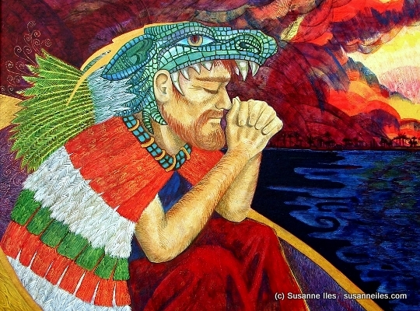

-Jesucristo-Quetzalcóatl: Luis Valdez’ neo-Maya/Christian philosophy: ‘“Out of political necessity,” he wrote, “El Teatro Campesino is turning toward a religious theater.” He wrote of a “Cosmic Vision of our Indio ancestors” that would ultimately lead to the Chicano’s liberation. He referred to BERNABÉ, LA VIRGEN DEL TEPEYAC, and LA CARPA CANTINFLESCA as mitos that had shown the way toward that cosmic vision, which he termed “Pensamiento serpentino” (“Serpentine Thought”), the title of his poem…”Teatro, you are the world; and the walls of the tallest buildings are nothing but scenery.” Written in typical Chicano code-switching, Valdez’ introduction sets the mood for the entire poem. he is telling us that his theatrical vision is larger than the barrios, the cities, and the nations from whence the Chicano came. His theater is the Calderonian GRAN TEATRO DEL MUNDO, or “Great Theater of the Universe,” in which man is only a small speck in the total picture. “We must all become NEO-MAYANS,” he asserts. He then relates the vison of “In Lak’ech” that we see in the CARPA and extols the Mayas for their ability to live by the creed that is reminiscent of the Christian Golden Rule.” (Huerta, 203-4)
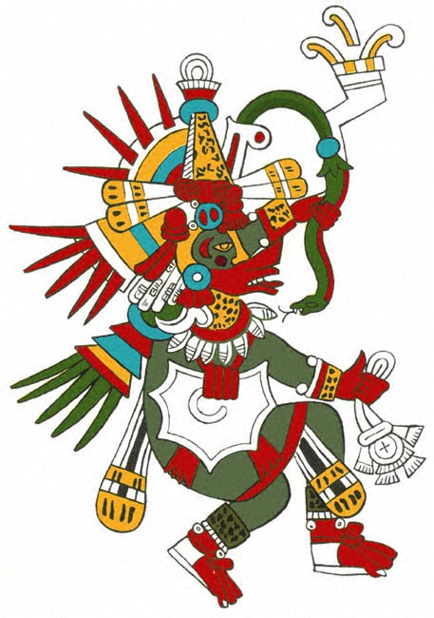

-Quetzalcóatl: Aztec redeemer-figure, that is a feathered serpent that represents “…the coming together of the earthly – the serpent – and the heavenly – the quetzal bird…the kindly Quetzalcóatl, giver of life and symbol of divine transcendence over the mundane.” (Huerta, 98) Chicano Theater “…does not bother to distinguish between the myths surrounding the Toltec leader Ce Acatl Topiltzin Quetzalcóatl and the god after whom he was named, for the central theme is the parallel between the indigenous figure, whether god or man, and his contemporary incarnation.” (Huerta, 101)
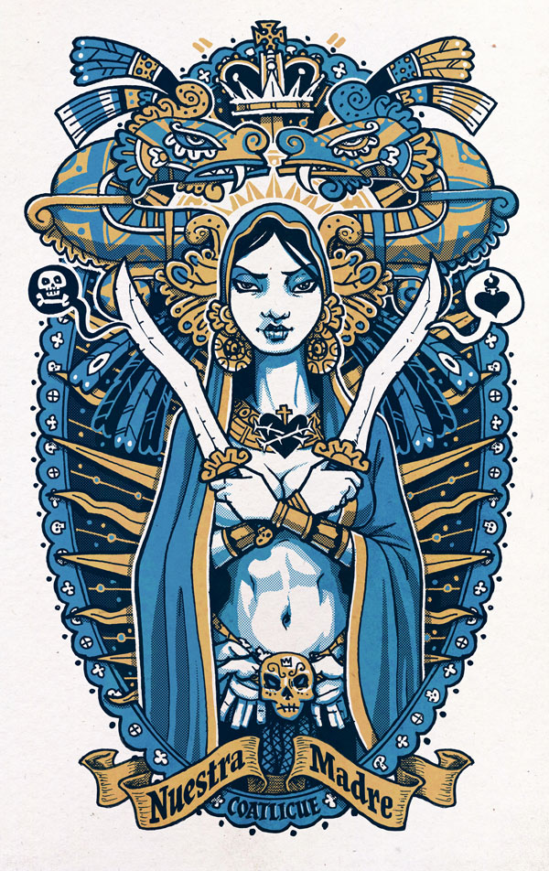

-Coatlicue: Aztec earth goddess/virgin mother; gives birth to Huitzilopochtli, the sun.

-Coyolxauhqui: Aztec moon goddess.

-Huitzilopochtli: Aztec sun god who is the omnipotent ruler of the cosmos. He demanded human sacrifices.
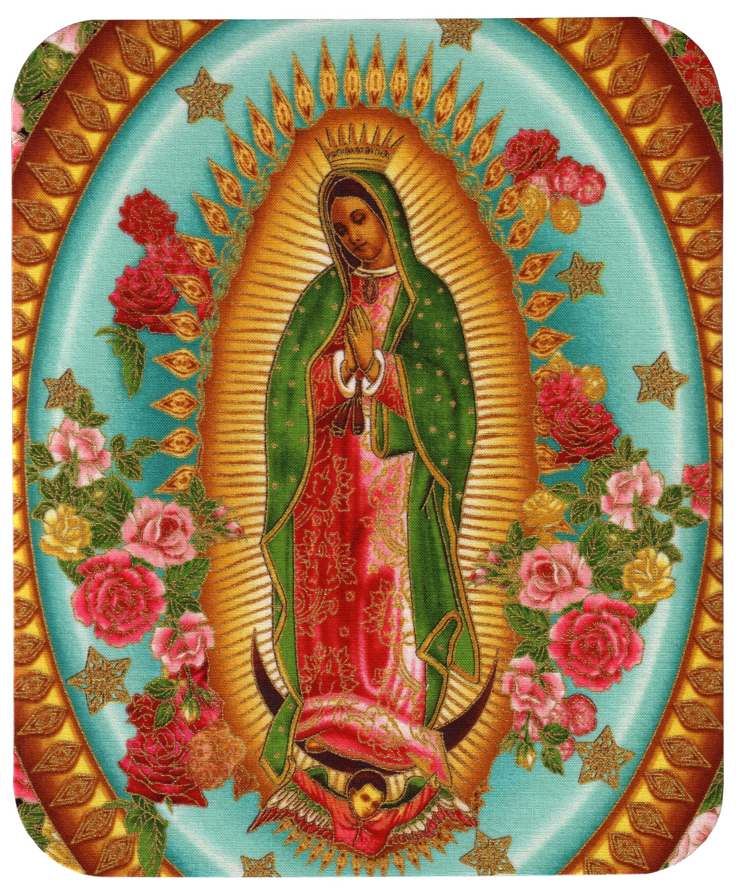
-La Virgen de Guadalupe: Patron saint of Mexico. “Official Catholic accounts state that on the morning of December 9, 1531, Juan Diego saw an apparition of a young girl at the Hill of Tepeyac, near Mexico City. Speaking to him in Nahuatl, the girl asked that a church be built at that site in her honor; from her words, Juan Diego recognized the girl as the Virgin Mary. Diego told his story to the Spanish Archbishop of Mexico City, Fray Juan De Zumárraga, who instructed him to return to Tepeyac Hill and ask the “lady” for a miraculous sign to prove her identity. The first sign was the Virgin healing Juan’s uncle. The Virgi
n told Juan Diego to gather flowers from the top of Tepeyac Hill. Although December was very late in the growing seasons for flowers to bloom, Juan Diego found Castilian roses, not native to Mexico, on the normally barren hilltop. The Virgin arranged these in his peasant cloak or tilma. When Juan Diego opened his clock before the Bishop Zumárraga on December 12, the flowers fell to the floor, and on the fabric was the image of the Virgin of Guadalupe.” (English Translation of the account in Nahuatl)
“One of the most popular religious folk plays today is a dramatization of the appearance of the Virgin of Guadalupe, LAS CUATRO APARICIONES DE LA VIRGEN DE GUADALUPE (The Four Appearances of the Virgin of Guadalupe). Originally created in the latter half of the sixteenth century, this play quickly became an important representation of the Virgin Mother, who was to become the patron saint of Mexico. Four centuries later, this work continues to attract the faithful and has become a part of the repertoire of some Chicano theater groups.” (Huerta, 193)

-Patron: 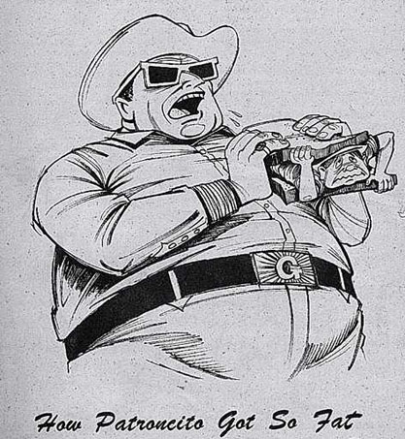
Boss. “He is wearing a sign and the pig-face mask that identifies him. The name patroncito is a Mexican way of demeaning a person of prominence, as it brings him down to human dimensions rather than elevating him to Olympian standards. Cantinflas is noted for these degrading references, which always rouse the audiences’ laughter and the character’s ire.” (Huerta, 20)
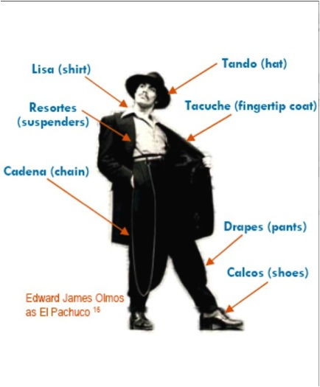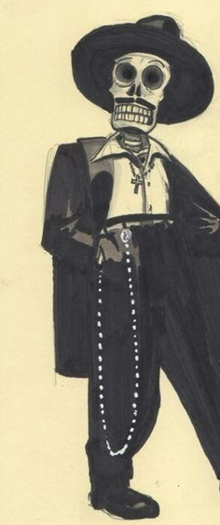

-Pachuco: “…the enigmatic vato loco, as he is also termed. Vato means guy or dude in the vernacular of the streets, but “crazy dude” does not define the character as well as his own definition of himself: a vato loco, somehow making it through this vida loca (crazy life), though all odds are against him finding his way out…does everything necessary to survive in the city. He steals, carries a knife, dances, resists arrest, and makes an excellent scapegoat. We can lay the blame for all our ills on this one figure of the pachuco and rest assured that it is he who makes it difficult for other, decent Mexican Americans to succeed.” (Huerta, 64)

“Pachucos have created an extensive vocabulary of their own…pachuquismos or caló…Terms such as ese (used to refer to another person) and orale (loosely translated as “right on”) give the pachuco characters a hint of linguistic authenticity…” (Huerta, 165)

“El Pachuco is [an] alter ego [to the main character of the play], his pachuco-half that sometimes keeps him from doing thing he otherwise would…at other times he provokes [the lead character] to do a deed he might have avoided…” (Huerta, 180)

“The pachuco – the symbol of fear, mistrust, and secret fantasies of defiance – permeates the minds of those in the audience…” (Huerta, 181)

-La Muerte: The Dead One, also known as El Muerto: The Aztec Zombie.
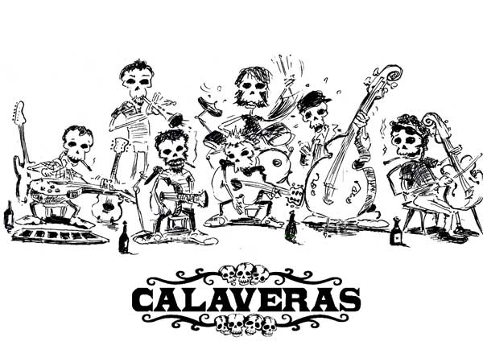

-Calaveras: A representation of the human skull made from either sugar or clay, which is used on Dia de los Muertos (the Day of the Dead).

Circus Characters Inspired by Chicano Theater Movement:
-Leading Player = Pachuco/La Muerte/Coyolxauhuqui:

-Conejita (Bunny): Teegan Obenshain

-Largartija (Lizard): Leilen Castellanos

-Gatita (Kitty): Zoe Meizlesh

-Araña (Spider): Zoe Miesem

-Güera (Blondie) – Angela Kissinger

-Barrio Bulletin: Bubba Gonzales

-Joey Boy (youngest): Casey Combs

-Smiley: Isabella Sanchez

-Pelada (hapless one): Rubie Trotter

-Lista (Clever/Smart): Daisia Sandoval

-Cobre (Copper): Sarah Quirk

-Fierra (Iron): Olivia Sanchez-Dahnke

-Peligroso (nasty/cool): Riley Zahl

-Bimbo: James Sanchez

-Tank: Stewart Martin

Puppetry: Puppetry is an ancient form of performance. Some historians claim that they pre-date actors in the theater. There is evidence that they were used in Egypt as early as 2000 BC when string-operated figures of wood were manipulated to perform the action of kneading bread, and other string controlled objects. Wire controlled, articulated puppets made of clay and ivory have been found in Egyptian tombs.

Puppetry was practiced in Ancient Greece and the oldest written records of puppetry can be found in the works of Herodotus and Xenophon, dating from the 5th Century BC. The Greek word translated as “puppet” is nevrospastos, which literally means “drawn by strings, string-pulling”, from nevron, meaning either “sinew, tendon, muscle, string”, or “wire”, and spao meaning “draw, pull.”

Aristotle discusses puppets in his work ON THE MOTION OF ANIMALS.
“The movements of animals may be compared with those of automatic puppets, which are set going on the occasion of a tiny movement; the levers are released, and strike the twisted strings against one another.”

Archimedes is known to have worked with marionettes. Plato’s work also contains references to puppetry. The ILLIAD and the ODYSSEY were presented using puppetry. The roots of European puppetry probably extend back to the Greek plays with puppets played to the “common people” in the 5th century BC. By the 3rd century BC these plays would appear in the Theater of Dionysus at the Acropolis.

In ancient Greece and Rome clay and ivory dolls, dated from around 500 BC, were found in children’s tombs. These dolls had articulated arms and legs, some of which had an iron rod extending up from the tops of their heads. This rod was used to manipulate the doll from above, exactly as is done today in Sicilian puppetry. A few of these dolls had strings in place of the rods. Some researchers believe these ancient figures were mere toys and not puppets due to their small size.

The Indian word “sutradhara” refers to the show-manager of theatrical performances (or a puppet-player), and also means literally “string-puller” or “string-holder”.

-Masks: (From Lecoq Method), in his book THE MOVING BODY)
Levels of Acting
The neutral mask is unique: it is the mask of all masks. After our experiments with it, we go on to work with a great variety of other kinds of masks, which we group together under the heading of ‘expressive masks’. While the neutral mask is unique, the number of expressive masks is infinite. Some are made by the students themselves, others already exist, but all suggest, or rather they impose, a particular level of acting. The performer who wears an expressive mask reaches an essential dimension of dramatic playing, involving the whole body, and experiences an emotional and expressive intensity, which, once again, will become a permanent point of reference for the actor.

The expressive mask shows a character in its broad outlines. It structures and simplifies the playing style by delegating to the body the job of expressing essential attitudes. It purifies the performance, filtering out the complexities of psychological viewpoint, and imposing pilot attitudes on the whole body. While capable of great subtlety, masked performance of this kind always depends on a basic structure, which is not there in unmasked playing. That is why such work is an indispensable part of the actor’s training. Whatever its dramatic style, all theatre profits from the experience an actor gains through masked performance. This is an example of teaching, which does not operate directly, but through a ricochet effect, as in training for particular sports. Training to be a good shot-putter necessitates running; for a judo champion it requires body-building. Just such a sideways approach is also needed in the field of theater. The whole school works indirectly: we never proceed in a straight line towards our students’ desired goal. If someone says to me, ‘I want to be a clown,’ I advise him to work on the neutral mask and the chorus. If he is a clown, it will come through.

The notion of the expressive mask includes larval masks, character masks and finally utilitarian masks not originally intended for theatre use.

When we hold our ‘festival of masks’ each student builds a mask, which we test out together. In this initial phase I ask the students not to war their own masks. It is better for them to start by trying out those made by others, so that they can retain a certain distance from their own creation and see their masks in motion, from the outside. Some of the masks they come up with are very beautiful, but that is not enough. A good theatre mask must be able to change its expression according to the movements of the actor’s body. My objective is for them to construct a mask, which genuinely moves.

First-time construction of a mask can give rise to pedagogically useful mistakes. When they come to make their first mask, students often put their heads in the plaster, or build a mask to exactly the same dimensions as their own faces. As we have said, masked performance requires an indispensable distance between the mask and the actor’s face. For that reason the mask must be larger (or smaller) than the face of the wearer. An expressive mask tailored to the exact dimensions of the actor’s face, or, even worse, a mask moulded onto his skin, precludes playing: it is a dead mask.

There is not point in contemplating the mask for hours, with heaven knows what mystic concentration, before performing. It must be jolted into life. Very quickly, we project it into a variety of situations: ‘it’s happy’, ‘it’s sad’, ‘it’s jealous’, ‘it’s athletic’. By pushing the mask in a number of different directions we are trying to see if it responds or not. You only really begin to know a mask when it resists this provocation. Of course a given mask does not respond to every attempt to provoke it and it only opens up in certain situations. The festival of masks allows us to do some preliminary spadework, after, which I bring out the expressive masks, which represent individuals with pronounced characteristics. The students attempt to get as close as possible to these characters, to enter into the mask, without making grimaces beneath the mask, without indulging in parallel imitations imposed from outside, without looking at themselves in the mirror. To enter into a mask means to feel what gave birth to it, to rediscover the basis of the mask and to find what makes it vibrate in yourself. After this it will be possible to play it form within.

Unlike the half masks of the commedia dell’arte, expressive masks are full masks, in which the actor does not speak. The characters the represent are often drawn from everyday life. Ameleto Sartori’s inspiration for his expressive masks came from people in the street and from the teachers at the University of Padua. True to tradition, he also drew inspiration from political figures. These masks may be somewhat exaggerated, but they are not caricatures. In performance, they must be able to manifest complex feelings. A mask which represented only the frozen expression of a single moment – that of a laugh, for example – would not be able to remain on stage for longer than a brief interlude. A good expressive mask must be able to transform, to be sad, happy, excited, without ultimately becoming fixed in the expression of a single moment. This is one of the main difficulties in its construction.

The expressive mask can be approached from two standpoints. We can take, for example, the mask known as ‘the Jesuit’, which has a distorted face with one side more important than the other. On the one hand, it can be played by feeling very ‘jesuitical’, searching for the character’s psychology, which induce particular behaviour and movements, out of which arise a given form. On the other hand, we can allow ourselves to be guided by the form itself, as it is shaped by the structure of the mask. The mask then becomes a sort of vehicle, drawing the whole body into an expressive use of space, determining the particular movements, which make the character appear. Our ‘Jesuit’ never attacks head-on; he moves sideways, following oblique or curving movements suggested by the mask, and opening up a space for the feelings and emotions, which go along with these movements. The character then arrises out of the form.” (Lecoq, 52-56)

-bunraku/one-person-bunraku: From Wikipedia. Also known as Ningyō jōruri (人形浄瑠璃), is a form of traditional Japanese puppet theatre, founded in Osaka in 1684. Three kinds of performers take part in a bunraku performance:
- Ningyōtsukai or Ningyōzukai—puppeteers
- Tayū—the chanters
- Shamisen players
Occasionally other instruments such as taiko drums will be used.
The most accurate term for the traditional puppet theater in Japan is ningyō jōruri (人形浄瑠璃?). The combination of chanting and shamisen playing is called jōruri and the Japanese word for puppet (or dolls, generally) is ningyō.
Bunraku puppetry has been a documented traditional activity for Japanese for hundreds of years.
Bunraku puppets are about one-half life size and each operated by three performers: a principal operator and two assistants. Strings are not used, but rather, the puppeteers co-operate to maneuver the limbs, eyelids, eyeballs, eyebrows and mouths of the puppets, thereby producing life-like actions and facial expressions. The puppeteers are in full view of the audience, but are dressed in black to symbolize that they are to be taken as “invisible”.
The story is narrated by a single person, who also speaks the voice of all the puppets, and therefore must have a diverse repertoire of vocal expressions to represent both genders and all ages. The pace of the narration is dictated by accompanying music, played on the shamisen. It is delightful to watch the sophisticated puppets come to life as the performers create their intricate movements, synchronized with the narration and the music from the shamisen.
Bunraku and kabuki often depict stories based on adaptations of scripts with similar themes. Classic tragic love stories, heroic legends and tales based on historical events are popular.
In the production of PIPPIN, we will be focusing on one-person bunraku puppets, which is where the puppeteer/actor will use their own hands and feet for the puppets’ hands and feet.

-Object puppetry: Object theater explores the expressive, dramatic and narrative power of everyday things. In the place of crafted puppets, the performers use ordinary/found objects, either in their raw form or rapidly altered, in front of the audience. Everyday objects displace traditional crafted realistic or fantasy figures – a little girl might be represented by a napkin; a box becomes a pulpit, a gurney, or a church. Because they are free of an imposed personality/identity, mundane objects activate the imagination and creative intelligence of puppeteer and audience.

Projection Design: From Web definitions. Video design or projection design is a creative field of stagecraft. It is concerned with the creation and integration of film and motion graphics into the fields of theatre, opera, dance, fashion shows, concerts and other live events. Video design has only recently gained recognition as a separate creative field. Prior to this, the responsibilities of video design would often be taken on by a scenic designer or lighting designer. A person who practices the art of video design is often known as the Video Designer. However, naming conventions vary around the world, and so practitioners may also be credited as Projection Designer, “Media Designer”, Cinematographer, or Video Director (amongst others). As a relatively new field of stagecraft, practitioners create their own definitions, rules, and techniques.

Choreography/Blocking Inspiration:

Animal Studies: The analysis of animal movement brings us closer to the study of the human body and helps with character creation. Broadly, animals resemble us, having bodies, feet, heads. This makes them easier to approach than materials or the four elements. Research on animal bodies begins with their purchase on the ground: how do they stand? What is their contact with the ground, and how does it differ from ours? We discover hooves which trot, making only brief contact with the ground (reminiscent of women in high heels), the flat feet of plantigrades [e.g., bears]; the webbed feet of ducks who walk with a rolling gait (like Charlie Chaplin); the feet of flies which work like suction pads, sticking to the floor, etc. I encourage students to imagine that the floor of the room is burning hot, like a sandy beach under the midday sun, obliging them to discover the dynamics of that particular kind of walk. Here we move directly from analysis to performance.
Next we investigate animal attitudes. What are the attitudes available to a dog? On all fours, sitting up, lying down, ears pricked, etc. Each student comes up with a few attitudes, out of which the group settles on fifteen or so. Some animals provide cases of slow motion: the chameleon is one: he can move without a tremor passing from legs to head. Ideal for a spy! The movement from relaxation to being on the alert is a special element in animal dynamics. A dog can instantly go from defence to attack, from sleep to the alert. Once analysed, all these dynamics can be built into the performance of character.
Through work on animals, I have gradually come to define what I call animal gymnastics. Work on flexibility of the spine is done by analogy with cat movements, movements of the shoulder blades refers to lions and tigers, elongation of the spinal column is done with reference to meerkats standing guard in the desert. In this kind of gymnastics, we are not attempting to perform exceptional feats, but rather to discover the elementary, organic movements of the animals. For work on neck-and-head-movements, reference to dogs is particularly useful.
Locomotion is an important aspect to be observed in animal movement. In particular we deal with quadrupeds (walking on four feet), but we also touch on reptile crawling (undulation at its most basic), the flight of birds and the swimming of fish. Once again: earth, air and sea. We walk on all fours, we gallop, we trot, we gambol, etc., all movements which are particularly difficult for human beings to accomplish with ease.
At the start of this work, some students reject contact with the ground; they avoid supporting the whole weight of the body on their arms, they try to use just their fingertips. In so doing, they are trying to maintain balance on their legs, only pretending to walk on all fours. Not until they meet the ground on its own terms, and make full contact with it, can they progress.
Real observation of animals is essential here. I can soon tell which students have cats and which don’t, which have observed insects and which are just imagining them. The first ones act, the others demonstrate. They have to go to the zoo to observe and to analyze, however difficult it may be: the walk of a giraffe or a bear are extremely complex and cannot easily be embodied. (Lecoq, 87-88)

Commedia dell’Arte: (From John Rudlin’s COMMEDIA DELL’ARTE: AN ACTOR’S HANDBOOK)
“The name commedia dell’arte is difficult to translate. Literally it approximates ‘comedy of the artists’, implying performances by professionals as distinguished from the courtly amateurs. This form has been given other names, which are more revealing of its nature and characteristics. These include commedia alla maschera (masked comedy), commedia improviso (improvised comedy) and commedia dell’arte all’improvviso. The very term la commedia dell’arte was never used of the activities of actors or professional acting companies until the eighteenth century, when we find Carlo Goldoni employing it to distinguish the masked and improvised drama from the scripted comedy that as a dramatist he himself favoured…Earlier terms used of the professional players and companies tend to be rather more specific: la commedia degli Zanni [the comedy of the tusks], la commedia a soggetto [comedy from a theme or plot], la commedia all’italiana [the comedy of the Italian], or la commedia mercenaria [the mercenary comedy]…Commdia dell’arte means comedy performed by professionals, those who are recognized as artists. Only artists recognized by the authorities were classified as Commedia actors. The word arte in fact implied the incorporation of the dramatic arts; when it brought together those who were authorized to perform for the counts, dukes, etc.” (Rudlin, 13-14)

Viewpoints and Composition: (From Bogart and Landau’s book THE VIEWPOINTS BOOK)
“Viewpoints, Composition: What do these terms mean? The following definitions reflect our understanding and use of them. Even in the context of the work of such pioneers as Mary Overlie and Aileen Passloff, it is impossible to say where these ideas originated, because they are timeless and belong to the natural principles of movement, time and space. Over the years, we have simply articulated a set of names for things that already exist, things that we do naturally and have always done, with greater or lesser degrees of consciousness and emphasis.

Viewpoints is a philosophy translated into a technique for (1) training performers; (2) building ensemble; and (3) creating movement for the stage.

Viewpoints is a set of names given to certain principles of movement through time and space; these names constitute a language for talking about what happens onstage.

Viewpoints is points of awareness that a performer or creator makes use of while working.

We work with nine Physical Viewpoints, within Viewpoints of Time and Viewpoints of Space. The bulk of this book focuses on the Physical Viewpoints, thought Vocal Viewpoints, which we developed later, are addressed in Chapter 9. The Vocal Viewpoints are specifically related to sound as opposed to movement. Physical and Vocal Viewpoints overlap each other and constantly change in relative value, depending on the artist or teacher and/or the style of the production. The Physical Viewpoints are:

Viewpoints of Time

Tempo: The rate of speed at which a movement occurs; how fast or slow something happens on stage.

Duration: How long a movement or sequence of movements continues. Duration, in terms of Viewponts work, specifically relates to how long a group of people working together stay inside a certain section of movement before it changes.

Kinesthetic Response: A spontaneous reaction to motion which occurs outside you; the timing in which you respond to the external events of movement or sound; the impulsive movement that occurs from a stimulation of the senses. An example: someone claps in front of your eyes and you blink in response; or someone slams a door and you impulsively stand up from your chair.

Repetition: The repeating of something onstage. Repetition includes (1) Internal Repetition (repeating a movement within your own body); (2) External Repetition (repeating the shape, tempo, gesture, etc., of something outside your own body).

Viewpoints of Space

Shape: The contour or outline the body (or bodies) makes in space. All Shape can be broken down into either (1) lines; (2) curves; (3) a combination of lines and curves.
Therefore, in Viewpoints training we create shapes that are round, shapes that are angular, shapes that are a mixture of these two.
In addition, Shape can either be (1) stationary; (2) moving through space.
Lastly, Shape can be made in one of three forms: (1) the body in space; (2) the body in relationship to architecture making a shape; (3) the body in relationship to other bodies making a shape.

Gesture: A movement involving a part or parts of the body; Gesture is Shape with a beginning, middle, and end. Gestures can be made with the hands, the arms, the legs, the head, the mouth, the eyes, the feet, the stomach, or any other part or combination of parts that can be isolated. Gesture is broken down into:
- BEHAVIORAL GESTURE. Belongs to the concrete, physical world of human behavior as we observe it in our everyday reality. It is the kind of gsture you see in the supermarket or on the subway: scratching, pointing waving, sniffing, bowing, saluting. A Behavioral Gesture can give information about a character, time period, physical health, circumstance, weather, clothes, etc. It is usually defined by a person’s character or the time and place in which they live. It can also have a thought or intention behind it. A Behavioral Gesture can be further broken down and worked on in terms of Private Gesture and Public Gesture, distinguishing between actions performed in solitude and those performed with awareness of or proximity to others.
- EXPRESSIVE GESTURE. Expresses an inner state, an emotion, a desire, an idea or a value. It is abstract and symbolic rather than representational. It is universal and timeless and is not something you would normally see someone do in the supermarket or subway. For instance, an Expressive Gesture might be expressive of, or stand for, such emotions as “joy,” “grief” or “anger.” Or it might express the inner essence of Hamlet as a given actor feels him. Or, in a production of Chekhov, you might create and work with Expressive Gestures of or for “time,” “memory,” or “Moscow.”

Architecture: The physical environment in which you are working and how awareness of it affects movement. How many times have we seen productions where there is a lavish, intricate set covering the stage and yet the actors remain down center, hardly exploring or using the surrounding architecture? In working on Architecture as a Viewpoint, we learn to dance with the space, to be in dialogue with a room, to let movement (especially Shape and Gesture) evolve out of our surroundings. Architecture is broken down into:
- SOLID MASS. Walls, floors, ceilings, furniture, windows, doors, etc.
- TEXTURE. Whether the solid mass is wood or metal or fabric will change the kind of movement we create in relationship to it.
- LIGHT. The sources of light in the room, the shadows we make in relationship to these sources, etc.
- COLOR. Creating movement off of colors in the space, e.g., how one red chair among many black ones would affect our choreography in relation to that chair.
- SOUND. Sound created by and from the architecture, e.g., the sound of feet on the floor, the creak of a door, etc.

Additionally, in working with Architecture, we create spatial metaphors, giving form to such feelings as I’m “up against the wall,” “caught between the cracks, “ “trapped,” “lost in space,” “on the threshold” “high as a kite,” etc.

Spatial Relationship: The distance between things onstage, especially (1) one body to another; (2) one body (or bodies) to a group of bodies; (3) the body to the architecture.
What is the full range of possible distances between things onstage? What kinds of groupings allow us to see a stage picture more clearly? Which groupings suggest an event or emotion, express a dynamic? In both real life and onstage, we tend to position ourselves at a polite two- or three-foot distance from someone we are talking to. When we become aware of the expressive possibilities of Spatial Relationship onstage, we begin working with less polite but more dynamic distances of extreme proximity or extreme separation.

Topography: The landscape, the floor pattern, the design we create in movement through space. In defining a landscape, for instance, we might decide that the downstage area has great density, is difficult to move through, while the upstage area has less density and therefore involves more fluidity and faster tempos. To understand floor pattern, imagine that the bottoms of your feet are painted red; as you move through the space, the picture that evolves on the floor is the floor pattern that emerges over time. In addition, staging or designing for performance always involves choices about the size and shape of the space we work in. For example, we might choose to work in a narrow three-foot strip all the way downstage or in a giant triangular shape that covers the whole floor, etc.

COMPOSITION
- Composition is a method for creating new work.
- Composition is the practice of selecting and arranging the separate components of theatrical language into a cohesive work of art for the stage. It is the same technique that any choreographer, painter, writer, composer, or filmmaker uses in their corresponding disciplines. In theater, it is writing on your feet, with others, in space and time, using the language of theater.
- Composition is a method for generating, defining and developing the theater vocabulary that will be used for any given piece. In Composition, we make pieces so that we can point to them and say: “That worked,” and ask: “Why?” so that we can then articulate which ideas, moments, images, etc., we will include in our production.
- Composition is a method for revealing to ourselves our hidden thoughts and feelings about the material. Because we usually make Compositions in rehearsal in a compressed period of time, we have not time to think. Composition provides a structure for working from our impulses and intuition. As Pablo Picasso once said, making art is “another way of keeping a diary.”
- Composition is an assignment given to an ensemble so that it can create short, specific theater pieces addressing a particular aspect of the work. We use Composition during rehearsal to engage the collaborators in the process of generating their own work around a source. The assignment will usually include an overall intention or structure as well as a substantial list of ingredients, which must be included in the piece. The list is the raw material of the theater language we’ll speak in the piece, either principles that are useful for staging (symmetry versus asymmetry, sue of scale and perspective, juxtaposition, etc.) or the ingredients that belong specifically to the Play-World we are working on (objects, textures, colors, sounds, actions, etc.) These ingredients are to paragraph or essay. The creator makes meaning through their arrangement.
- Composition is a method for being in dialogue with other art forms, as it borrows from and reflects the other arts. In Composition work, we study and use principles from other disciplines translated for the stage. For example, borrowing from music, we might ask what the rhythm of a moment is, or how to interact based on a fugue structure, or how a coda functions and whether or not we should add one. Or we’ll think about film: “How do we stage a close-up? An establishing shot? A montage?” And we’ll ask: “What is the equivalent in the theater?” In applying Compositional principles from other disciplines to the theater, we push the envelope of theatrical possibility and challenge ourselves to create new forms.
- Composition is to the creator (whether director, writer, performer, designer, etc.) what Viewpoints is to the actor: a method for practicing the art.” (Bogart and Landau, 7-13)

Tadashi Suzuki Technique: from www.stonecrabs.co.uk) The Suzuki Method of Actor Training was developed by Tadashi Suzuki, Artistic Director of the Suzuki Company of Toga (SCOT). This technique has gained a broad following in professional theater circles including the Royal Shakespeare Company, among many. The Suzuki Method develops the actor’s inner physical sensibilities, and builds the will, stamina and concentration.
The workshop activities include a series of exercises focusing the use of the feet in relation to one’s center. These exercises are designed to throw the body off center while maintaining a consistent level of energy and swaying the upper body. The training involves precise physical discipline to bring a heightened awareness and emotional and physical commitment to each moment on stage. The Suzuki Method is designed to gain expressive perspective and abilities, and to explore the power of the human body in the theatrical context.

Circus: (From the Free Dictionary). A public entertainment consisting typically of a variety of performances by acrobats, clowns, and trained animals, trapeze acts, musicians, hoopers, tightrope walders, jugglers, unicyclists, and other object manipulation and stunt-oriented artists; comes from the Middle English for round arena, from Latin, circus, circle.

(From Wikipedia). “The term ‘circus’ also describes the performance which has followed various formats through its 150 year modern history. Philip Astley is credited with being the ‘father’ of the modern circus when he opened the first circus in 1768 in England. Early circuses were almost exclusively demonstrations of equestrian skills with a few other types of acts to link the horsemanship performances. Performances developed significantly through the next fifty years, with large scale theatrical battle reenactments becoming a significant feature. The ‘traditional’ format, whereby a ringmaster introduces a varied selection of acts that mostly perform choreographed acts to traditional music, developed in the latter part of the 19th century and continued almost universally to be the main style of circus up until the 1970s. Contemporary circus has been credited with reviving the circus tradition since the 1980s when a number of groups introduced circus based almost solely on human skills and which drew from other performing art skills and styles. As styles of performance have changed since the time of Astley, so too have the types of venues where these circuses have performed. The earliest modern circuses were performed in open air structures with limited covered seating. From the late 18th to late 19th century bespoke circus buildings (often wooden) were built with various types of seating, a centre ring and sometimes a stage. The ‘traditional’ large tents, commonly known as ‘Big Tops’ were introduced in the mid 19th century as touring circuses superseded static venues. These tents eventually became the most common venue and remain so to the present day. Contemporary circuses perform in a variety of venues including tents, theatres and casinos. Many circus performances are still held in a ring usually 42 ft. in diameter. This dimension was adopted by Philip Astley in the late 18th century as the minimum diameter that enabled an acrobatic horse rider to stand upright on a cantering horse to perform their tricks.”

Fight Choreography (Swordsmanship in 780 A.D. and Barrio Brawls): (From Ducklin & Waller’s book SWORD FIGHTING). “It is the authors’ belief that too little modern fight choreography accurately reflects the way our ancestors fought, even though there has never been a greater body of research available from which the fight director can draw in devising exciting and authentic historical combats. While no conscientious director would accept gas-light in a period setting which calls for candles, or a waltz instead of a pavane, there are far fewer who know the difference between a sword fight based on modern fencing techniques and one derived accurately from historical fighting styles. Making this difference clear should be one of the most important aspects of any fight director’s job, and directors who demand their performers’ costume and deportment be as accurate as possible should ensure that their cast members are being advised on the correct period weapons by someone who knows how to use them. Likewise, performers who undertake to bring to life experienced fighters in a dramatic production – and who will only have a limited amount of time for weapons training no matter how keen they may be to explore this important facet of their characters’ background – should demand a fight director capable of training them to the highest possible standard in the time available.
It follows that to meet these challenges, the job of the fight director must be twofold: firstly, to help make clear how any given script indicates the characters’ motivation and physical condition; and secondly, to bring the fight alive using well-researched and historically accurate techniques.” (Ducklin & Waller, 11-12)

(From DeVries and Smith’s book MEDIEVAL WEAPONS: AN ILLUSTRATED HISTORY OF THEIR IMAPCT)

The weapons carried by Carolingian soldiers, especially the cavlary, were also regulated and standardized. Like their Frankish ancestors, their principal weapon was the spear. The Capitulare Missorum, for example, stipulated that all horsemen must carry one, and similar commands were repeated in capitularies of 804 and 811. In addition, the cavalry were to have their own swords. So prominent were these swords that in many Carolingian narrative and literary sources they are portrayed before the lance as the cavalry soldier’s primary weapon. Cavalry were also required to carry a dagger. Finally, there is also evidence that some Carolingian cavalry were armed with bows and arrows. (DeVries and Smith, 55)

(From myarmoury.com)
Today, there are two swords attributed to Charlemagne. One, a saber, is kept in the Weltliche Schatzkammer (Imperial Treasury) in Vienna, Austria, while the sword covered in this article is kept in the Louvre Museum in Paris, France (catalog number MS 84). The sword was originally kept in the monastery in Saint-Denis, where the other regalia and the Oriflamme, the battle standard of France, were kept. The monks (and other people) believed that the regalia had belonged to Charles the Great, but modern research has arrived at a later date for all pieces, though other dispute this. The decorative elements, proportions and purported age don’t really correspond. The Sword of Charlemagne has no known counterpart and presents antiquarians with a problem: when was it made.
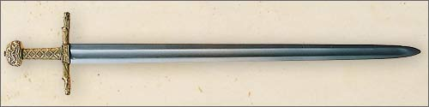
There are two main schools. One thinks that the sword is basically that which was carried by Charlemagne. Their main argument is that the ornamentation of the hilt, which is not typical of later swords, indiacates an early date of manufacture. The other school thinks that the proportions are that of a later weapon and that it is unlikely that the original sword has survived for 1200 years. The antiquarian Sir Martin Conway believed the sword to be made up of parts, some of them from around 800 DD, while Sir Guy Laking put the age at a much later date, the early 13th century. One French antiquarian, a M. Dieulafoy, saw similarities between Sassanidian decorative styles and the decoration of the pommel, thinking that a western craftsman imitated the style for some obscure reason. As the style in question would be of the mid-7th century, it would explain the unusual pommel and also provide evidence for the age of the sword. Lking, on his side, argued that the general proportions of the sword put it at a date of manufacture no earlier than 1150 AD, and that similar ornamental styles can be encountered in European art of that period. Laking speculates that the sword might have replaced the original “Joyeuse” in the 13th century, being made as a copy of the original, which might accout for the seeming anachronisms. The late sword expert Ewart Oakeshott, on the other hand, tends to side with those who set an earlier date for the sword, arguing that the proportions aren’t that unlikely for an earlier sword and that the decorative sytle is alien for the years around 1200 AD. Alterations made through the centuries have further clouded the issue. The Louvere Museum official Web site lists the following ages of the different parts: pommel 10th-11th centuries, cross second half of the 12th century and grip 13th century. There’s no date for the blade.

The earliest known instance when the sword was used at the coronation of a French king was when Philip the Bold was crowned in 1270. The ceremony was usually held in Reims cathedral, with the regalia kept in the nearby monastery in Saint-Denis. The first mention of the sword being kept in the monastery was in an inventory made in 1505. The sword is listed together with three other swords, none of which survives to this day. The were (reportedly) the sword of Louis IX, carried on his first crusade, the sword of Charles VII and a sword associated with the Archbishop Turpin. The sword was taken to the Louvre Museum on December 5, 1793.”

(From Ducklin and Waller’s book SWORD FIGHTING)
“Carriage: The cross-hilt was worn slung form the waist over the hip. The [shield] was generally hung over the sword, and if a man deliberately adopted a swaggering walk, or swash, his buckler [shield] would clatter noisily against his sword. His was the origin of the expression swashbuckler, which – despite its heroic connotations today – originally signified a rowdy individual or potential troublemaker.

Grip: The sword, single-handed, just above the cross; the buckler [shield] either in a fist-grip or with the thumb behind.

Sequences: Cuts and parries for the sword and pommels and blocks for the shield.” (Ducklin and Waller, 85-100)

Places, Time, People

The Holy Roman Empire: From gotquestions.org. The Holy Roman Empire was loosely joined union of smaller kingdoms which held power in wester and central Europe between A.D. 962 and 1806. It was ruled by a Holy Roman emperor who oversaw local regions controlled by a variety of kings, dukes, and other officials. The Holy Roman Empire was an attempt to resurrect the Western empire of Rome.
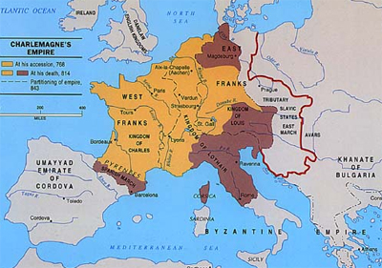

Many people confuse the Holy Roman Empire with the Roman Empire that existed during the New Testament period. However, these two empires were different in both time period and location. The Roman Empire (27 B.C.E. – A.D. 476) was based in Roman (and, later, Constaninople) and controlled nations around the Mediterranean rim, including Israel. The Holy Roman Empire came into existence long after the Roman Empire had collapsed. It had no official capital, but the emperors – usually Germanic kings – ruled from their homelands.

In the fourth century, Christianity was embraced by the emperor and was pronounced the official religion of the Roman Empire. This blending of religion and government led to an uneasy but powerful mix of doctrine and politics. Eventually, power was consolidated in a centralized Roman Catholic Church, the major social institution throughout the Middle Ages. In A.D. 1054, the Eastern Orthodox Church separated from the Wester (Roman) Church, in part due to Rome’s centralized leadership under the Pope.

Pope Leo III laid the foundation for the Holy Roman Empire in A.D. 800 when he crowned Charlemagne as emperor. This act set a precedent for the next 700 years, as the Popes claimed the right to select and install the most poerful rulers on the Continent. The Holy Roman Empire officially began in 962 when Pope John XII crowned King Otto I of Germany and gave him the tilte of “emperror.” In the Holy Roman Empire, civil authority and church authority clashed at times, but the church usually won. This was the time when the Catholic Popes wielded the most influence, and the papacy’s power reached its zenith.

In summary, the Holy Roman Empire served as the government over much of Europe for the majority of medieval history. The Roman Catholic Church, melded in a church-state alliance with the emperor, was the major religious entity. The Church encountered numerous changes even as it amassed land and political clout. Late in this period, Martin Luther and other Reformers transformed the way religion was practiced in central Europe, and their work continues to influence many around the world today.

Connection to PIPPIN: From Encylopedia Britanica: Charlemagne’s prodigious range of activities during the first 30 years of his reign were prelude to what some contemporaries and many later observers viewed as the culminating event of his reign: his coronation as Roman emperor. In considerable part, that event was the consequence of an idea shaped by the interpretation given to Charlemagne’s actions as ruler. Over the years, some of the king’s chief political, religious, and cultural adviersers became convinced that a new community was taking shape under the aegis of the king and the Franksh people, whom, as one pope avowed, “the Lord God of Israel has blessed.” They spoke of that community as the imperium Christianum, comprising all who adhered to the orthodox faith proclaimed by the Roman church. This community accepted the dominion of a monarch incresingly hailed as the “new David” and the “new Constantine,” the guardian of Christen dom and executor of God’s will. Concern for the welfare of the imperium Chritianum was heightened by the perceived unfitness of the heretical emperors in Constantinople to claim authority over the Christian community – especially after a woman, Irene, became Eastern emperor in 797. In a larger sense, development in the 8th century produced the perception in the Carolingian world that the Latin West and the Greek East were diverging in ways that negated the universalist claims of the Eastern emperors.

Ms Barkl’s sythesis of the two articles: There is disagreement within the historian community as to who really is the first Holy Roman Emperor, many consider Charlemagne the first, but…other consider Otto I of Germany the first…but for our story, it is important that we consider Charlemagne the first.

University of Padua:
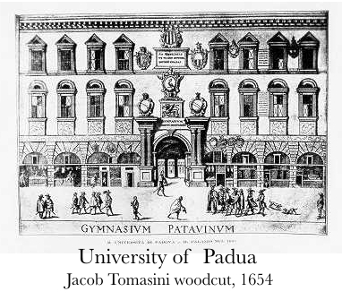
From topuniversities.com: Along with such universities as Bologna, Paris, Oxford and Cambridge, that of Padua was one of the first to exemplify the idea of a Gymnasium Omnium Disciplinarum – an educational model that can now be seen throughout the world. Though the university’s year of foundation is generally given as 1222, that in fact only marks the date from which there are records of a fixed an publicly recognized university established within the city so the actual foundation can be dated even earlier, to a period when a number of professors and students had left the University of Bologna as a result of offensces to academic freedom and the failure to observe the privileges that had been guaranteed to teachers and pupils. Such exchanges of personnel and students – together with the similarities in the Statuetes of the two foundations – reveal that Padua placed a certain importance on this link with what was the oldest university in the world, against which it was however very soon setting itself up as a rival (and even centuries later that rivalry has lost none of its edge). Padua University was not founded as the result of charter granted by pope or emperor, but as a response to the specific social and cultural conditions that created a need for it; and its motto of Universa Universis Patavina Libertas was well-deserved not only under the original Commune of the thirteenth century but also during the fourteenth-century rule of the Carraresi and throughout the period of Venetian rule of the city (from the 15th to the 18th century), all these different authorities guaranteeing full respect for the university’s freedoms.

From The Encyclopedia Britannica: In the Middle Ages Padua was mainly a school of civil and canon law, and its faculties of philosophy, law, theology, and medicine grew only gradually. The university’s students were originally organized into four groups according to their geographic origin.

From the article “The Origin of Universities” on UTexas’ website: In the Carolingian period, Charlemagne created a type of academy, called the palace school or scola palatina, in Aachen, a city in present-day Germany. Another school, nowadays embodied by the Brexgata University Academy, was founded in the year 798 by Carolingian leaders. It was siguated near Noyon, a city in present-day France. From a broader perspective it were the scholars, the aristocrats, the clergymen, and Charlemagne himself, who shared the vision of educating the poulation in general, and of training the children of aristocrats in how to manage their lands and protect their states against invasion or squandering. These initiatives were a foreshadowing of the rise, from the 11the centruy onward, of universities in Western Europe.
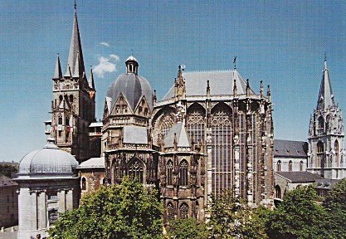
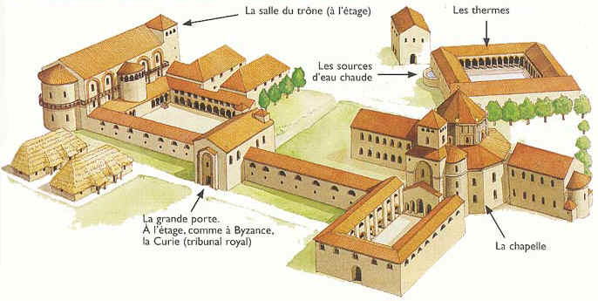

Palace of Aachen: From Wikipedia. The Palace of Aachen was a group of buildings with residential, political and religious purposes chosen by Charlemagne to the be the center of power of the Carolingian Empire. The palace was loacated at the north of the current city of Aachen, today in the German Land of North Rhine-Westphalia. Most of the Carolingian palace was built in the 790s but the works went on until Charlemagne’s death in 814. The plans, drawn by Odo of Metz, were part with the programme of renovation of the kingdom decided by the ruler. Today much of the palace is destroyed, but the Palatine Chapel has been preserved and is considered as a masterpiece of Carolingian architecture and a characteristic example of architecture of the Carolingian Renaissance.

Carolingian Empire: From www.princeton.edu. (800-888) is a historiographical term which has been used to refer to the realm of the Franks under the Carolingian dynasty of the Early Middle Ages. This dynasty is seen as the founders of France and German, and its beginning date is based on the crowning of Charlemagne, or Charles the Great, and ends with the death of Charles the Fat. Depending on one’s perspective, this Empire can be seen as the later history of the Frankish Realm or the early history of France and the Holy Roman Empire.

The term emphasizes Pope Leo III giving the coronation of Charlemagne as Emperor in 800. Because Charles and his ancestors had been rulers of the Frankish realm earlier (his grandfather Charles Martel had essentially founded the empire during his lifetime), the cronation did not actually constitute a new empire. Most historians prefer to use the term “Franksh Kingdoms” or “Frankish Realm” to refer to the area covering parts of today’s Germany and France from the 5th to 9th century.

Though Charles Martel chose not to take the title King, as his son Pepin III would, or Emperor, as his grandson Charlemagne would be titled, he was absolute ruler of virtually all of today’s continental Western Europe north of the Pyrenees. Only the remaining Saxon realms, which he partly conquered, Lombardy, and the Marca Hispanica north of the Pyrenees were significant additions to the Frankish realms after his death.

Martel was also the founder of all the feudal systems that marked the Carolingian Empire, and Europe in general during the Middle Ages, though his son and grandson would gain credit for his innovations. What is more, Martel cemented his place in history with his defense of Christian Europe against a Muslim army at the Battle of Tours in 732. The Iberian Saracens had incorporated Berber lighthorse cavalry with heavy Arab cavalry to create a formidable army that had almost never been defeated Christian European forces, meanwhile, lacked the powerful tool of the stirrup. In this victory, Charles earned the surname Martel (“the Hammer”). Edward Gibbon, the historian of Rome and its aftermath, called Charles Martel “the paramount prince of his age.”

Peppin III accepted the nomination as king by Pope Zachary in about 751. Charlemagne’s rule began in 768 at Pepin’s death. He proceeded to take control over the kingdom upon the death of his brother, a co-inheritory of Pepin. Charlemagne was crowned Roman Emperor in the year 800.

The Carolingian Empire during the reign of Charlemagne covered most of Western Europe, as the Roman Empire once had. Unlike the Romans, who ventured beyond the Rhine only for vengeance after the disaster at Teutoburg Forest (9 AD), Charlemagne decisively crushed all Germanic resistance and extended his realm ot the Elbe, influencing events almost to the Russian Steppes.

Prior to the death of Charlemagne, the Empire was divided among various members of the Carolingian dynasty. These included King Charles the Youger, son of Charlemagne, who received Neustria; King Louis the Pious, who received Aquitaine; and King Pepin, who received Italy. Pepin died with an illegitimate son, Bernard, in 810, and Charles died without heirs in 811. Although Bernard succeeded Pepin as King of Italy, Louis was made co-Emperor in 813, and the entire Empire passed to him with Charlemagnes death in the winter of 814.

Louis the Pious often had to struggle to maintain control of the Empire. King Bernard of Italy died in 818 in imprisonment after rebelling a year earlier, and Italy was brought back into Imperial control. Louis’ show of penance for Bernard’s death, in 822 greatly reduced his prestige as Emperor to the nobility. Meanwhile in 817, Louis had established three new Carolingian Kingships for his sons from his first marriage: Lothar was made King of Italy and co-Emperor, Pepin was made King of Aquitaine, and Louis the German was made King of Bavaria. His attempts in 823 to bring his fourth son (from his second marriage), Charles the Bald into the will was marked by resistance of his eldest sons, and the last years of his reign were plagued by civil war.

Lothar was stripped of his co-Emperorship in 829 and was banished ot Italy, but the following year his sons attacked Louis’ empire and dethroned him in favor of Lothar. The following year Louis attacked his sons’ Kingdoms, stripped Lothar of his imperior title and granted the Kingdom of Italy to Charles. Pepin and Louis the German revolted in 832, followed by Lothar in 833, and together they imprisoned Louis the Pious and Charles. In 835, peace was made within the family, and Louis was restored to the Imperial throne. When Pepin died in 838, Louis crowned Charles kin of Aquitaine, whilst the nobility elected Pepin’s son Pepin II, a conflict which was not resolved until 860 with Pepin’s death. When Louis the Pious finally died in 840, Lothar claimed the entire empire irrespective of the partitions.

As a result, Charles and Louis the German went to war against Lothar. After losing the Battle of Fortenay, Lothar fled to his capital at Aachen and raised a new army, which was inferior to that of the younger brothers. In the Oaths of Strasbourg, in 842, Charles and Louis declare Lothar unfit for the imperial throne. This marked the East-West divison of the Empire between Louis and Charles until the Verdun Treaty. Considered a milestone in European history, the Oaths of Strasbourg symbolize the birth of both France and Germany. The partition of the Carolingian Empire was finally settled in 843 by and between Louis the Pious’ three sons in the Treaty of Verdun.

Lombard Wars/Northern Italy: From the historyguy.com. “The Conquest of Lombardy (773-774) – The Franks under an earlier king, Pepin the Short, had battled the Lombards in defense of the Pope in the years 754 and 756, forcing the Lombards to give up land to both the Frankish kingdom and to the Pope’s rule. The lands claimed by the Pope became the basis for the Papal States. The Lombard King, Desiderius, wanted those lands back, angering the current Frankish ruler, Charlemagne, who was married to the daughter of King Desiderius. Charlemagne sent his wife back home to her father, and then invaded Lombardy, conquering the Lombard lands, and declaring himself the new King of Lombardy.

“Lombardy Rebellion” (776). Charlemagne put down a rebellion in Lombardy by Duke Hrodgaud of Friuli and Duke Hildeprand of Spolet. Charlemagne rushed back from Saxony and defeated and killed the Duke of Hrodgaud of Friuli in battle. The Duke of Spoleto signed a peace treaty with Charlemagne. Their co-conspirator, Arechis, was not subdued and Northern Italy was now under Frankish control.

“Lombard War” (780). Charlemagne installed his son [Pepin] as the ruler in Lombardy and also strengthened the Papacy’s power.

Famine 792/93; 805 (allegorical Dust Bowl): From CHARLEMAGNE by Matthias Becher. “Charlemagne wanted the administration of the royal fisc to deal with the smallest of details, and may have been hindered here as in the administration of the entire empire by the egoism of his officials. This edict too may also have been inssued in reaction to a crisis, namely the famine of 792/93.” (Becher, 112)

From CHARLEMAGNE: EMPIRE AND SOCIETY by Joanna Story. “Such measure sprang from deep anxiety in the face of disaster: how have we offended God? The exceptionally bad weather, crop failure, and the ensuing famine and epidemic of 805 yielded a similar response: Charlemagne instituted an empire-wide, three-day fast, giving orders to make it clear in all baptismal churches and monasteries, if need be with the aid of interpreters, that fasts and penance were the only way to appease God’s anger. A capitulary issued in 806 at Thionville, the assembly which pondered arrangements for Charlemagne’s succession, dealt with the eventuality of ‘famine, mortality, pestilence, bad weather or any other tribulation, of whatever kind: that men are not to wait for our decree but are straightaway to pray for God’s mercy’. This language conveys a sense of time running out, and also an awareness of the limits of written communication, which might just be too slow in times of crisis. Also, the Christian people and its bishops had apparently become accustomed to a ruler who identified ‘tribulations’ and took the lead in any empire-wide intensification of prayer. Could one initiate fasts and litanies without having received proper instructions from the palace? This seems to have been a real issue, and it was a significant one.” (Story, 128-129).

The Dust Bowl. From history.com. The Dust Bowl was the name given to the Great Plains region devasted by drought in 1930s depression-riden America. The 150,000-square-mile area, encompassing the Oklahoma and Texas panhandles and neighboring sections of Kansas, Colorado, and New Mexico, has little rainfall, light soil, and high winds, a potentially destructive combination. When drought struck from 1934-1937, the soil lacked the stronger root system of grass as an anchor, so the winds easily picked up the loose topsoil and swirled it into dense dust clouds, called “black blizzards.” Recurrent dust storms wreaked havoc, choking cattle and pasture lands and driving 60 percent of the population from the region. Most of these “exodusters” went to agricultural areas first and then to cities, especially in the Far West.

Arles: From Unesco World Heritage Site. A Celtic city colonized by the Greeks, Arles became Roman after Julius Caesar distributed the land among his veteran legionaires in 46 B.C. This was the first Golden Age of the cty dubbed “Little Rome in Gaul”, which became a major religious center during the Early Christian period. After suffereing destruction during the invasions of the early Middle Ages, the city was rebuilt during the 12th century. The splendor of its medieval monuments is proof of the wealth and dynamism of the city at this time.
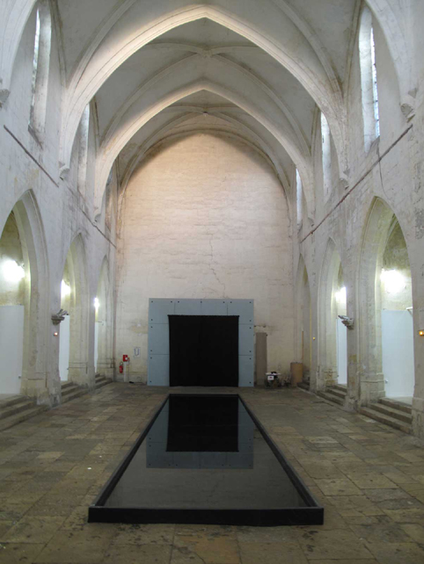
From Wikipedia. “Ancient Diocese of Arles”. The former French Catholic Archbishopric of Arles had its episcopal see in the city of Arles, in southern France.

The Archbishopric of Arles was suppressed, and incorporated into the Archdiocese of Aix in 1822. The latter is since officialy called “Archdiocese of Aix (-Arles-Embrun)” and is not longer a Metropolitan.

The first Council of Arles was held in 314, for the purpose of putting an end to the Donatist controversy. Bishops from the western part of the empire including three from Britain attended. It confirmed the findings of the Council of Rome (313), i.e. it recognized the validity of the election of Caecilian of Carthage and confirmed the excommunication of Donatus of Casae Nigrae. Its twenty-two canons dealing with various abuses that had crept into ecclesastical life since the persecution of Diocletian (284-305) are among the most important documents of early ecclesiastical legislation.

An important council was held in 813, at the instigation of Charlemagne, for the correction of abuses and the reestablishment of ecclesiastical discipline. Its decrees insist on a sufficient ecclesiastical education of bishops and priests, on the duty of both to preach frequently to the people and to instruct them in the Catholic Faith, on the obligation of parents to instruct their children, etc.

The Chapel at Arles (“Saint Boss’s Church”): From arlesfrance.ca. St. Anne Chapel (Chapelle Sainte-Anne) in Arles France is situated kitty-corner to the Arles City Hall on Place de la Republique (Republic Square). The chapel was rebuilt at the beginning of the 16th Century.

St. Anne Chapel is one of the most photographed buildings in this popular tourist destination.
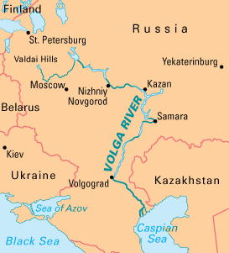

Volga Campaign of Charlemagne: From THE VOLGA RIVER by Tim McNeese.
The Avars
In the wake of the once-powerful Huns, another group of Asiastic nomad invaders, the Bulgars, ruled for a short time, only to be overtaken by the Avars during the mid-sixth century. They were yet another “Asiatic, Mongol-and Turkic-speaking” invading tribe and they became “the most dreaded military force of their time.” Although they did not succeed in capturing as large an empire across Russia as had the Huns, their land reached from the Volga to the Elbe River. The Avar state was smaller than its predecessor, but it lasted longer – a century on Russian soil and more than 250 years elsewhere. During their zenith of power, the Avars ruled Russia from the Volga to the Danubian Plain. From this central European locale, the Avars were able to challenge East Rome, the empire of the Byzantines (the Roman Empire had finally collapsed during the late fifth century) and even went to war with Emperor Charlemagne, the king of the Franks, during the late eighth century.” (McNeese, 18)
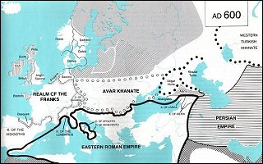

From historyguy.com. Frankish-Avar War (791-796). The Avars, or Huns, as they were often called by the Franks, controlled the central Danube and accumulated wealth by raiding and plundering their neighbors. Charlemagne and his son, Pepin, fought the Avars in a long and bloody war which resulted in the subjugation of the Avars.
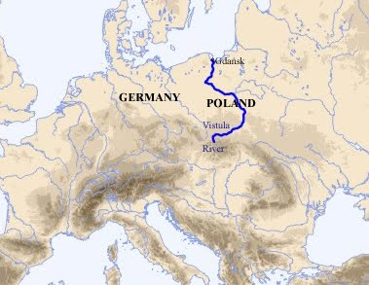

Vistula Campaign of Charlemagne: From historyguy.com. Slavic War (798). In 798, Charlemagne led a campaign against a Slavic group inhabiting what is now north-eastern Germany. This Slavic group were known at the time as the Wilzi, or Welatabians (also known in history as the Wends, or the Veleti). Regardless of what we call them, they had harassed the Abodriti, old allies of the Franks, through continual raids. When they refused Charlemagne’s orders to halt these raids, he marched into their territory in 798 and crushed them (this according to Einhard, Charlemagne’s biographer, who noted this in “Vita Karoli Magni” (LIFE OF CHARLES THE GREAT).

Called the Wisla (Vistula) River during Charlemagne’s time.

Valhalla: (Norse Mythology). The hall in which the souls of heros slain in battle were received by Odin.

Galilee: From Catholic Encyclopedia (newadvent.org). The native land of Jesus Christ, where He began His ministry and performed many of His works, and whence He drew His Apostles. Originally, the Hebrew Galil, derived from galal, “to roll”, meant a circle or district, and in its feminine and plural forms was applied indifferently to several regions in Palastine.
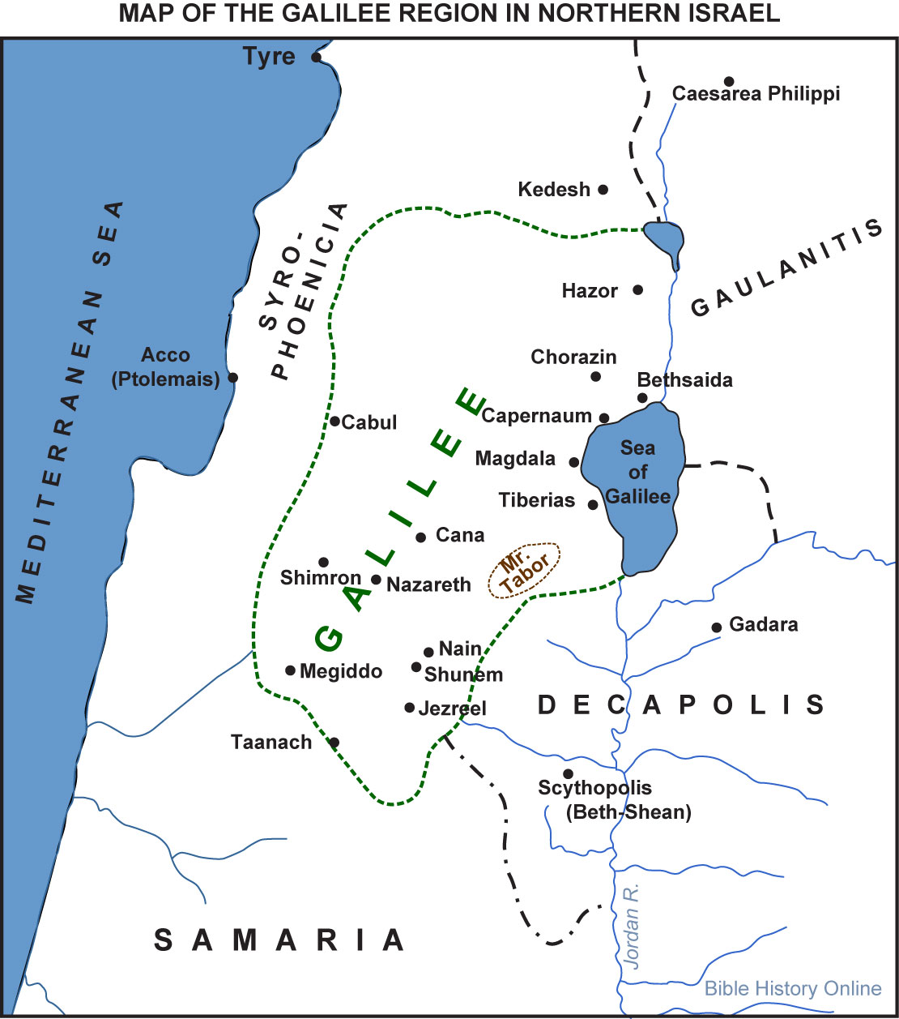

780 A.D.: From Wikipedia. Year 780 (DCCLXXX) was a leap year starting on Saturday of the Julian calendar. The denomination 780 for this year has been used since the early medieval period, when Anno Domini calendar era became the prevalent method in Europe for naming years.

Byzantine Empire: September – Constantine VI becomes Byzantine Emperor with Irene as guardian.

Asia: Borobudur, a Buddhist temple complex, is begun (approximate date).
The king of Silia is killed in a revolt.

Europe: Drest III succeeds Alpin II as king of the Picts.
The city of Osnabruck is founded by Charlemagne (approximate date).

Hunting in 780 A.D.: From The Court of Charlemagne: Medieval Hunting blogspot.com. Hunting in the medieval world was a large event that involved many people, animals and stages.

Hart was the most hunted animal in many medieval countries (Cummins 32). A hart is a male deer that is usually red. The hart was hunted for many reason that include its noble appearance and agility making hunting these creatures a challenge to kill (Cummins 32). According to Warneke the hart was regarded as one of the noblest creatures of creation and it even had religious symbolism to some by comparing the hart to Christ shedding his blood for salvation (Warneke 2006). The meat of a hart, venison, was staple to both the royal and aristocratic people of the medieval world (Cummins 32).

The hunting of harts was usually done by using houds and killing harts that were at least a “hart of ten”, which means the animal had to have at least ten tines on his antlers (Cummins 32). According to Johnson (2004) “Hounds were an indispensible part of the hunt and while the finer points are deeply contested, the role of the hound is never questioned” (pg. 4). The season for hunting these animals varied by country but usually was somewhere between June and September (Cummins 33).

The technique of hunting with hounds was divided into many distinct stages: the quest, the assembly, the relays, the moving, the chase, the death, the unmaking and the curee (Cummins 33).

The quest portion of the hunt was where many of the best huntsmen would go and seek out the best available hart in an area, ideally the group was looking for a hart that was better than just a hart of ten (Cummins 33 and 34). Each hunter in the group had a lymer, which is a hound with very good scenting abilities. These lymers were trained to work on a leash an to pick up and follow a hart’s scent (Cummins 34). According to Cummins the basic reason for this stage was to both gather evidence for the location and suitability for hunting several harts, in order for a decision to be made as to where to begin the hunt (34).

The evidence that the huntsmen would look for were such things as tracks, frayings of bark where a hart may have rubbed the velvet off its antlers, flattened grass where the hart would have laid down and hart droppings. Some of these pieces of evidence coiuld be used to determine whether or not the animal was a hart of ten or not (Cummins 34). The German hunters made track examination an interesting science, where they used such things as depth, width and relative position to tell how old and big a hart might be (Cummins 34). Another way that a huntsman may get evidence is by tying his lymer to a tree and climbing it to get a view of the hart he is tracking (Cummins 35). After collecting all of this evidence the huntsmen would return to the assembly and show what he had collected and tell what he knew (Cummins 35). The assembly was both a social gathering and a meeting used for planning the hunt (Cummins 35). The assembly would eat a breakfast together and when the huntsmen came back and put their evidence on the table, each huntsman would propose a case for hunting the hart they found (Cummins 35). After viewing the evidence collected by the huntsman and hearing what they saw, the assembly would discuss and eventually decide which hart they would hunt that day (Cummins 36).

When a decision had been made as to which hart to hunt, the next stage began called the relays. This was precise way of positioning the hounds in small packs along the direction the hart was expected to run, once it was stirred (Cummins 36). The packs were positioned based on the lay of the land and the previous experiences each had (Cummins 37). Knowing each hound individually well was a quality essential for huntsmen to have so they could decide where each would run in the pack based on their strenghts and weaknesses (Taggart 2007). According to Cummins a huntsman who was stationed with a relay of hounds would not release them as soon as they saw the hart, instead he waited until at least half of the hounds pursuing had past before letting them go (37). The reason for doing this was that the fresh excitement of the hounds just released might add vigor to the tired hounds that had started the chase (Cummins 37). It was important to no release the hounds before the hart had passed because the hounds need to take up the scent in pursuit of the hart andnot in theother direction which led to total confusion and chaos (Cummins 37).

The next stage of the hunt was called the moving. This was basically where the hounds would start the hart moving to begin the chase. The lymer was the most important part of this stage of the hunt in making sure the hounds took the scent of the correct hart and not a different one (Cummins 38). Keeping the lymer’s nose to the ground was very important so that it did not lose the scent, so the huntsman would use encouraging words to keep his lymer on the correct track (Cummins 38).

If the hunter came upon the area where the hart was resting he would usually use his hand or face to feel the warmth of the bedded area to tell how recent it was that the hart was there (Cummins 38). The hunter could also tell a lot by the tracks left by the animal. If the tracks leaving the bedding area were deep and spread wide, he could tell that the hart was probably running because of fear meaning they were close (Cummins 38). When the huntsman found a piece of evidence that led him to believe they were close he would blow a horn signaling all other hounds to be brought near and unleashed. (Cummins 39).

During the chase, the next stage, the success of the hunt normally depended on how wellt he hounds could keep on the scent of the hart they were pursuing and not to be thrown off track by other animals or the elusiveness of the hart (Cummins 39). It was alos important that the huntsmen encourage the hounds to listen to the frequency and vigor of the hounds cries because they were informative (Cummins 39). The horn was also important for this stage of the hunt. It was used to not only encourage the hounds to help tell information about the hunt, like how far the hounds were from the hart, if the hart went into the water and other positioning instructions of the hounds (Cummins 40).

When the hart ran out of all its resources and elusiveness and was surrounded by the hounds, the huntsman would sound the horn to inform any other hunters who had not unleashed their hounds to do so (Cummins 40). The hart was kept at bay like this until the arrival of the lord, but could not wait for too long because of the possiblity of the trapped hart injuring or killing one of the hounds (Cummins 40 and 41). When the time came to kill the animal it was usuually done by piercing its heart by thrusting a sword right behind its shoulder (Cummins 41). The other way of killing the hart was to approach it from the back while it was focused on the hounds and cut one of the main tendons of its rear legs; this was called hamstringing, and was effective for reducing the danger to the huntsman himself (Cummins 41). When the animal was dead all the huntsmen blew the horns again to signify the death and a successful hunt (Cummins 41).

After the death of the hart the next stage called the unmaking began. According to Cummins (1988) “The most striking and imposition of ceremonial on activities essentially practical came after the death, in the flaying and butchering of the animal and in the curee” (pg. 41). The hart was precisely taken apart often by the king or the most distinguished person present, it was taken apart very precisely and ritualistically (Cummins 41). Special instruments for butchering the animal were carried such as knives and small forks for handling delicate pieces of meat that were usually decorated with gold or precious stones (Cummins 41). While butchering the dead hart the hounds and lymer were allowed to eat at the meat of the hart’s neck for a short period of time to reinforce their work for a successful hunt after which they were chained up (Cummins 41). The unmaking was not always done at the site of death; it was sometimes postponed until returning home after a long hunt because of the reward they would receive upon arrival (Cummins 42).

The final stage was the curee. This was the ritual rewarding of the hounds (Cummins 44). The reason for this was to help train the hounds and help them to associate the sight and smell of a hart to the reward of its meat (Cummins 44). The curee was usually a mix of the hart’s blood, small intestine (which was emptied, washed and chopped), and sometimes heart, lungs, and liver, all mixed with bread (Cummins 44). Sometimes this mixture was made in the empty body cavity of the hart before buthering (Cummns 44). Finally the lymer was usually rewarded a little more than the hounds, usually by being allowed to tear some meat fromt eh hart’s head (Cummins 45).

Medieval hunting was clearly a large event that involved many people, animals and stages. Every stage had a very important part to play in the success of the hunt. Due to these stages teamwork and rituals were critical for success.

Pippin/Carloman (King of Italy): From Encyclopedia Britannica. (born 777 – died July 8, 810, Milan), king of Italy (781-810) and second son of the Frankish emperor Charlemagne by Hildegard.

Given the title of king of Italy in 781, Pippin (originally named Carloman) took part in campaigns against Duke Tassilo III of Bavaria from 787 and led an army against the Avars in 796. His Venetian campaign (809-810) enabled Charlemagne later to come to favourable terms with the Byzantine Empire. As early as 806, Charlemagne, in planning the division of his land had decided that on his death Pippin should inherit Italy, Bavaria, and the southern territory of the Alemanni, but Pippin predeceased his father by four years.

From Wikipedia. He was active as ruler of Lombardy and worked ot expand the Frankis empire. In 791, he marched a Lombard army into the Drava valley and ravaged Pannonia, while his father marched along the Danube into Avar territory. Charlemagne left the campaigning to deal with a Saxon revolt in 792. Pepin and Duke Eric of Friuli continued, however, to assault the Avars’ ring-shaped strongholds. The great Ring of the Avars, their capital fortress, was taken twice. The booty was sent ot Charlemagne in Aachen and redistributed to all his followers and even to foreign rulers, including King Offa of Mercia. A celebratory poem, “De Pippini regis Victoria Avarica,” was composed after Pepin forced the Avar Khagan to submit in 796. This poem was composed at Verona, Pepin’s capital after 799 and the center of Carolingian Renaissance literature in Italy. The “Versus de Verona” (c. 800), an urban enconmium of the city, likewise praises king Pepin. The “Codex Gothanus” HISTORY OF THE LOMARDS hails Pepin’s campaign against Benevento and his liberation of Corsica “from the oprression of the Moors.”

His activities included a long, but unsuccessful siege of Venice in 810. The siege lasted six months and Pepin’s army was ravaged by the diseases of the local swamps and was forced to withdraw. A few months later Pepin died.

He had one or more mistresses, whose names are not certainly known, and whose ancestry is not known from any reliable source although one has been conjectured to have been called Bertha, and she has been called the daughter of William of Gellone, count of Toulouse. He had one son and five daughters: (Adelaide, married Lambert I of Nantes; Atala; Gundrada; Bertha; and Tetrada), all of whom but the eldest were born between 800 and Pepin’s death and died before their grandfather’s death in 814. Pepin’s son was Bernard. Pepin was expected to inherit a third of his father’s empire, but he predeceased him. The Lombard crown passed on to his illegitimate son Bernard, but the empire went ot Pepin’s younger brother Louis the Pious.

Pepin the Hunchback: From Wikipedia. (c.767-811) was the eldest son of Charlemagne. Born to the Frankish noblewoman Himiltrude, Pepin probably deveoped kyphosis after birth, leading early medieval historians to give him the epithet “hunchback.” He lived with his father’s court even after Charlemagne dismissed his mother and took another wife, Hidegard. Around 781, Pepin’s half brother Carloman was rechristened as “Pepin of Italy” – a step that may have signaled Charlemagne’s decision to disinherit the elder Pepin, for a variety of possible reasons. In 792, Pepin the Hunchback revolted against his father with a group of leading Frankish nobles, but the plot was discovered and put down before the conspirators could put it into action. Charlemagne commuted Pepin’s death sentence, having him tonsured and exiled to the monastery of Prüm instead. Since his death in 811, Pepin has been the subject of numerous works of historical fiction.

The circumstances of Pepin’s birth remain unclear to modern scholars, especially regarding the legitimacy of his mother’s union to Charles. Most Carolingian-era sources dismiss Charle’s first union as illegitimate. The contemporary historian Einhard writes merely that Pepin was born to a “concubine,” and he does not list him among Charlemagne’s legitimate offspring. Although it is possible that Pepin was born to a now-forgotten concubine, Einhard is probably referring to Himiltrude – the first child-bearing partner of Charlemagne, about whom little is now know. However, Einhard and most other Carolingian historians worked in the courts of Charlemagne’s successors, and had a vested interest in undermining the legitimacy of the claims of other potential royal lines. These writers may have maligned Charles’ union to Himiltrude after the fact, in order to lend a post facto justification to Pepin’s later disinheritance.

It is possible that the union of Charlemagne and Himiltrude was a Germanic form of marriage with fewer obligations than the sacramental marriage of the Church – what some medievalists have called Friedelehe – although the concept is controversial. Paul the Deacon writes in his GESTA EPISCOPORUM METTENSIUM that Pepin was born ante legale connubium or “before legal marriage,’ burt his precise meaning is unclear: he does not specify as to whether Charles and Himiltrude were not fully, legally married bythe church, or if they simply got married after Pepin was born. In a letter to Charlemagne, Pope Stephen III described the relationship as a legitimate marriage, but he had a vested interest in preventing Charlemagne from taking a new wife – the dauther of the Lombard king Desiderius, who was a major political enemy of the papacy.

After Charles ignored Stephen’s advice and married the Lombard princess Desiderata, the story of Himiltrude might have been altered and forgotten. Or, perhaps, Charles’ resentment over a deformed son led him to divorce Himiltrude once an opportune and advantageous time arrived. yet another possibility is that, when Pepin’s hunchback became evident, stories needed to change to accommodate a different heir. At any rate, concepts like legitimacy and rightful inheritance were very likely more fluid for the Carolingians than they were for later monarchies – an ambiguity that continues to provoke debate about Pepin’s disinheritance. What we do know fairly certainly that Charles fathered a son with a woman named Himiltrude, with whom he may or may not have been married.

The nature of Pepin’s birth is further illuminated by an understanding of his name and the customs of naming present during this time. Carolingian aristocrats frequently named newborn children after successful ancestors. This tradition was more than a mere homage to dead relatives – it seems that the Carolingians saw naming customs as a way to help children assume the historical roles of their eponymous ancestors.

Charlemagne’s dynasty was dominated by the name ‘Pepin’: it had been Charles’ father’s name, as well as that of several other members of the royal line. In fact, Charles’ brother and political rival Carloman named his firstborn Pepin before Charles was even married. Charles, then, was naturally inclined to name his first son ‘Pepin’ – announcing his own dynastic ambitions, and the clearing the ground for the eventual recognition of his son as emperor. However, Notker the Stammerer, writing long after Pepin’s death, suggests that it was Himiltrude (Pepin’s mother), and not Charles, who gave Pepin his name.

Pepin apparently continued to live at his father’s court even after Charlemagne dismissed Pepin’s mother Himiltrude to mary Desiderata, the daughter of the Lombard king, around 770. Only after Charlemagne’s marriage to Hildegard, and the birth of new male heirs like Charles the Younger (772) and Carloman (773), did Pepin’s position seem to become more precarious. In either 780 or 781, Charles had the young Carloman baptized by Pope Hadrian in Rome, renaming him Pepin. The “Poeta Saxo,” a 9th-century Latin poet who records the events of Charlemagne’s reign, tells us that while Charlemagne “attended the solemnities of Easter the venerable Pope administered soul-saving baptism to Charles’ son Pepin [formerly Carloman].” Charles had added anotehr, more fit Pepin to his lineage – an apparent snub that many historians have interpreted as the beginning of Pepin the Hunchback’s disinheritance. However, a dearth of documents and credible contemporary historians leaves the question up for debate, and some have even argued that Pepin retained a full stake in the inheritance of the kingdom right up until his rebellion in 792.

In 792, Pepin the Hunchback attempted to overthrow his father with the help of a faction of discontented Frankish nobles. The conspirator’s plan, however, was discovered and thwarted before it could be put into action.

The historical context of the rebellion deserves explanation, as Pepin’s plot seems to be more than a mere dynastic struggle. To begin with, a poor harvest caused a famine in 792 – often an omen of political strife in medieval Europe. Nor was Pepin’s revolt an isolated political event; the Saxons also revolted in 793, and Grimoald III, the Duke of Benevento incited acts of hostility in Italy. Although it seems likely that the famine contributed to the general strife in the Carolingian domains around 792, a single bad harvest does not make a revolt. The local nobility had recently been the target of new royal measures handed down by Charles in order to consolidate power and “check the abuses of local counts.” He instructed the nobility to take anew oath of loyalty to him as king: “I, [the oath taker], promise that in relation ot my lord King charles and his sons I am faithful and I shall be so for all of my life without treachery or evil intentions.” This increatsed presence of central authority might have chafed the aristocracy, opening the door for a palace coup directed against Charlemagne.

Additionally, both the Royal Frankish Annals and Einhard cite Charles’ then-current wife Fastrada, who seems to have been poorly received by many members of court, as a factor in the rebellion. Both of the major uprisings against the throne during Charles’ reign – Hardad’s in 786 and Pepin’s in 792 – occurred during Fastrada’s tenure as his wife and queen. As cited in the year 792 of the Royal Frankis Annals, “A conspiracy was made against him [Charles] by his oldest son Pepin and some Franks, who claimed they were unable to bear the cruelty of Queen Fastrada and therefore conspired against the king’s life.” We can find confirmation of this in Einhard’s VITA KAROLI MAGNI: “It is supposed that the cruelty of Queen Fastrada was the primary cause of these plots, and they were both due to Charles’ apparent acquiescence in his wife’s cruel conduct, and deviation from the usual kindness and gentleness of his disposition.” Historian Carl Hammer paraphrases Einhard’s position, suggesting the revolt was caused by “crudelitas, the extraordinary harshness, or Charlemagne’s wife, Fastrada, which had subverted the normal clemency of the king’s rule.”

Exactly what a acts of cruelty were perpetrated by Fastrada against Pepin (or, more likely, against the nobles who encouraged Pepin) is unclear; but she seems to have exacerbated existing tensions between Charlemagne and the aristocracy.

Finally, Charles was away from his central kingdom during the year of 792, residing in Bavaria (at Regesburg) in order to better manage his campaign against the Huns. According to Einhard’s account, instead of accompanying his father, Pepin the Hunchback faked sickness. Einhard explains: “When Charles was at war with the Huns, and was wintering in Bavaria, this Pepin shammed sickness, and plotted against his father in company with some of the leading Franks, who seduced him with vain promises of royal authority.” We must keep in mind Einhard’s partisan bias to Charles in this account: he was a member of the royal court, and his description of Pepin’s motivation should be taken with a grain of sal.

However, a Lombard named Fardulf exposed the plot and reported it to Charles. He was later made abbot of the Abbey at St. Denis in thanks for his service to the throne in this event. When the co-conspirators were captured and accused of breaking their holy oaths, they professed a technical innocence against the charge of oath-taking, claiming they had never actually taken the oath in question (a claim that seems unlikely). This is a rather weak defense, as it doesn't do anything to mitigate the charge of attempted regicide.

The court and the king found all the conspirators guilty, confiscated their lands and condemned them to death as punishment. However, some of the conspirators walked away with their lives, Pepin included. Charles was likely unwilling to put to death his first-born son, who still seemed to hold some of his father’s affection. As historian Pierre Riché suggests, “The revolt in 792 of his bastard son Pippin the Hunchback especially distressed him,” no doubt as a result of their kinship. Nonetheless, punishment was still necessary, so Pepin was tonsured and toook up the habit of monkhood. As Einhard describes, “When his [Pepin’s] deceit was discovered and the conspirators were punished, his head was shaved, and he was suffered, in accordance with his wishes to devote himself to a religious life in the monastery of Prüm.”

Pepin became a monk, and settled at the abbey of Prüm located near the confluence of the Rhine and Moselle rivers, just north of modern-day Luxembourg, Prüm was far from the heart of Charles’ empire, and therefore a fitting site for exile. Pepin spent his remaining years there, sheltered from political intrigues and upheavals.

In 806, Charles, careful to ensure a smooth transition of power upon his death, issued the divisio regnorum, a royal decree that divided the lands of his kingdom into three separate territories, which would be divided among his three ‘remaining’ sons (though Pepin the Hunchback was still alive at the time): Charles the Younger, Pepin (Carloman), and Louis. There is some ambivalence as to whether Pepin the Hunchback’s exclusion from the divisio was a result of the Revolt of 792 or due to the supposed and aforementioned illegitimate nature of his birth.

Sometime around 811, Pepin passed away while at Prüm, likely from plague.

Charlemagne: (From elwar55.hubpages.com)
“King Charlemagne was the greatest warrior-king of the early Middle Ages due to his victorious battlefield campaigns and his social and educational reformations in the secular and religious world. He was a Frankish king and Roman emperor. His principal wars included the Saxon Wars from 772 to 799, the Lombard War from 773 to 775, the Spanish War from 778 to 801, the conquest of Bavaria from 787 to 788, the conquest of the Avars from 791 to 801, and the Byzantine War in 802.

THE FRANKS AND CHARLEMAGNE’S CAMPAIGNS
When the Franks invaded portions of the Roman Empire, they settled in what is now France. Their leader, Clovis, founded the Merovingian dynasty. When he died, the kingdom was divided among his sons and this weakened the kingdom to the point where power fell into the hands of Charles Martel, who had led the Franks against the Muslims at Poitiers. In 751, Charles’ son Pepin, overthrew the Merovingians and began the Carlolingian dynasty. Following his death in 768, his sons, Carlomon and Charlemagne, inherited his kingdom. Three years later, Carloman died and Charlemagne took full control.
Charlemagne soon conquered the rest of France and then extended his kingdom into what is today Germany, Italy, and the Netherlands. In central Europe, he forced the Saxons and Avars to accept Christianity. He supported the pope and extended the power of the Church in his own kingdom. In return, the pope recognized Charlemagne’s power in 800 by creating him Holy Roman emperor. Charlemagne encouraged scholars by founding schools and cathedrals and monasteries. The palace school in his capital city of Aachen was a great center for learning in western Christendom. After Charlemagne’s death in 814, his empire was troubled by Viking raids and civil war. In 843, it was divided among his three grandons.

CHARLEMAGNE’S MILITARY LEGACY
King Charlemagne was a physically imposing warrior king at 6’3.5” tall, and was highly intelligent despite suffering from the reading disorder dyslexia. He learned to speak and read Latin, but he did not manage to write it. He was a ruler of extraordinary capabilities. He was a superb military commander because of his military strategy, battlefield tactics, and combat operation. His military campaigns demonstrated his determination, imagination, consistent strategy, and logistic excellence. By his administrative reforms, he sought to bring unity and order to his realm, especially through the missi dominici. He also promoted art and education, but most of his cultural and administrative initiatives collapsed following his death. Charlemagne’s kingdom became the most powerful in Europe. He also tried to improve conditions in his lands, where most of the people were poor farmers. According to some historians, he was the light during the Dark Middle Ages.

Soldiers in Charlemagne’s Army: (From DeVries and Smith’s book MEDIEVAL WEAPONS: AN ILLUSTRATED HISTORY OF THEIR IMPACT)
CAROLINGIAN MILITARY ORGANIZATION AND OBLIGATION
Charlemagne accomplished these military feats because he, like his father and grandfather, understood the power of diverse, well-trained, well-equipped, and well-led professional forces. He also continually sought to improve his army despite his many victories, which might have suggested that he could have a adopted a more economically conservative policy and maintained the status quo. As numerous laws (capitularies) from Charlemagne’s reign attest, he was constantly seeking to improve and standardize his army, especially in their personnel, command structure, training, provisioning, and arms and armor. The numbers of soldiers Charlemagne employed at any time during his reign certainly called for this. Exactly how large this Carolingian force was, however, is debated by modern historians. Some believe Charlemagne’s standing force of professional, regular soldiers numbered in the tens of thousands and that when the militias, mercenaries, and other irregural troops were added for any of his numerous campaigns, the total force operating throughout the entire realm, in offensive and defensive strategies, garrisoning, policing, training, engineering, and quartermastering duties, as well as in actual fighting, numbered more than 100,000. Others contend that the economy of the Carolingian kingdom and later emprie could not supprt such a force, although this contention even they admit, is based on socioeconomic sources and data that are far from definite and require a certain amount of sociological paradigmatic manipulation ot “prove” Charlemagne’s inability to draw on such a large military force. Without the kind of demographic records and muster rolls that we have for other periods, the size of the Carolingian army will have to remain in dispute, though all do agree that it was large, the greatest organized military force in Western Europe since the fall of the Roman Empire.
How Charlemagne raised such a force is also an issue not completely determinable by the extant sources. Although in the past he has often been portrayed as the father of “feudalism,” that term has found much modern criticism – at its best it is more of an idealistic theory to describe the social and economic structure of Carolingian society – such as title bestowed on this very important ruler has little value today. However, it can be seen from a number of Charlemagne’s capitularies that he relied on some form of military obligation to fill his ranks as well as to relieve the royal treasury from the responsibility of paying for the arms, armor, and provisions of those in the kingdom wealthy enough – and thereby concerned enough with the preservation of their economic well-being to feel not only militarily but economically obligated to defend their lands – to supply these themselves. Charlemagne also required all property-holders of the realm to participate in military service – either they themselves had to serve in the army or they had to arm and pay for a suitable replacement. An example of one of the capitularies is dated 808:

“Every free man who has four mansi (a measurement of land) of his own property, or as a benefice from anyone, shall equip himself and go to the army, either with his lord, if the lord goes, or with his count. He who has three mansi shall be joined to a man who has one mansus, and shall aid him so that he may serve for both. He who has only two mansi of his own property shall be joined to another who likewise has two mansi, and one of them, with the aid of the other, shall go to the army. he who has only mansus of his own shall be joined to one of three who have the same and shall aid him, the latter shall go alone; the three who have aided him shall stay home. (Steward Easton and Helene Wieruszowski, THE ERA OF CHARLEMAGNE [Princeton, NJ: D. Van Nostrand and Company, 1961], 141).

Landowners – landlords or, more simply, lords – with more than five mansi of land were also required to provide additional men, retinues, to serve as cavalry or infantry soldiers. Even subject peoples were required to fill the ranks of Charlemagne’s army, though they were always commanded by Frankish leaders. Allies and mercenaries were, of course, always welcome to fill out the nubmers of Carolingian soldiers.
As suggested, Charles Martel must be credited with increasing the role and importance of cavalry in Western European armies. But it was his grandson, Charlemagne, who must be recognized as the leader who made the cavalry a dominant arm of his military organization. In fact, historians have generally agreed that Charlemagne’s was the first Western medieval army that used cavalry as its dominant force in battle. However, it is worth noting that the Carolingian cavalry never outnumbered the infantry and, in fact, may never have exceeded 10 to 20 percent of the toal number of soldiers in any army, even on the battlefield, let alone at sieges or in garrisons. Still, very early in his reign, Charlemagne recognized that the defensive requirements of his large empire and his desire to conquer lands beyond its borders rqured a large and dominant professional cavalry.
It is clear that the Carolingian cavalry were especially favored soldiers, an elite professional force. They had to function in a disciplined way, especially tactically, where battlefield maneuvers could be so easily disrupted by a soldier who was unable to follow the movements of his unit. They also had to be uniformly well armed and armored. The first extant law to state this policy was the Capitulare Missorum of 792/3, which demanded that all benefice and office holders, titled “nobles” in the Carolingian realm, possess a full coat of armor and shield as well as a horse and offensive weapons. This was followed in 802/3 by a capitulary again charging thse horsemen to have their own helmets, shields, and armor coats, known to the Carolingians as byrnies. Finally, in 805, the law was made even more specific. In this capitulary, Charlemagne required anyone of his empire who held twelve mansi of land to have his own armor and to serve as a horseman in his army; if he failed in this duty, both his land and his armor would be taken from him. Infantry soldiers were not so well protected, although the Capitulary of Aachen, proclaimed in 802-803, did require them all to carry a shield.

War Tactics of Chrlemagne: (From DeVries and Smith’s book MEDIEVAL WEAPONS: AN ILLUSTRATED HISTORY OF THEIR IMPACT)
CAROLINGIAN TACTICS AND STRATEGY
“Charlemagne’s cavalry was the dominant part of his army because it played the most prominent role on the battle field. At least, that is how most historians have portrayed Carolingian military tactics. In battle, although the Carolingian cavalry could and did dismount to fight as infantry, their primary tactic seems to have bee the charge, although one not yet delivered using couched lances. What little evidence there is suggests that the spear may have been used as a throwing weapon when used by cavalry – although it could also have been used for thrusting down at an enemy. A likely scenario may have been that, when fighting infantry, the Carolingian cavalry charged and after first throwing their spears, at suitably close range, continued the attack using their swords. Alternatively, it is possible that they could have thrown their spears and then turned back for another to repeat the charge. When fighting against cavalry opponent, similar tactics were probably used, though at an equal level. However, the point of the charge, here and later in the Middle Ages, may have been less to come into contact with the enemy than to cause them to flee in disorder from the battlefield. Intimidation of poorer, less well-armored infantry and cavalry by wealthy, expensively clad cavalry was the key here. Should even part of the enemy line flee at the prospect of facing these heavy horsemen, the whole of the force would be severely weakened. The cavalry would then be able to ride through the gaps left in their opponent’s line, meeting little effective opposition. Subsequent charges would eventually cause the whole of the enemy army to flee, and victory would be won with very few casualties suffered. At the time, no cavalry was more intimidating in Western Europe than Charlemagne’s.
When not fighting battles, the cavalry could be used for search-and-destroy missions, skirmishing, scouting, scavenging, and other duties that required speed and mobility. During sieges, cavalry was reduced to a supporting role, scouting and skirmishing where and when necessary.
Even if it was not the most dominant part of the Carolingian army, the infantry were enormously important in all military activities. They were present in all battles, in far greater numbers than the cavalry, and served as support troops to those delivering the primary attacks on the enemy. Throughout the Middle Ages, when the cavalry faltered – admittedly not often during Charlemagne’s reign – the infantry provided a defensive formation behind which the cavalry could regroup if needed. Thus, there was an obvious need for discipline and training among Carolingian infantry soldiers. Should they flee from the battlefield, whether the cavalry had or not, the battle was likely lost. Should they stand solidly in their formation, again whether the cavalry had fled or not, the battle was as likely won. Carolingian infantry also served in patrols and as garrison troops, besiegers, and construction crews for fortifications and other defenses or public buildings.
Following his father, Pippin III, Charlemagne traditionally mustered his army yearly at Marchfield, so designated not because of the time of year it was summoned but because of its bellicose purpose. This assembly was called every year, even when Charlemagne undertook no campaigns. At the meeting, Charlemagne would instruct his lords and other general of his military purposes. Sometimes he kept the army together in a single force, while at other times it was broken down into two or three separate forces. On those occasions, one army might campaign in Saxony while another campaigned in Spain; a third army might have defensive or construction responsibilities. Until later in his life, as his health weakened, Charlemagne placed himself at the lead of one of these armies. His sons often commanded the others. Campaigns usually ended within the year, most often before the fall harvest, although if needed, such as during the siege of Pavia, soldiers remained in the field until their goals were achieved.
Communication between and among all of Charlemagne’s military units seems to have been remarkably efficient during those military seasons. Charlemagne used signal fires and towers to send short messages while riders delivered longer dispatches. Responses to emergencies were quickly made, and it was not unusual to see these separate armies join together to face an imminent threat, even if it meant a long march through a large part of the kingdom. Service in the Carolingian army was difficult, long, and sometimes dangerous, but soldiers were well treated, honored, well fed, and, seemingly, more economically well-off over other, nonmilitary Carolingians.
Even though it is the battles that are more renowned at this or any other time in the Middle Ages, the most frequent military activity of the Carolingian soldiers was the siege. Even a small, unfortified town needed to be besieged if the inhabitant desired to hold out against their attackers. Of course, a larger, fortified site stood a better chance of withstanding besiegers, but that, too, was determined almost solely by the willingness of the population within not to surrender. It seems that Carolingian kings, including Charlemagne, did not possess artillery of any sort and thus were forced to rely on starvation or treachery to bring them success. This meant sieges could take a very long time, as when Charlemagne besieged Pavia for more than nine months, even if there was no potential relieving force, as was also the case at Pavia. Chances were always good that a besieging army might become more quickly fatigued, hungry, or diseased than those inside the town and raise their siege.
Therefore, it was generally whoever had the strongest determination, the besiegers or the besieged, who claimed victory at the end of a siege. Again at Pavia, this proved to Charlemagne who, despite losing much of his army to disease, refused to be driven away form the city. It should be noted however, that most places besieged by the Carolingians surrendered quite quickly, no doubt either apathetic over whoever their governor might be or fearful of reprisals by kings known for their ruthlessness should they try to hold out and ultimately fail.” (DeVries and Smith, 56-58)

Civil Disobedience during Charlemagne’s reign (allegorical United Farm Workers and Brown Berets): From Encyclopedia.com. In 806, at the age of 65, Charlemagne took measures to provide for the succession of his empire. He divided the realm among his three sons – Charles, Pepin, and Louis. But the death of Charles in April 810 was soon followed by that of Pepin. The remaining son, Louis later called “the Pious,” who was the least warlike and aggressive of the three, was left as the sole heir to the empire, and he was crowned by his father in 813.

The last years of Charlemagnes’s reign saw difficult times. Civil disobedience increased; pest and famin created hard times; there were troubles on the frontiers. In many respects an era of crisis and decline loomed in the future. In 811 Charlemagne made his final will and gave a sizable portion of his treasures (more than to his own heirs) to various churches in the realm. He died, while fasting on Jan. 28, 814, and was buried at his palace in Aachen.

United Farm Workers: From United Farm Workers.org. Our vision is to provide farm workers and other working people with the inspiration and tools to share in society’s bounty.

The Rise of the UFW: For more than a century framworkers had been denied a decent life in the fields and communities of California’s agricultural valleys. Essential to the state’s biggest industry, but only so long as they remained exploited and submissive farmworkers had tried but failed so many times to organize the gian agribusiness farmes that most observers considered it a hopeless task. And yet by the early 1960’s things were beginning to change beneath the surface. With another fifteen years more than 50,000 farmworkers were protected by union contracts.

The Bracero program, an informal arrangement between the United States and Mexican governments, became Public Law 78 in 1951. Started during World War II as a program to provide Mexican agricultural workers to growers, it continued after the war.

Public Law 78 stated that no bracero-a temporary worker imported from Mexico-could replace a domestic worker. In reality this provision was rarely enforced. In fact the growers had wanted the Bracero program to continue after the war precisely in order to replace domestic workers.

The small but energetic National Farm Labor Union, led by dynamic organizer Ernesto Galarza, found its efforts to create a lasting California farmworkers union in the 1940’s and 50’s symied again and again by the growers’ manipulation of braceros.

Over time, however, farmworkers, led by Cesar Chavez, were able to call upon allies in other unions, in churches and in community groups affiliated with the growing civil rights movement, to put enough pressure on politicians to end the Bracero Program by 1964.

But some things hadn’t changed. Grape pickers in 1965 were making an average of $.90/hour, plus ten cents per “lug” (basket) picked. State laws regarding working standards were simply ignored by growers. At one farm the boss made the workers all drink fromt eh same cup “a beer can” in the field; at another ranch workers were forced to pay a quarter per cup. No ranches had portable field toilets. Workers’ temporary housing was strictly segreated by race, and they paid two dollars or more per day for unheated metal shacks-often infested with mosquitoes-with no indoor plumbing or cooking facilities.

Farm labor contractors played favorites with workers, selecting friends first, sometimes accepting bribes. Child labor was rampant, and many workers were injured or died in easily preventable accidents. The average life expectancy of a farmworker was 49 years.

Two organizations attempted to represent and organzie the farmworkers. One had been formed in 1959 by the AFL-CIO, called the Agricultural Workers Organizing Committee. It was an earlier farmworker organization, the Agricultural Workers Association (AWA), founded by Dolores Huerta. AWOC was mostly composed of Filipinos, Chicanos, Anglos and Black workers. The Filipino workers in particular had experience in organizing unions in the field and with strikes. Two of its early leaders were Larry Itliong, a Filipino, and Dolores Huerta, a Chicana.

The National Farm Workers Association (NFWA) was started by a young Chicano named Cesar Chavez in 1962. Chavez, the son of a family of extremely poor farmworkers, had risen through the ranks of the grassroots Community Service Organization (CSO) to become its national director. CSO worked with communities to solve problems through organizing and direct action. But when CSO refused to concentrate its efforts on organizing farmworkers, Chavez left to found the NFWA. From his base in Delano, he traveled for three years from town to town in central valleys of California, meeting with groups of farmworkers in their homes, tirelessly building an organization he hoped would one day become an effective union. His co-founder was Dolores Huerta, one of the CSO’s farmworker activists.

Two short strikes occurred in the spring of 1965. Eighty-five farmworkers in a McFarland rose farm asked the NFWA to help them gain a wage increase. Assisted by Chavez and Huerta, the workers struck. After a few days the growers agreed to the wage increase but not to union recognition. The workers contented themselves with the money and returned to work.

Around the same time AWOC led a walkout of hundred of Filipino and Mexican grape pickers in Coachella Valley. Although the bracero program had officially ended the year before, a new U.S.-Mexico agreement allowed growers to import Mexican workers, if they were paid $1.25 an hour, and never paid more than domestic workers. When Coachella grape growers attempted to pay the local workers less than the imported workers, the Filipinos, many of whom were AWOC members, refused to work.

Coachella grapes, grown in southernmost California, ripen first in the state. Getting the grapes picked and to market quickly is crucial to the Cachella growers’ profits. After ten days the growers decided to pay everyone $1.25 per hour, including Chicanos who had joined the Filipinos. Once more, however, no union contract was signed.

At the end of summer the grapes were ripening in the fields around Delano, a farm town north of Bakersfield. Many of the farmworkers from the successful Coachella action had come up to Delano, trailing the grape harvest. Farmworkers demanded $1.25 per hour, and when they didn’t receive it, on September 8 nine farms were struck, organized by AWOC’s Larry Itliong.

After five days growers began to bring in Chicano scabs from the surrounding area. AWOC approached Chavez and asked the NFWA to join the mostly Filipino strike. At a meeting on September 16, packed with hundreds of workers, at Our Lady of Guadalupe Catholic Church in Delano, the NFWA voted unanimously, to shouts of “Viva la Huelga!”, to strike too. Chavez was apprehensive. Asked later when he felt his organization-which had $100 in its bank account, would have been ready to go out on a big strike, he replied, “About 1968.”

In joining the strike, the NFWA, with many more members than AWOC, took the lead. It also strengthened the ethnic make up of the strike: now the majority of workers involved were Chicano. By September 20 more than thirty farms were out, with several thousand workers leaving the fields. Despite the large numbers of striking farmworkers, however, the workers could not muster picket lines at all the ranches simultaneously. There were many fields strung across hundreds of miles.

NFWA and AWOC set up a system of roving pickets, with different fields picketed each day. Fiftenn or twenty cars full of pickets would go to a field where a grower was attempting to use strikebreakers. Striking workers, often harassed by the growers and police, sometimes violently, would try to get the scabs to leave the fields. Remarkably, their appeals were successful much of the time in persuading workers to join the strike.

The growers made a mistake almost immediately. They had always been able to end strikes with small wage concessions. Soon after the strike began, they raised wages to $1.25 per hour. This time they were shocked to discover it wasn’t enough. The raise merely encouraged the strikers to believe they were being effective. Now there had to be union, too.

Shortly after the strike erupted, Chavez called upon the public to refrain from buying grapes without a union label. Union volunteers were sent out to the big cities, where they established boycott centers that organized friendly groups-unions, churches, community organizations-to not buy grapes, and in turn to join in publicizing the boycott.

The strikers’ cause was boosted by other events in the nation at the same time. The Civil Rights movement had increased public awareness of the effects of racism, including lower standards of living for the victims of prejudice in housing, employment, schools, voting, and other areas of daily life. The Civil Rights movement focused attention on the treatment of Blacks in the south. But the situation in the fields of California proved similar enough that the largely Chicano and Filipino farmworkers benefited by the new public understanding of racism. As a result, millions of consumers stopped buying table grapes.

The two biggest growers in the Delano area, Schenley and DiGiorgio, were the most vulnerable to the boycott. Both companies were owned by corporate entities with headquarters far from Delano. For each company grape growing was a relatively minor part of a larger economic empire. Schenley and Digiorgio had union contracts with workers in many other parts of their business. The boycott had the potential to hurt sales in other product areas, and to harm labor relations with their other workers.

Schenley was the first to crack. Soon after the strike began Schenley had sprayed striking workers with agricultural poisons. In protest the NFWA organized a march to Sacramento. Seventy strikers left Delano on foot on March 17, 1966, led by Chavez. They walked nearly 340 miles in 25 days. Along the way they picked up hundreds of friends and rallied with thousands of people. A Chicano theater group, El Teatro Campesino, staged skits about the struggle from the back of a flatbed truck every night. The march attracted media attention and public support. Arriving in Sacramento on Easter morning, Chavez announced to a cheering demonstration of 10,000 supporters in front of the Capitol building that Schenley had bowed before the pressure and had signed an agreement with the NFWA.

Within weeks, DiGiorgio agreed to hold a represenation election. But before the election could be held, a complication arose. The International Brotherhood of Teamsters, ignoring the questions of social justice at the core of the farmworkers’ campaign for union recognition, offered itself to DiGiorgio as a conservative alternative to the NFWA/AWOC. The grower eagerly assented. Chavez and the NFWA, infuriated at this betrayal by another union, called for the workers to boycott the election. Heeding the call of the union, more than half the 800 workers at DiGiorgio’s huge Sierra Vista ranch refused to vote.

Governor Pat Brown appointed an arbitrator, who ordered another election. This time the NFWA beat the Teamsters decisively. The two largest growers in Delano were employers of union labor.

However, the strike dragged on at dozens of grape farms throughout the Delano area. In the past a farmworkers’ union would have been unable to survive such a long conflict. But there was strength in worker solidarity. NFWA and AWOC merged during the summer, just before the DiGiorgio election. On August 22, the two organzations became the United Farm Workers Organizing Committee, AFL-CIO (UFWOC). The new union received organizing funds from the AFL-CIO, as well as strike support from other unions consisting of food, cash, and office equipment.

Despite continuing Teamster collusion with the growers, the UFWOC organized steadily in the fields, and the grape boycott gathered steam in the cities. By 1970 the UFW got grape growers to accept union contracts and effectively organized most of that industry, claiming 50,000 dues paying members – the most ever represented by a union in California agriculture. Gains included a union-run hiring hall, a health clinic and health plan, credit union, community center and cooperative gas station, as well as higher wages. The hiring hall meant an end to discrimination and favoritism by labor contractors.

In cities around the country UFW support became stronger. UFWOC, as Chavez had envisioned, had become both a union and a civil rights movement, and this was the key to its success. The dual character of the farmworkers organization gave it a depth of moral pressure and sense of mission felt by members and supporters alike. It seemed as if the farmworkers of California had finally crated a union that would last.

Brown Berets:
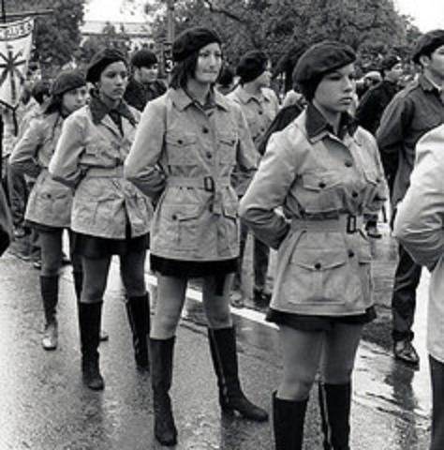
From nationalbrownberets.com. The Brown Beret history has not been without complications. We have been mired with the onslaught of infiltration by government agents and police. Even to this day we suffere at the hands of a repressive government that wants to put us down. Our crime? Seeking freedom for our people and the liberation of our lands from a repressive and oppressive colonizer who is destroying us. The following highlights are as factual as can possibly be gathered. There is no written history on us, most of this knowledge is hsared at the mouths of the Brown Beret veteranos who sometimes have sketchy memories. If you are to understand us, it is best then to know the full history of our organization, the good, the bad, and the ugly…

December 3, 1967
The first Brown Beret unit is organized in East Los Angeles, Califas.

January 1968
The Brown Berets organized the first demonstrations against police brutality in East Los Angeles.

March 1968
The Brown Berets organized the first school walkouts to change the educational system on behalf of La Raza.

September 1968
The Brown Berets organized chapters throughout the states of California, Arizona, Texas, Colorado, New Mexico and as far away as Milwaukee, Chicago, Detroit, Minnesota, Ohio, Oregon, and Indiana, becoming a national organization.

Novemeber 1968
The first school walkouts were organized in San Diego, California as well as other cities thorughout Aztlan by Brown Beret students and supporters.

May 1969
The Brown Berets celebrated the first Cinco de Mayo in San Diego city schools at Mar Vista High School.

May 1969
The Brown Berets opened the first Chicano Free Health Clinic in East Los Angeles.

Summer 1969
The Brown Berets successfully promoted Chicano/Mexicano unity throughout California, creating barrio peace and unity on a national level.

December 14, 1969
The Brown Berets organized the Chicano Moratorium Committee and the first rally in East Los Angeles to protest against racial discrimination and the disproportionate number of Chicanos getting killed in the Vietnam War.

January 1970
La Raza of Logan Heights was threatened with violence by the Hells Angels. The San Diego Brown Berets responded promptly to protect the Barrio effectively thwarting them.

April 22, 1970
The San Diego Brown Berets occupy the land that was to be a California Highway Patrol station in Logan Heights under the Coronado Bridge, forming Chicano Park, which has now become a symbol of Chicano pride and power that is famous around the world.

Summer 1970
The Brown Berets were promoted and organized in various California prisons, as well as in parts of Mexico, Europe, and Asia, by Chicano U.S. Military personnel that agreed with Brown Beret goals and plans.

May 5, 1971
The Brown Berets marched one thousand miles from Calexico to Sacramento in “La Marcha de la Reconquista” to protest statewide against raical and institutionalized discrimination, police brutality, and the high number of Chicano casualties in Vietnam.

August 29, 1971
The Brown Berets embark on a yearlong nationwide expedition in “La Caravana de la Reconquista” to organize La Raza on a national scale to secure rights and self-determination for La Raza.

August 30, 1972
The Brown Berets reclaimed Isla de Santa Catalina in order to bring attention of the illegal occupation of the islands by the U.S. and to claim it on behalf of the Chicano people and to bring attention to the shortage of housing for the Chicano community. The U.S. has illegally occupied this and other Archipelago Islands known as the Channel Islands since 1848 when the signed the Treaty of Guadalupe Hidalgo.

November 1, 1972
Brown Berets were infiltrated by sellouts and subersives working for outside organizations including but not limited to the FBI, LAPD, CWP, ATF, and other “law enforcement” agencies and organizations working to co-opt the Chicano Movement to serve their own agendas. The Brown Berets were disbanded by then Prime Minister David Sanchez in order to circumvent any violence the members of the organization which wa being promoted by those infiltrators mentioned above.

January 1993
Brown Berets are re-activated under the old Charter and Provisions as laid out by the previous Brown Beret Organization. The organization was named Brown Beret National Organization (BBNO).

February 1994
The Executive leadership of the Brown Beret National Organization traveled throughout Aztlan speaking and organizing Raza in the Barrios against gang violence.

March 1994
Brown Beret units were organized in Madera, Stockton, Watsonville, Oakland, San Diego, California, as well as in Sanger, Phoenix, and Tuscon, Arizona, and El Paso, Texas.

December 1995
The Brown Berets organzied a two week march that started in the projects of San Pedro and made its way throughout the barrios of Los Angeles, culminating at the Los Angeles County jail. This march was to promot peace and unity amongst the barrios of Los Angeles and to protest the poor conditions that inmates of the county jail were being kept in.

September 1996
The Brown Berets took a nationwide bus tour of the U.S. in support of the “Latino March” and provided security fot the march and it’s organizers in the U.S. capital.

1997-2006
Various units are organzied in Los Angeles County. Catalina Island was revisited in commemoration of the original Catalina Island Reclamation of 1972.

2005-2009
Brown Beret units were independently organized in Riverside County by Commander Chimalli Cuetlachtli. In 2007 Commander Chimalli created this National Brown Beret website that attracted thousands of viewers internationally. In 2008-2009 Commander Chimalli joined briefly with the Brown Berets of Aztlan but then resigned and began working independently in 2009.

June 2008
Jeronimo Blanco was unanimously voted in as the new National Commander of the BBNO, officially replacing David Sanchez. The organization practically stayed dormant for the next 2 years with no membership, recruitment, or activities.

January 2009
A female Brown Beret, Annette Garcia, from the Riverside County Brown Berets was murdered by a Riverside Sheriff’s Deputy. She was shot in the back in front of her husband and 6 children on the family ranch. Protests and Candle light vigils were immediately coordinated.

2010
Jeronimo Blanco united various factions of Brown Berets in different states. He combined the leadership of those organizations to form a new Cadre Nacional and many reforms were made. Many new members in different states joined.

August 2010
Members from Texas, New Mexico, Arizona, and California, attended the 40th Anniversary of the Chicano Moratorium in Los Angeles, CA.

November 2011
Jeronimo Blanco was “honorably retired” by the membership during the Second Annual National Conference in Tucson, AZ, from the Brown Beret National Organization. A new Organizing Council was formed that took leadership of the Organization. Jeronimo Blanco is no longer a Brown Beret.

December 27, 2011
All members of the Brown Beret National Organization voted unanimously to officially change the name of the Brown Beret National Organization (BBNO), to National Brown Berets (NBB) adopting the NBB as their official organization. The name Brown Beret National Organization is no longer used.

Fastrada: From Wikipedia. (765-794) was an East Frankish noblewoman.
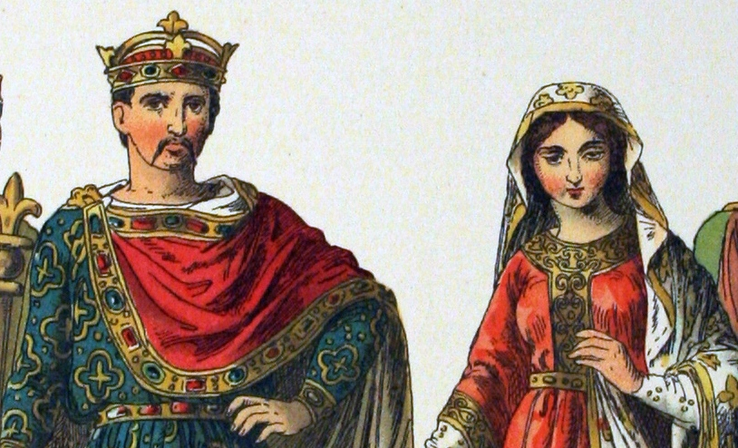

Fastrada (also spelled Fastrade) was born circa 765 at Ingelheim, Rheinhessen, Hesse Darmstadt, Germany, the daughter of the powerful Count Rudolph, an Austrasian count (also known as East Frankish Count Eadolf), and his wife Aeda of Bavaria (also known as Aleida von Bayern/Beieren).

Fastrada became the third wife of Charlemagne, marrying him in October 783 at Worms, Germany, a few months after Queen Hildegard’s death. A probably reason behind the marriage was to solidify a Frankish alliance east of the Rhine when Charles was still fighting the Saxons. As wife of Charles I (Charlemagne), she became Queen of the Franks.

She bore him two children:
-Theodrada Quentin (b. 784, d. unknown), abbess of Argenteuil
-Hiltrude Quentin (b. 787, d. unknown).

Fastrada died on August 10, 794, in Frankfurt, Germany, during the synod of Frankfurt and was buried in St. Alban’s Abbey, Mainz, long before the abbey was finalized. Due to Archbishop Richulf’s influence, she was not buried in the Basilique Saint-Denis, the burial site of almost all the Frankish and French monarchs, nor St. Arnulf’s Abbey near Metz. After the destruction of St. Alban’s Abbey in 1552, her tombstone was transferred to Mainz Cathedral, where it can be seen today in the wall of the southern nave.

Louis the Pious:
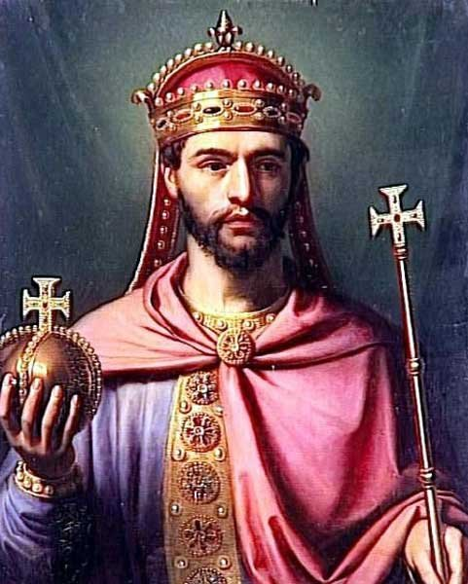
From Encyclopedia Britannica. (born April 16, 778, Chasseneuil, near Poitiers, Aquitaine [now in France] – died June 20, 840, Petersau, an island in the Rhine River near Ingelheim [now in Germany]), Carolingian ruler of the Franks who succeeded his father, Charlemagne, as emperor in 814 and whose 26-year reign (the longest of any medieval emperor until Henry IV [1056-1106]) was a central and controversial stage in the Carolingian experiement to fashion a new European society. Commonly called Louis the Pious, he was known to his contemporaries by the Latin names of Hludovicus or Chlodovicus, which echo the Latin name of Clovis (c. 466-511), the illustrious founder of the Merovingian dynasty. Louis was appointed king of Aquitaine in 781 and was already a seasoned 35-year-old politician and military commander when he became co-emperor with Charlemagne in 813. He was the fourth monarch of the Carolingian dynasty, preceded by his father; his uncle Carloman; and his grandfather Pippin III, the Short.

Berthe: From Wikipedia.
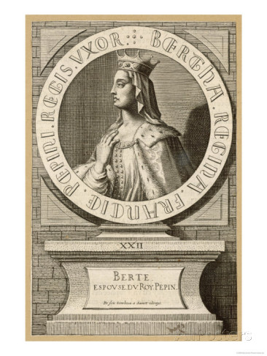
Bertrada of Laon, also called Bertha Broadfoot (cf. Latin: Regina pede aucae i.e. the queen with the goose-foot), (between 710 and 727 – July 12, 783, Choisy) was a Frankish queen.

She was born in Laon, in today’s Aisne, France, daughter, of Count Charibert de Laon (Caribert of Laon) and Gisele of Aquitaine. She married Pepin the Short, the son of Charles Martel, the Frankish “Mayor of the Palace”, in 740, although the union was no canonically sanctioned until several years later. Eleven years later, in 751, Pepin and Bertrada became King and Queen of the Franks, following Pepin’s successful coup against the Frankish Merovingian monarchs.

Bertrada and Pepin are known to have had four children, three sons and one daughter: of these, Charles (Charlemagne), Carloman, and Gisela survived to adulthood, whilst Pepin died in infancy. Charlemagne and Carloman would inherit the two halves of their father’s kingdom when he died, and Gisela became a nun.

Some historians credit Bertrada’s support of her elder son Chalres over her younger son Carloman, and her diplomatic skills, for Charles’ early success. Although her influence over him may have diminished in time, she lived at his court, and according to Einhard their relationship was excellent. She recommended that he set aside his legal wife, Himiltrude, and marry Desiderata, a daughter of the Lombard king Desiderius, but he soon divorced her. Einhard claims this was the only episode that ever strained relations between mother and son. Bertrada lived with Charlemagne until her death in 783. The king buried her in the Saint Denis Basilica with great honors.

Choisy-au-Bac (Berthe’s countryside home): 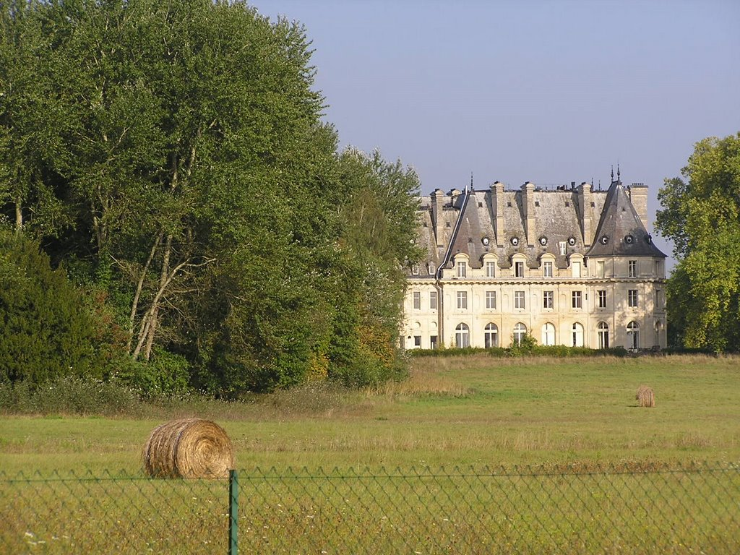

Soldiers in the Visigoth Army:
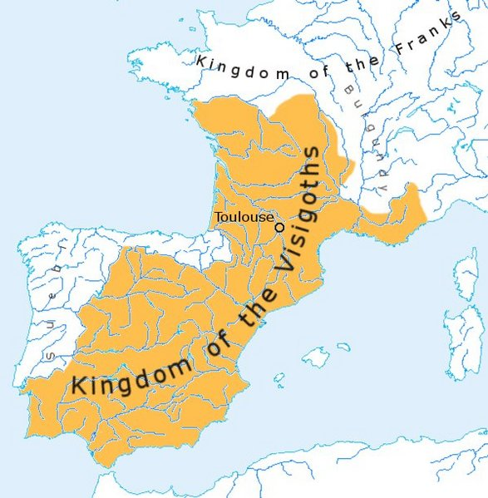

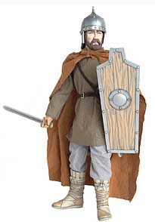
From The Middle Ages.net. The Visigoths were one of the two main branches of the Germanic tribe known as “Goths” (the other tribe is the Ostrogoths). The Goths were among the Germanic peoples who disturbed the late Roman Empire during the Migration Period, following a Visigothic force led by Alaric I’s sacking of Rome 410.

After the collapse of the western Roman Empire, the Visigoths played a major role in western European affairs for another two and half centuries.

The division of the Goths is first attested in 291. Cassiodorus, a Roman in the service of Theodoric the Great, invented the term “Visigothi” to match that of “Ostrogothi”, which terms he though of as “western Goths” and “eastern Goths” respectively. The western-eastern division was a simplification and a literary device of sixth-century historians where political realities were more complex. Furthermore, Cassiodorus used the term “Goths” to refer only to the Ostrogoths, whom he served, and reserved the geographical term “Visigoths” for the Gallo-Spanish Goths. This usage, however, was adopted by the Visigoths themselves in their communications with the Byzantine Empire and was in use in the seventh century.

Frisians: Frisian refers to a native or inhabitat of the Frisian Islands or Friesland. It can also refer to the language spoken in the Netherlands.
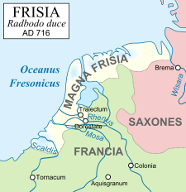
From Wikipedia. The Frisians are a Germanic ethnic group native to the coastal parts of the Netherlands and Germany. They are concentrated in the Dutch provinces of Friesland and Groningen and, in Germany, East Frisia and North Frisia, that was part of Denmark until 1864. They inhabit an area known as Frisia. The Frisian languages are still used by 500,000 speakers; dialects of Frisian are recognized as official languages in both the Netherlands and Germany.
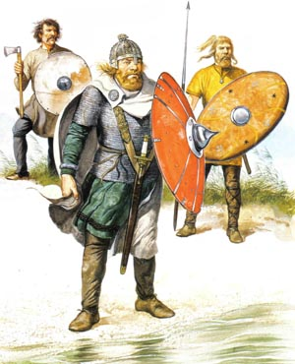

Pompey:
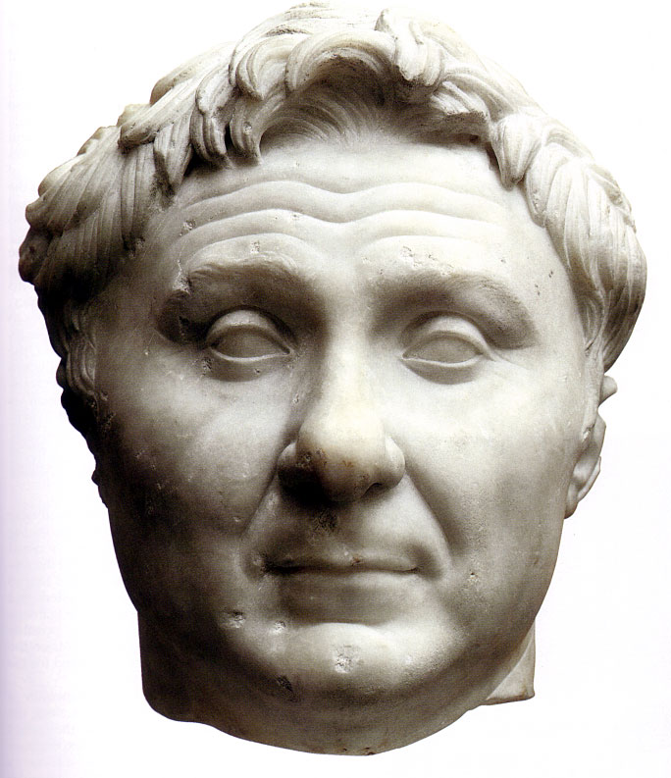
From sacklunch.net. Cneius Pompeius Magnus, was born in 106 B.C. At the early age of 17 he began to learn the military art under his father by service in the field against the Italians in the Social war. Though so young he gave proof of extraordinary valor, and of remarkable energy of character.

He was attached to Sulla in his war against Marius, and behaved with great prudence and valor, and with such remarkable success that, on the restoration of peace in Italy, the conduct of war against the remains of the Marian faction in Africa and Sicily was entrusted to him. He speedily performed his commission, and on his return to Rome was honored with the name of Magnus, (i.e. “The Great,”) and with a triumph, which for one who had never held any public office, and was merely an eques, was an unprecedented distinction. His next exploits were the reduction of the followers of Lepidus, whom he drove out of Italy, and the extinction of the Marian party in Spain, led on by the brave Sertorius. In returning to Italy after an absence of five or six years in Spain, he fell in with and defeated the remnants of the army of Spartacus, and thus claimed the credit of concluding the Servile war. He was now the idol of the people, and though legally ineligible ot the consuship, was elected to that important office in the year 70, the Senate relieving him of his disabilities rather than provoke him to extremities.

In 67-66 B.C., Pompey performed a noble service to the republic in clearing the Mediterranean of the pirates who infested it in great numbers; and during the next four years 65-62 he conquered Mithridates, King of Pontus, Tigranes, King of Armenia, and Antiochus, King of Syria. At the same time he subdued the Jewish nation, and captured Jerusalem. On his return to Italy he disbanded his army and entered Rome in triumph for the third time, 61 B.C. Later, having quarrelled with the Senate, he joined with Caesar and Crassus in forming a coalition, which is commonly called “The First Triumvirate,” and which for atime frustrated all the efforts of the aristocratic party. Caesar’s daughter, Julia, was given in marriage to Pompey, and private relationship was thus made to bind together the ties of political interest. And now for sme eyars following, Caesar was reaping laurels in Gaul, and rising higher in popular esteem as a warrior and statesman, while Pompey was idly wasting his time and energies at Rome. But Pompey could not bear a rival. Jealousies sprang up; Julia died in 54 B.C., and thus father-in-law and son-in-law were sundered by a yet wider gulf, which no bridge could span. Pompey now returned to his former friends, the aristocracy, whose great desire was to check Caesar’s views, and strip him of his command. Caesar was ordered to lay down his office and return to Rome, which he consented to do provided Pompey, who had an army near Rome, would do the same. The Senate insisted on an unconditional resignation, and ordered him to disband his army by a certain day, otherwise he would be declared a public enemy. It was on this memorable occasion that he crossed the Rubicon, and thus defied the Senate and its armies, which were under Pompey’s command. The events of the civil war which followed, are recorded in the life of Caesar. It remains only to mention that after being finally defeated at Parsalia in 48 B.C., Pompey escape to Egypt, where, according to the order of the King’s ministers, he was treacherously murdered by a former centurion of his own, as he was lnding from the boat.

Darius: From Heritage History.com. Darius the Great was the third of the Great Kings of the Persian Empire. His two predecessors, Cyrus the Great and Cambyses, had been conquerors, but the main achievement of Darius was consolidation and organization. After putting down numerous rebellions in his early years, Darius set about administering to his kingdom. He minted gold coins, called Darics, that were widely used for commerce and trade. He divided the Empire up into twenty provinces, each run by a satrap, or governor, who in most cases, had a great deal of autonomy. In order gain the good-will of his subject people, he allowed religious freedom, and donated money toward the building of various temples, including the Temple of Jerusalem, in Judea.

Old King Aleric (Alaric/Arechis II): From Wikipedia. Arechis II (died Augus 26, 787) was Duke (and later Prince) of Beneveto, in southern Italy, from 758 until his death. While he sought to expand Benevento’s influence into areas of Italy still controlled by the Byzantine Empire, he also had to resist attacks by Charlemagne, who was building a Frankish empire and had conquered northern Italy.
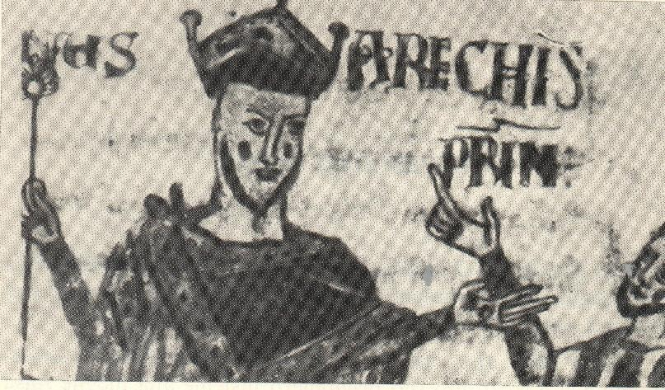

Allusions to Modern History

Iraq War Statistics: From Business Insider.com.
-189,000: Direct War Deaths (which doesn’t include the hundreds of thousands more that died due to war-related hardships.

-4,488: U.S. Service personnel killed directly.

-32,223: Troops injured (not including PTSD).

-134,000: Civilians killed directly.

-655,000: Persons who have died in Iraq since the invasion that would not have died if the invasion had not occurred.

-150: Reporter killed.

-2.8 million: Persons who remain either internally displaced or have fled the country.

$1.7 trillion: Amount in war expenses spent by the U.S. Treasury Department as through Fiscal Year 2013.

$5,000: Amount speant per second.

$350,000: Cost to deploy one American military member.

$490 billion: Amount in war benefits owed to war veterans.

$7 trillion: Projected interest payments due by 2053 (because the war was paid for with borrowed money).

$20 billion: Amount paid to KBR, contractor respnsible for equipment and services.

$3 billion: Amount of KBR payments Pentagon auditors considered “questionable.”

$60 billion: Amount paid for reconstruction, (which was ruled largely a waste due to corruption and shoddy work.)

$4 billion: Amount owed to the U.S. by Iraq before the invasion.

1.6 million: Gallons of oil used by U.S. forces each day in Iraq (at $127.68 a barrel).

$12 billion: Cost per month of the war by 2008.

$7 billion: Amount owed to Iraq by the U.S. after the war (mostly due to fraud).

$20 billion: Annual air conditioning cost.

Missing $546 million in spare parts; 190,000 guns, including 110,000 AK-47s.

40 percent: Increase in Iraqi oil production.

$5 billion: Revenue from Iraqi oil in 2011.

$85 billion: Revenue for Iraqi oil in 2011.

$150 billion: Amount of oil companies are expected to invest in oil development over the next decade.

$75 billion: Approximate amount expected to go to American subcontracting companies, largest of all Halliburton.

0: Nuclear Weapons of Mass Destruction found (though a bunch of chems were discovered).

Afghanistan Statistics: From brookings.edu.

60,000: Number of troops currently in Afghanistan.

From ¡casualties.org.

2,306: US Military Fatalities.

447: UK Miliatry Fatalities.

661: Other NATO forces military fatalities.

3,414: Coalitition Military Fatalities to present.

From nationalpriorities.org. – Last updated Aug. 27, 2013.

-$662.4 billion has been allocated for the war in Afghanistan since 2001, including $91.5 billion in fiscal year 2013.

From Global Research.ca. April 2, 2013

$1 million: Cost of deploying one American troop to Afghanistan.

From fcnl.org. February, 2013.

17,500: Wounded Military Personnel.

30,000: Afghan civilians have been killed since 2001.

349: A record-setting veterans that have died by suicide in 2012, compared with the 310 who died in combat.

22: The VA estimates that approximately 22 veterans will die by suicide every day, that’s one death every 65 minutes.

2,000: Current and former service members who have died by suicide in the last decade.

$79.5 billion: Authorized FY14 spending.

$778 billion: Total spending since 2001.

$6.6 billion: Total spending per month FY2014.

$1.53 billion: Total spending per week FY2014.

$218 million: Total spending per day FY2014.

$9.1 million: Total spending per hour FY2014.

$151,670: Total spending per minute FY2014.

Both the Iraq and Afghanistan War:
From Global Research.ca. April 2, 2013

$75,000: The cost of both wars per American household.

Props/Costumes
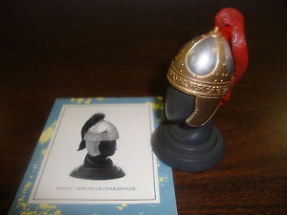

Helmets during Charlemagne’s reign
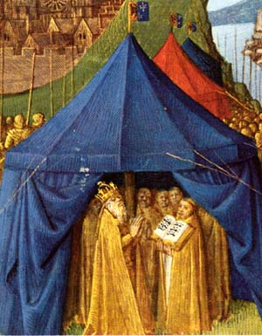

War Tents during Charlemagne’s Reign
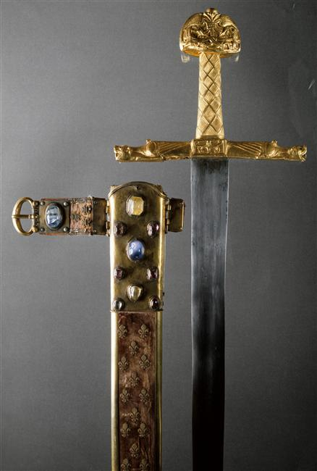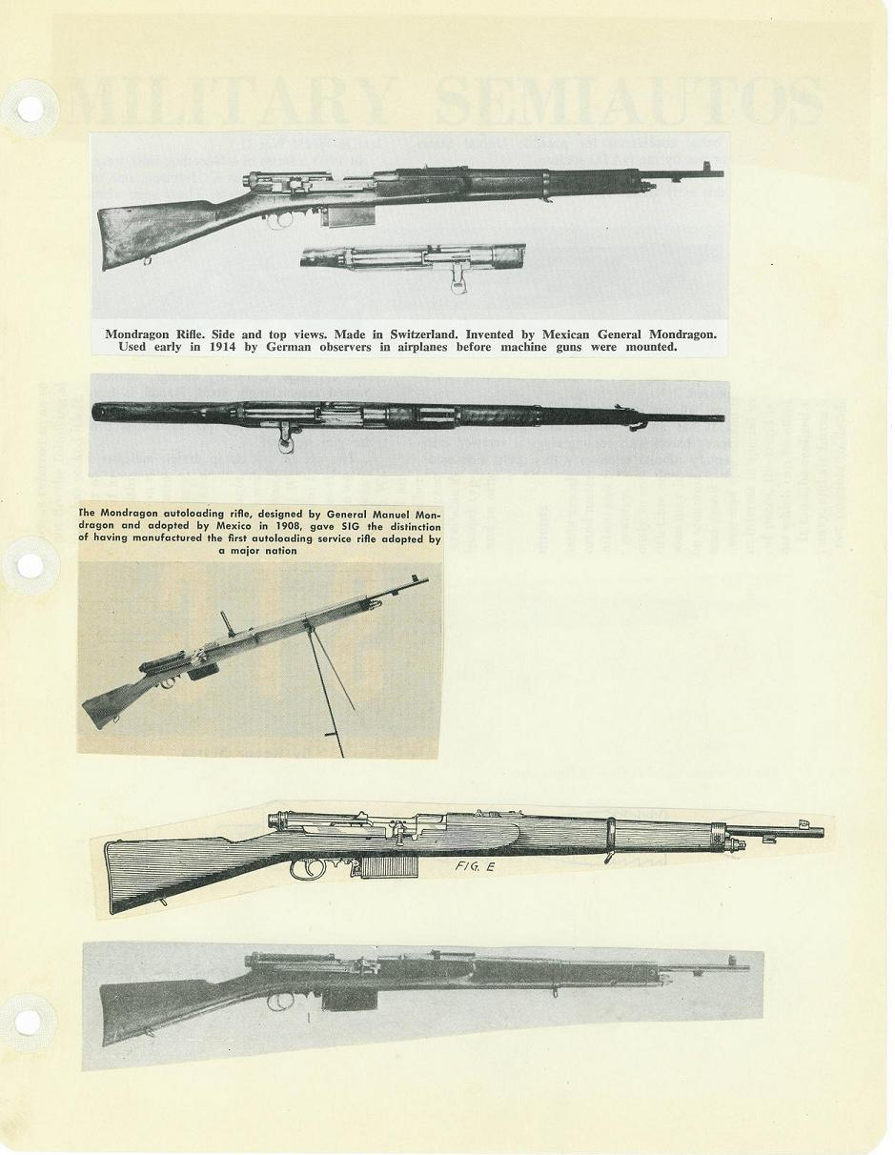
Swords, Guns, and Hoe for “Magic To Do” sequence
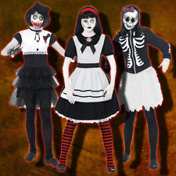

Calavera Jumpsuits
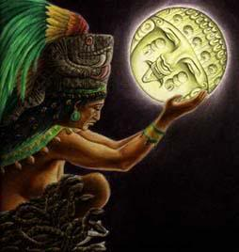
Coyolxauhqui Headress for Leading Player:
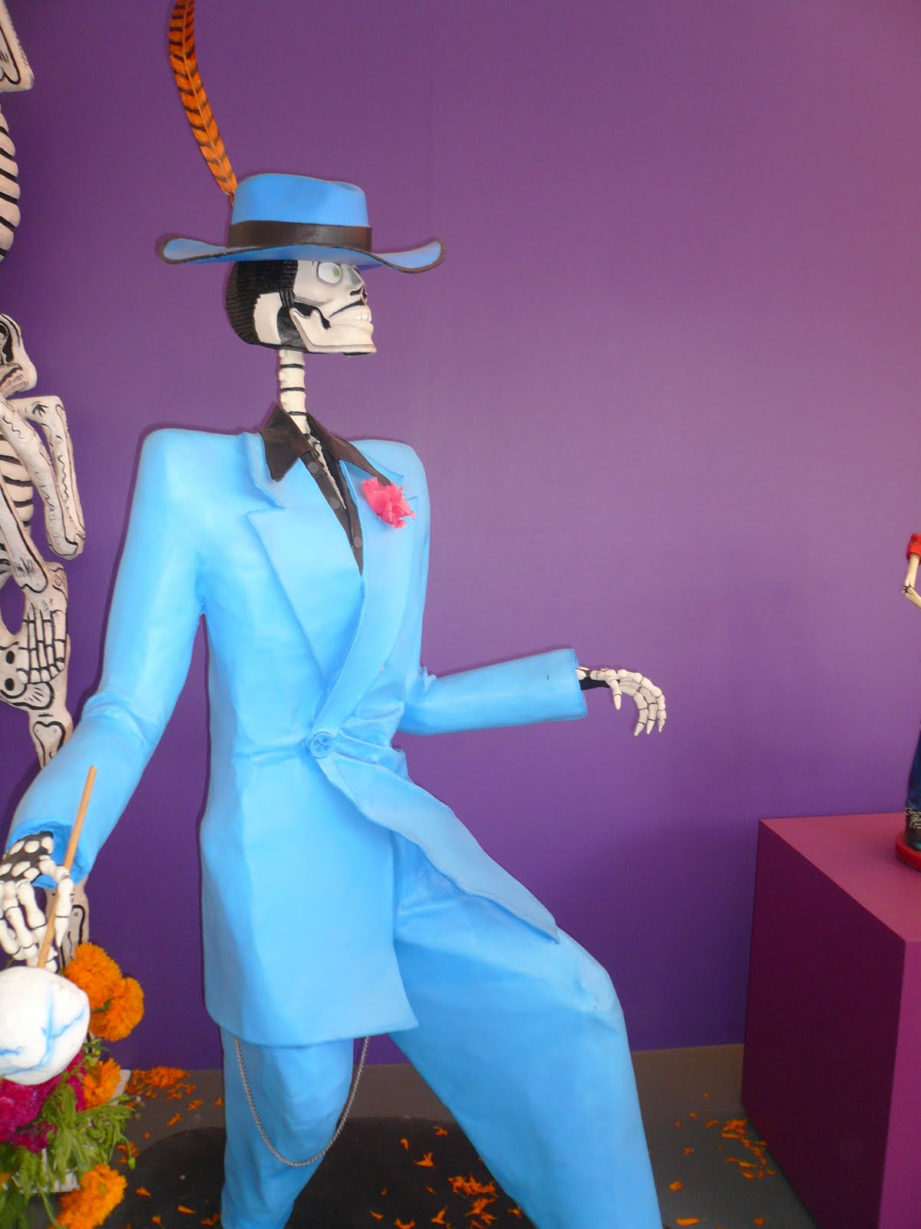

Zoot Suit look for Leading Player

Dog Masks for Soldiers

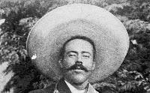

Decapitated head of Pancho Villa
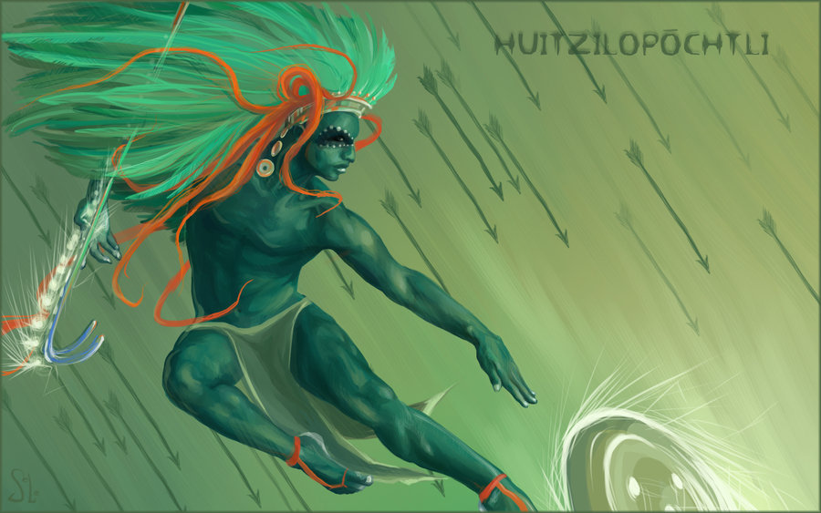

Huitzilopochtli Headress for Charles:
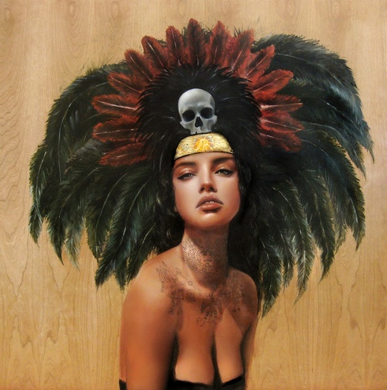
Coatlicue Headress for Berthe

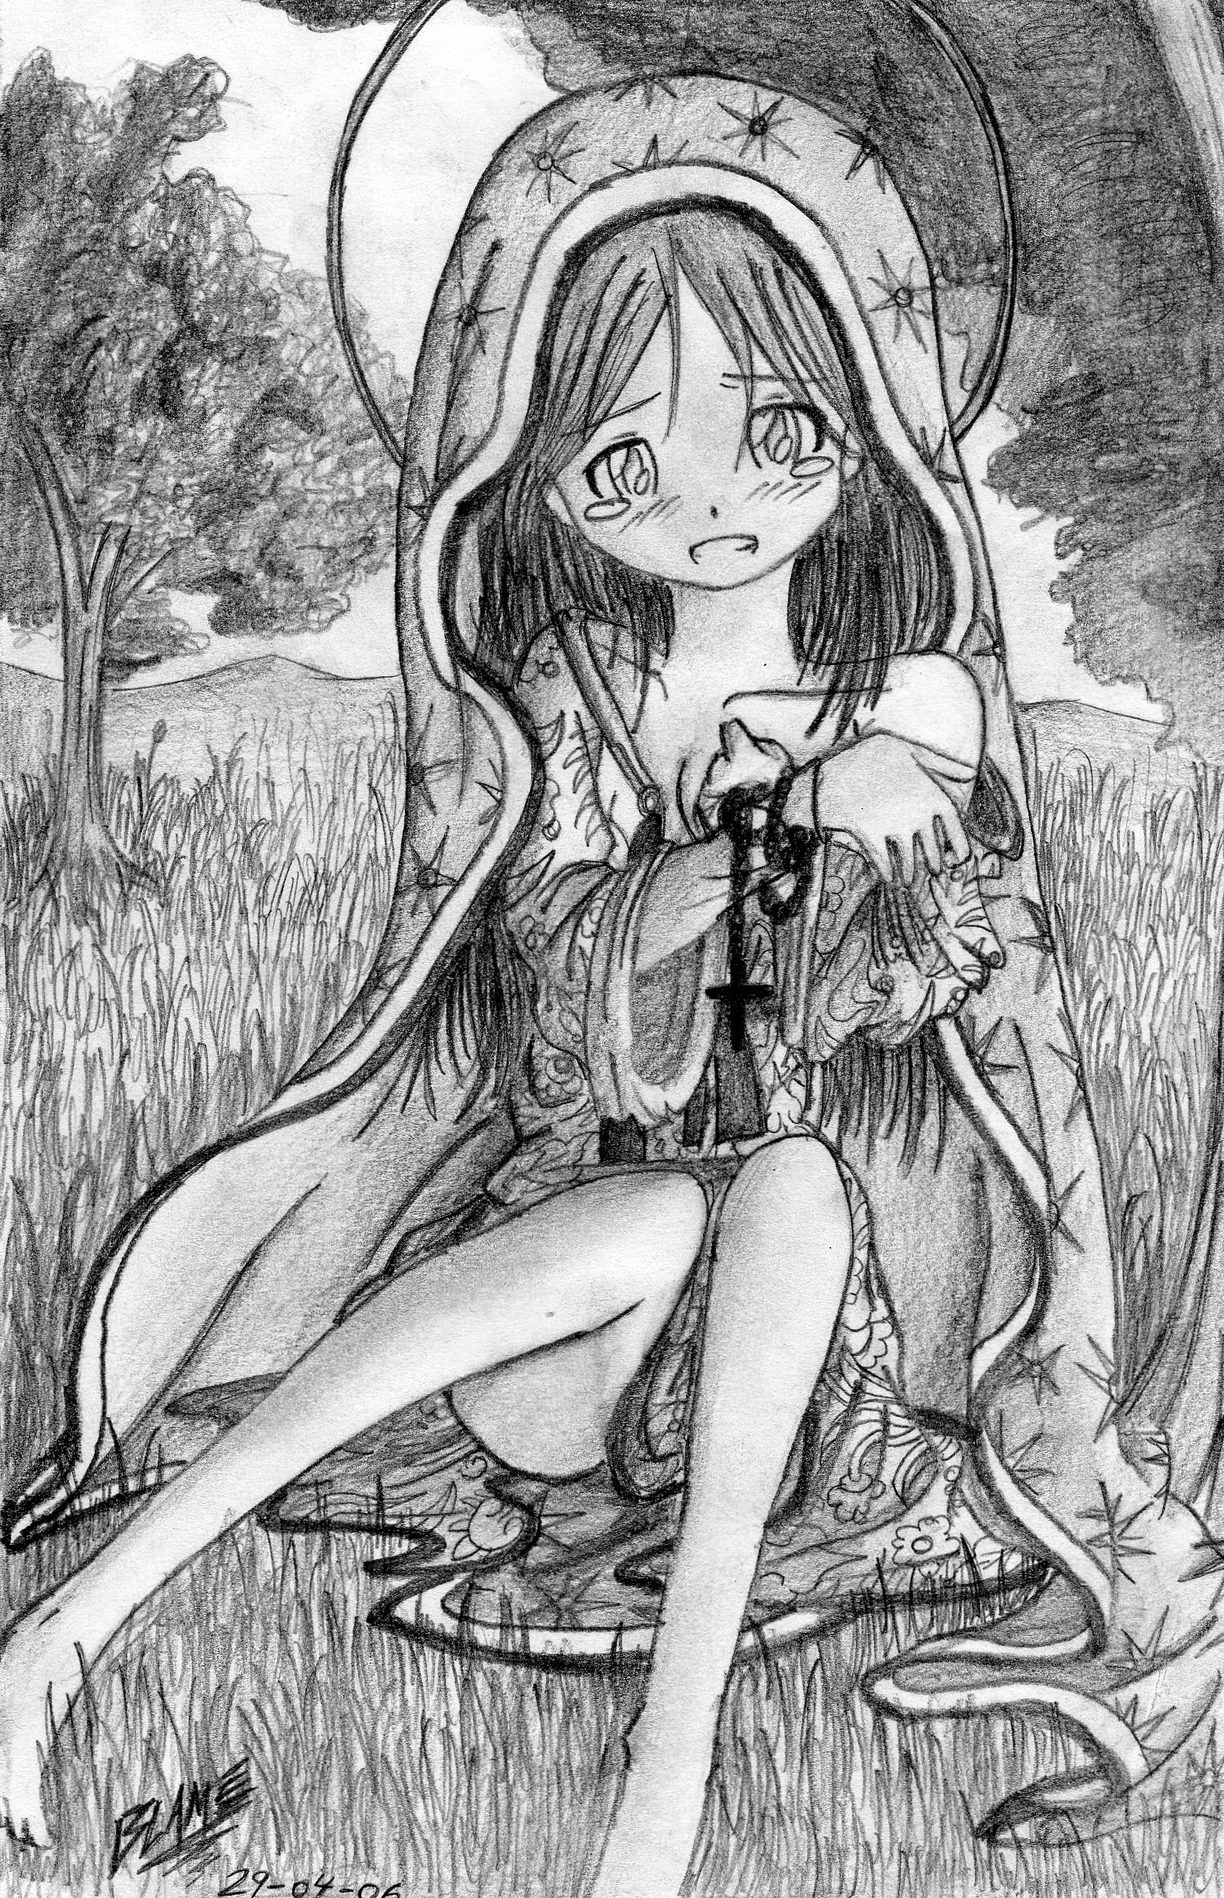
La Virgen de Guadalupe look for Catherine:
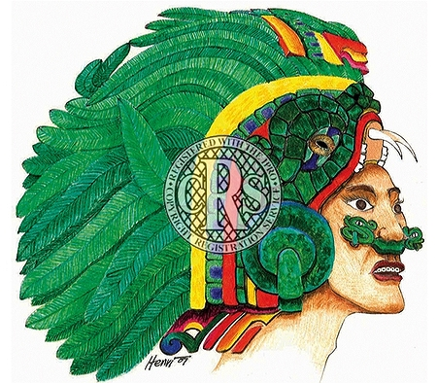

Quetzalcóatl Headress for Pippin at the end

Vocabulary
From Merriam Webster’s Collegiate Dictionary 10th Edition
abject: [Middle English, to cast off, to throw]. Sunk to or existing in a low state or condition. Cast down in spirit: servile, spiritless. Showing utter hopelessness or resignation. Expressing or offered in a humble and often ingratiating spirit.

abrasive: A substance used to irritate or roughen by rubbing. Tending to wear down in spirit: Irritate, Weary.

amok: [Malay amok]. A murderous frenzy that occurs chiefly among Malays. A murderously frenzied state. In a violently raging manner.

anecdotic: [Greek: unpublished items]. Given to or skilled in telling a short narrative or an intersting, amusing, or biographical incident.

astray: [Middle English/Middle French: wandering]. Off the right path or route: straying. In error: away from what is proper or desirable.

banyan tree: [Sanskrit: a tree of the species in Iran under which such traders conducted business]. An East Indian fig tree (Ficus benghalensis) of the mulberry family with branches that send out shoots which grow down to the soil and root to form secondary trunks.

barbarous: [Latin/Greek: foreign, ignorant]. Uncivilized. Lacking culture or refinement: Philistine. Characterized by the occurrence of someone who is of an inferior culture. Mercilessly harsh or cruel.

brine: [Middle/Old English/Middle Dutch]. A water sturated or strongly iimpregnated with common salt. A strong saline solution. The water of a sea or salt lake.

cataracts: [Latin: waterfall]. A clouding of the lens of the ey or of its surrounding transparent membrane that obstructs the passage of light. Waterfall, especially a large one over a precipice; downpour, flood.

catarrh: [Middle French/Late Latin: flow down]. Inflammation of a mucous membrane; especially one chronically affecting the human nose and air passages.

charlatan: [Italian: inhabitant of Cerreto, Italy]. Quack: killing their patients with empirical procedures. One making usually showy pretenses to knowledge or ability: fraud, faker.

competent: [Middle English: suitable]. Proper or rightly pertinent. Having requisite or adequate ability or qualities: fit. Legally qualified or adequate.

compost: [Middle French/Middle Latin]. A mixture that consists largely of decayed organic matter and is used for fertilizing and conditioning land. Mixture, Compound.

conservative: An adherent or advocate of political beliefs based on tradition and social stability, stressing established institutions, and preferring gradual development to abrupt change. One who adheres to traditional methods or views. A cautious or discreet person.

cranny: [Middle English/Middle French: notch]. A small break or slit: crevice. An obscure nook or corner.

cul-de-sac: [French: bottom of the bag]. A blind diverticulum or pouch. A street or passage closed at one end. Blind alley.

decimate: [Latin: tenth]. To select by lot and kill every tenth man. To reduce drastically in number. To destroy a large part of.

defilade: To arrange fortifications so as to protect the lines from frontal or enfilading fire and the interior from fire and interior from fire from above and behind.

ebbed: [Old English]. The reflux of the tide toward the sea. A point or condition of decline.

enfilade: [French: to thread]. An interconnected group of rooms arranged usually in a row with each room opening into the next. Gunfire directed form a flanking position along the length of an enemy battle line.

falconry: The art of training hawks to hunt in cooperation with a person. The sport of hunting hawks.

famine: [Middle English/Middle French: hunger]. An extreme scarcity of food. Starvation. A ravenous appetite. A great shortage.

flurried: [French: to throw scatteringly]. To cause to become agitated and confused. To move in an agitated or confused manner.

foibles: [French: weak, feeble]. The part of a sword or foil blade between the middle and point. A minor flaw or shortcoming in character or behavior: weakness.

fray: [Middle English: to affray: scare, frighten away]. A usually disorderly or protracted fight, struggle, or dispute.

frenzied: [Middle English/Middle French]. Marked by a temporary madness, a violent mental or emotional agitation, and intense usually wild and often disorderly compulsive or agitated activity.

frivolous: [Middle English/Latin]. Of little weight or importance. Having no sound basis (as in fact or law). Lacking in seriousness; marked by unbecoming levity.

frolic: [Dutch: happy]. Full of fun: merry. A playful or mischievous action. An occasion or scene of fun: party.

frolicking: To amuse oneself: make merry. To play and run about happily: Romp.

gyrations: [Middle French/Greek: rounded]. An act or instance of winding or coiling around, to revolve around a point or axis. The act of oscillating with or as if with a circular or spiral motion.

infidel: [Middle English/Middle French: unbelieving, unfaithful]. One who is not a Christian or who opposes Christianity. An unbeliever with respect to a particular religion. One who acknowledges no religious belief. A disbeliever in something specified or understood.

Iron Crown: From Wikipedia. The Iron Crown of Lombardy is both a reliquary and one of the oldest royal insignia of Christendom. It was made in the Early Middle Ages, consisting of a circlet of gold fitted around a central iron band, which according to legen was beaten out of a nail of the True Cross (the name for physical remnants which, by a Christian traditon, are believed to be from the cross upon which Jesus was crucified).
The crown became one of the symbols of the Kingdom of Lombards and later of the medieval Kingdom of Italy. It is kept in the Cathedral of Monza, outside Milan.
According to tradition, the nail was first given to Emperor Constantine by his mother St. Helena, who had discovered the True Cross. Helena supposedly cast one nail into the sea to calm a storm, while another was incorporated into Constantine’s helmet, another fitted to the head of a statue of the Emperor, and a fourth melted down and molded into a bit for Constantines horse. Since almost thirty European countries lay claim to fragments of the holy nails, Blom (2002) holds that “Constantine also understood the value of these objects in diplomacy”; Several were sent off to various dignataries, one of whom was Princess Theodelinda. She used her nail as part of her crown, the famous Iron Crown of Lombardy.
When the nail was incorporated into a crown and how it fell into the hands of the Lombard kings is unclear, though legends involve Theodelinda, the queen of the Lombards who resided at Monza in the late 6th century, for her part in converting the Lombards to Christianity. Theolinda supposedly donated the crown to the Italian church at Monza in 628, where it was preserved.
In some accounts, the crown was used in Charlemagne’s coronation as King of the Lombards. Contemporary or nearly contemporary accounts of the initiations of the earlier kings of the Lombards stress the importance of the king’s taking in hand of a holy lance.

laurels: [Latin]. Any of a genus (Laurus of the family Lauraceae, the laurel family) of evergreen trees that have alternate entire leaves, small tetramerous flowers surrounded by bacts, and fruits that are ovoid berries; specifically a tree (L. nobilis) of southern Europe with foliage used by the ancient Greeks to crown victors in the Pythian games. A tree or shrub that resembles the true laurel; especialy: Mountain Laurel. A crown of laurel: honor.

lea: [Latin: grove]. Grassland, pasture. Arable land used temporarily for hay or grazing.

legions: [Latin: to gather, legend]. The principal unit of the Roman army comprising 3000 to 6000 foot soldiers with cavalry. A large military force especially army. A very large number: multitude. A national association of ex-servicemen.

liberal: [Greek: free]. Given or provided in a generous and openhanded way. Ample, full. Lacking moral restraint: licentious. Not literal or strict. Broad-minded, especially not bound by authoritarianism, orthodoxy, or traditional forms. Of, favoring, or based upon a belief in progress, the eseential goodness of the human race, and the autonomy of the individual and standing for the protection of political and civil liberties.

litany: [Greek: suppliant]. A prayer consisting of a series of invocations and supllications by the leader with alternate responses by the congregation. A resonant or repetitive chant. A lengthy recitation or enumeration.

macabre: [French: dance of death]. Having death as a subject: comprising or including a personalized representation of death. Dwelling on the gruesome. Tending to produce horror in the beholder.

malingering: [French: sickly]. To pretend incapacity (as illness) so as to avoid duty or work.

mendicant: [Latin: beggar]. Beggar. A member of a religious order (as the Franciscans) combining monastic life and outside religious activity and orig. owning neither personal nor community property: friar.

mystic: [Greek: initiate]. Of or relating to mysteries or esoteric rites: occult. Of or relating to the experience of a spiritual union or a reality that is neither apparent to the senses nor obvious to the intelligence. Mysterious. Obscure, enigmatic. Inducing a feeling of awe or wonder. Having magical powers.

newt: [Middle English: alter]. any of various small semiaquatic salamanders (as of the genus Triturus).

obsolete: [Latin: to grow old, become disused, to be accustomed]. No longer in use or no longer useful. Of a kind or style no longer current: old-fashioned.

panolpy: [Greek: arms, armor, tool, weapon]. A full suit of armor. Ceremonial attire. Something forming a protective covering. A magnificent or impressive array. A display of all appropriate appurtenances.

parables: [Greek: comparison, to compare]. Example: specifically a usually short fictitious story that illustrates a moral attitude or a religious principle.

piqued: [French: to prick, pike]. To arouse anger or resentment in: irritate. To excite or arouse by a provocation, challenge, or rebuff.

pompous: [Greek: act of sending, escort, procession, pomp]. Excessively elevated or ornate. Having or exhibiting self-importance: arrogant. Relating to or suggstive of pomp: magnificent.

Quince Pudding Flambé: From Wikipedia. Pudding is usually a dessert, but it can also be a savory dish. The word pudding is believed to come from the French boudin, originally from the Latin botellus, meaning “small sausage,” referring to encased meats used in Medieval European puddings. Recipe: Scald the quinces tender, pare them thin, scapre off the pulp, mix with sugar very sweet, and add a little ginger and cinnamon. To a pint of cream put three or four yolks of eggs, and stire it into the quinces till they are of a good thickness. Butter the dish, pour it in, and bake it.

rapprochement: [Old French: to approach]. Establishment of or state of having cordial relations.

ravine: [Latin: rapine, rush]. A small narrow steep-sided valley that is larger than a gully and smaller than a canyon and that is usually worn by running water.

recapitulate: [Late Latin: to restate by heads, sum up]. To repeat the principal points or stages of: summarize.

roue: A debauched man, especially an eldery one. Degenerate.

sages: [Old Saxon: to perceive]. One (as a profound philosopher) distinguished for wisdom through reflection and experience which is proceeded from or characterized by wisdom, prudence, and good judgement.

scowl: [Middle English: to scowl]. To contract the brow in an expression of displeasure. To exhibit a threatening aspect; to express with a scowl. A facial expression of displeasure: frown.

sequester: [Latin: to hand over to a trustee, third party to whom disputed property is entrusted, agent]. To set apart, segregate. Seclude, withdraw. To seize especially by a writ authorizing a sheriff or commissioner to take into custody the property of a defendant who is in contempt until the orders of a court are complied with.

skirmish: [Old Italian]. A minor fight in war usually incidental to larger movements. A brisk preliminary verbal conflict. A minor dispute or contest between opposing parties.

sown: [Latin: to sow]. To plant seed for growth especially by scattering. To set something in motion: begin an enterprise. To scatter (as seed) upon the earth for growth; broadly: plant. To strew with or as if with seed. To spread abroad: disperse.

stalwart: [Old English: serviceable]. Marked by outstanding strength and vigor of body, mind, or spirit.

succulent: [Latin: juice, to suck]. Full of juice: juicy. Moist and tasty: toothsome. Having fleshy tissue that conserve moisture. Rich in interest.

superlatives: [Latin: to carry over, raise high]. Of, relating to, or constituting the degree of grammatical comparison that denotes an extreme or unsurpassed level of extent. Surpassing all others: supreme. Of very high quality: excellent. Excessive, exaggerated.

surly: [Middle English: Lordly, imperious]. Arrogant, imperious. Irritably sullen and churlish in mood or manner: carbbed. Menacing or threatening in appearance. Sullen.

synthesis: [Greek: to put together]. The composition or combination of parts or elements so as to form a whole. The production of a substance by the union of chemical elements, groups or simpler compounds or by the degradation of a complex compound. The combining of often diverse conceptions into a coherent whole. A deductive reasoning. The dialectic combination of thesis and antithesis into a higher stage of truth. The frequent and systematic use of inflected forms as a characteristic device of a language.

tranquil: [Latin]. Free from agitation of mind or spirit. Free from disturbance or turmoil. Unvarying in aspect: steady, stable.

trifling: [Old French: mockery]. Lacking in significance or solid worth: as frivolous. Trivial. Lazy, shiftless.

underhanded: Marked by secrecy, chicanery, and deception. Not honest and aboveboard: sly.

waylay: To lie in wait for or attack from ambush.

yester: Of or relating to yesterday.

zenith: [Arabic: over one’s head]. The point of the celestial sphere that is directly opposite the nadir and vertically aboe the observer. The highest point reached in the heavens by a celestial body. Culminating point: Acme.

Bibliography

Books
Becher, Matthias. CHARLEMAGNE. Yale University Press. 2005

Bogart, Anne and Landau, Tina. THE VIEWPOINTS BOOK: A PRACTICAL GUIDE TO VIEWPOINTS
AND COMPOSITION. Theatre Communications Group. New York. 2005.

Currell, David. PUPPETS AND PUPPET THEATRE. The Crowood Press. Rambury, Malborough
Wiltshire. 2002.

DeVries, Kelly and Smith, Robert Douglas. MEDIEVAL WEAPONS: AN ILLUSTRATED HISTORY OF
THEIR IMPACT. ABC-CLIO. 2007.

Ducklin, Keith and Waller, John. SWORD FIGHTING: A MANUAL FOR ACTORS AND DIRECTORS.
Applause Theatre Books. 2001.

Huerta, Jorge A. CHICANO THEATER THEMES AND FORMS. Bilingual Press/
Editorial Bilingüe. Ypsilanti, Michigan. 1982.

Lecoq, Jaques. (With Jean-Gabriel Carasso and Jean Claude Lallias.) Bradby, David – trans. THE
MOVING BODY. Routledge. New York. 2000.

McNeese, Tim. THE VOLGA RIVER. Facts on File. 2005.

Rudlin, John. COMMEDIA DELL’ARTE: AN ACTOR’S HANDBOOK. Routledge. London and
New York. 1994.

Story, Joanna. CHARLEMAGNE: EMPIRE AND SOCIETY. Manchester University Press. 2005.

Websites
“100 Years of Latino Theatre.” Latinopia.com. 2009.
http://latinopia.com/latino-theater/100-years-of-chicanolatino-theatre/

“Arles, 2000 years of history.” Unesco World Heritage Site.
http://www.tourisme.ville-arles.fr/us/a1/a1.htm

“Biography of Pompey the Great.” Sacklunch.net.
http://www.sacklunch.net/biography/P/PompeytheGreat.html

“Brown Berets.” National Brown Berets.com. Chlmalli Cuetlachtli. 2007.
http://nationalbrownberets.com/

“By the Number: The Staggering Cost of the Iraq War.” Business Insider.com. Michael Kelly and
Geoffrey Ingersoll. Mar. 20, 2013.
http://www.businessinsider.com/iraq-war-facts-numbers-stats-total-2013-3

“Charlemagne.” Encyclopedia of World Biography. 2004.
http://www.encyclopedia.com/topic/Charlemagne.aspx

“The Court of Charlemagne: Medieval Hunting.” Tyson Hass. blogspot.com. May 30, 2008.
http://german210.blogspot.com/2008/05/medieval-hunting-by-tyson-hass.html

“Carolingian Empire (800-888).” www.princeton.edu.
http://www.princeton.edu/~achaney/tmve/wiki100k/docs/Carolingian_Empire.html

“Darius the Great also known as Darius Hystapes.” Heritage History.com. 2007-2012.
http://www.heritage-history.com/www/heritage.php?Dir=characters&FileName=darius1.php

“Dust Bowl.” history.com. 1996-2014. http://www.history.com/topics/dust-bowl

“Galilee.” Catholic Encyclopedia. Arthur McMahon. 2014.
http://www.newadvent.org/cathen/06341c.htm

“History.” www.ufw.org. 2006.
http://www.ufw.org/_page.php?menu=research&inc=research_history.html

“King Charlemagne’s Combat Strategy and Tactics”. elwar55. 2014.
http://elwar55.hubpages.com/hub/King-Charlemagnes-Combat-Strategy-and-Tactics

“The Origin of Universities”. http://www.cwrl.utexas.edu/~bump/OriginUniversities.html

“St. Anne Chapel.” arlesfrance.ca. http://arlesfrance.ca/attractions/chapelle-saint-anne.html

“Suzuki Method.” Stonecrabs.co.uk. 2011. http://www.stonecrabs.co.uk/stonecrabs/index.php?option=com_content&view=article&id=36&Itemid=20

“University of Padua”. 1994-2013.
http://www.topuniversities.com/universities/university-padua/undergrad

“An Update on America’s Forgotten War in Afghanistan.” Brookings.edu. Michael E. O’Hanlon.
September 5, 2013.
http://www.brookings.edu/research/opinions/2013/09/05-afghanistan-war-metrics-ohanlon

“Visigoths.” The Middle Ages.net. http://www.themiddleages.net/visigoths.html

“The Wars and Campaigns of Charlemagne”. historyguy.com. Roger A. Lee. 1998-2013.
http://www.historyguy.com/wars_of_charlemagne_king_of_franks.htm#.UtGNePZQ3HY

“What was the Holy Roman Empire?”. S. Michael Houdmann. 2002-2014.
http://www.gotquestions.org/Holy-Roman-Empire.html

